

FACULTY OF COMPUTING SEMESTER II, SESSION 2025/26

SECJ3104 SEC02 APPLICATION DEVELOPMENT

SOFTWARE REQUIREMENT

PROJECT TITLE: ThriftIn UTM

PREPARED BY:
NAME | MATRIC NUMBER
ASILAH BINT MOHD RAZAK
ANGIE WONG SIAW THING
AINA ZAFIRAH BINTI AHMAD MUZAMIR
TAN JIA YING

SUBMISSION DATE:

TABLE OF CONTENT

1.0 INTRODUCTION TO APPLICATION 4
1.1 INTRODUCTION 4
1.2 PROBLEM STATEMENT 4
1.3 THE PROPOSED SYSTEM 4
1.4 TECHNOLOGY AND TOOL USED 4
1.5 FUNCTIONAL REQUIREMENTS 5
2.0 APPLICATION DIAGRAM 6
2.1 USE CASE DIAGRAM 6
3.0 USER MANAGEMENT SUBSYSTEM SPECIFICATION 7
3.1 USER REGISTRATION & LOGIN MODULE (ANGIE) 7
3.1.1 UC001: REGISTER ACCOUNT 8
3.1.2 UC002: LOGIN ACCOUNT 11
3.1.3 UC003: RECOVER PASSWORD 13
3.2 PROFILE AND VERIFICATION MODULE (ANGIE) 15
3.2.1 UC014: VERIFY EMAIL 17
3.2.2 UC015: MANAGE PERSONAL DETAILS 21
3.2.3 UC016: VERIFY MATRIC NUMBER 25
3.2.4 UC017: REVIEW SUBMISSION FOR VERIFICATION OF MATRIC NUMBER 29
3.2.5 UC018: VIEW VERIFICATION HISTORY 32
3.3 ACCESS CONTROL AND AUTHORIZATION MODULE (ANGIE) 35
3.3.1 UC030: ATTEMPT TRANSACTION WITH RESTRICTIONS CHECK 36
3.3.2 UC031: TEMPORARILY SUSPEND USER ACCOUNT FOR INVESTIGATION 38
3.3.3 UC032: PERMANENT SUSPEND USER ACCOUNT 40
3.3.4 UC033: VIEW REPORT REASON AND EVIDENCE 42
3.3.5 UC034: REINSTATE TEMPORARILY SUSPENDED AND RESTRICTED USER 44
4.0 PRODUCT AND MARKET SUBSYSTEM SPECIFICATION 46
4.1 PRODUCT LISTING & MANAGEMENT MODULE (AINA ZAFIRAH) 46
4.1.1 UC004: ADD NEW PRODUCT 47
4.1.2 UC005: VIEW OWN PRODUCT LISTING 49
4.1.3 UC006: EDIT PRODUCT LISTING 50
4.1.4 UC007: DELETE PRODUCT 52
4.2 PRODUCT AND MARKET SUBSYSTEM: SEARCH AND RECOMMENDATION MODULE (AINA ZAFIRAH) 54
4.2.1 UC019: SEARCH PRODUCT 55
4.2.2 UC020: FILTER PRODUCT BY CATEGORY 56
4.2.3 UC021: VIEW PRODUCT DETAILS 58
4.2.4 UC022: VIEW PRODUCT RECOMMENDATION 59
4.3 PURCHASING AND PAYMENT MODULE (AINA ZAFIRAH) 61
4.3.1 UC035 VIEW WALLET 62
4.3.2 UC036 TOP UP WALLET 63
4.3.3 UC037 BUY ITEM 66
4.3.4 UC038 MAKE PAYMENT 67
4.3.5 UC039 VIEW ORDER HISTORY 70
4.3.6 UC040 VIEW ORDER RECEIPT 71
4.3.7 UC041 CANCEL ORDER 73
5.0 ANALYTICS AND INSIGHTS SUBSYSTEM SPECIFICATION 76
5.1 USER ACTIVITY DASHBOARD MODULE (ASILAH) 76
5.1.1 UC008: VIEW USER ACTIVITY OVERVIEW 77
5.1.2 UC009: FILTER ACTIVITY BY DATE 78
5.2.3 UC010: EXPORT USER ACTIVITY REPORTS 80
5.2 SALES & PERFORMANCE MODULE (ASILAH) 82
5.2.1 UC023: VIEW PERSONAL SALES PERFORMANCE 84
5.2.2 UC024: VIEW GLOBAL MARKETPLACE ANALYTICS 86
5.2.3 UC025: VIEW TOP SELLING PRODUCTS BY CATEGORIES 88
5.2.4 UC026: GENERATE SALES TREND REPORTS 90
5.3 BUYER SPENDING SUMMARY MODULE (ASILAH) 92
5.3.1 UC042 : VIEW PERSONAL SPENDING SUMMARY 94
5.3.2 UC043 : VIEW TOP SPENDING CATEGORIES 95
5.3.3 UC044 : GENERATE SPENDING TREND REPORTS 97
6.0 COMMUNICATION AND SUPPORT SUBSYSTEM SPECIFICATION 99
6.1 CHAT & MESSAGING MODULE (JIA YING) 99
6.1.1 UC011: RECEIVE MESSAGE 101
6.1.2 UC012: SEND MESSAGE 103
6.1.3 UC013: REPORT AND BLOCK USER 106
6.2 NOTIFICATION & ALERT MODULE (JIA YING) 109
6.2.1 UC027: RECEIVE NOTIFICATION SETTINGS 111
6.2.2 UC028: VIEW NOTIFICATION LIST 113
6.2.3 UC029: MANAGE NOTIFICATION SETTINGS 115
6.3 HELP CENTRE AND FEEDBACK MODULE (JIA YING) 117
6.3.1 UC045: ACCESS HELP CENTER 118
6.3.2 UC046: SUBMIT FEEDBACK 120
6.3.3 UC047: CONTACT SUPPORT 122

INTRODUCTION TO APPLICATION

INTRODUCTION
ThriftIn UTM is a mobile application developed to create a secure and convenient online marketplace exclusively for the Universiti Teknologi Malaysia (UTM) students. It aims to address the challenges faced by students when buying and selling preloved items through informal platforms like WhatsApp or Telegram, where they often lack structure and trust. The app promotes sustainable consumption and supports student entrepreneurship by providing a verified environment for trading used goods such as books, clothes, electronics and room essentials within the campus community.

PROBLEM STATEMENT
Currently, UTM students rely on general messaging groups for selling and buying used items, which often leads to issues such as scams, disorganized listings and deletion of posts by group administrators. There is also no proper verification system to ensure that buyers and sellers are genuine UTM members, causing trust issues. Additionally, students find it difficult to search for specific items or sellers due to the lack of structured organization. Hence, a dedicated and verified digital platform is needed to ensure safety and efficiency and better user experience in student-to-student transactions

THE PROPOSED SYSTEM
The proposed system, ThriftIn UTM, is a cross-platform mobile application designed to centralize the process of buying and selling preloved items within UTM. It includes key subsystems such as User Management for authentication using UTM email, Product and Market for listing and AI-based recommendations, Analytics and Insights for monitoring sales and user activity and Communication and Support for in-app chat and notifications. The system ensures verified users, secure transactions and easy navigation through categorized listing and intelligent search features.

TECHNOLOGY AND TOOL USED
ThriftIn UTM will be developed using React Native for the front end to ensure cross-platform compatibility, and Node.js with Express.js for backend development to handle APIs and business logic. MySQL will be used as the database to manage user, product, and transaction data. For AI-powered product recommendations, FastAPI will serve as a dedicated microservice. Axios will facilitate communication between the frontend and backend. The team will use Figma for UI/UX design, Trello for project management, GitHub for version control, and Expo for testing the mobile application.

FUNCTIONAL REQUIREMENTS

The functional requirements of ThriftIn UTM focus on providing a seamless, secure, and intelligent trading experience for students. The system allows users to register and verify their accounts using official UTM email addresses to ensure that only genuine members of the university community can access the platform. Once verified, users can list their preloved items by adding product details, descriptions, and images through the Product Listing and Management feature. Buyers can easily search and filter items using keywords or categories, while an integrated AI recommendation system suggests relevant products based on user preferences and browsing history. To ensure smooth and safe transactions, the platform supports secure payment options such as e-wallets and bank transfers. Additionally, ThriftIn UTM includes an in-app chat system that enables real-time communication between buyers and sellers, along with instant notifications for messages, updates, and order statuses. For administrators, an analytics dashboard provides valuable insights into user activities, sales trends, and popular product categories, allowing better monitoring and decision-making to enhance the overall platform performance.

APPLICATION DIAGRAM

USE CASE DIAGRAM

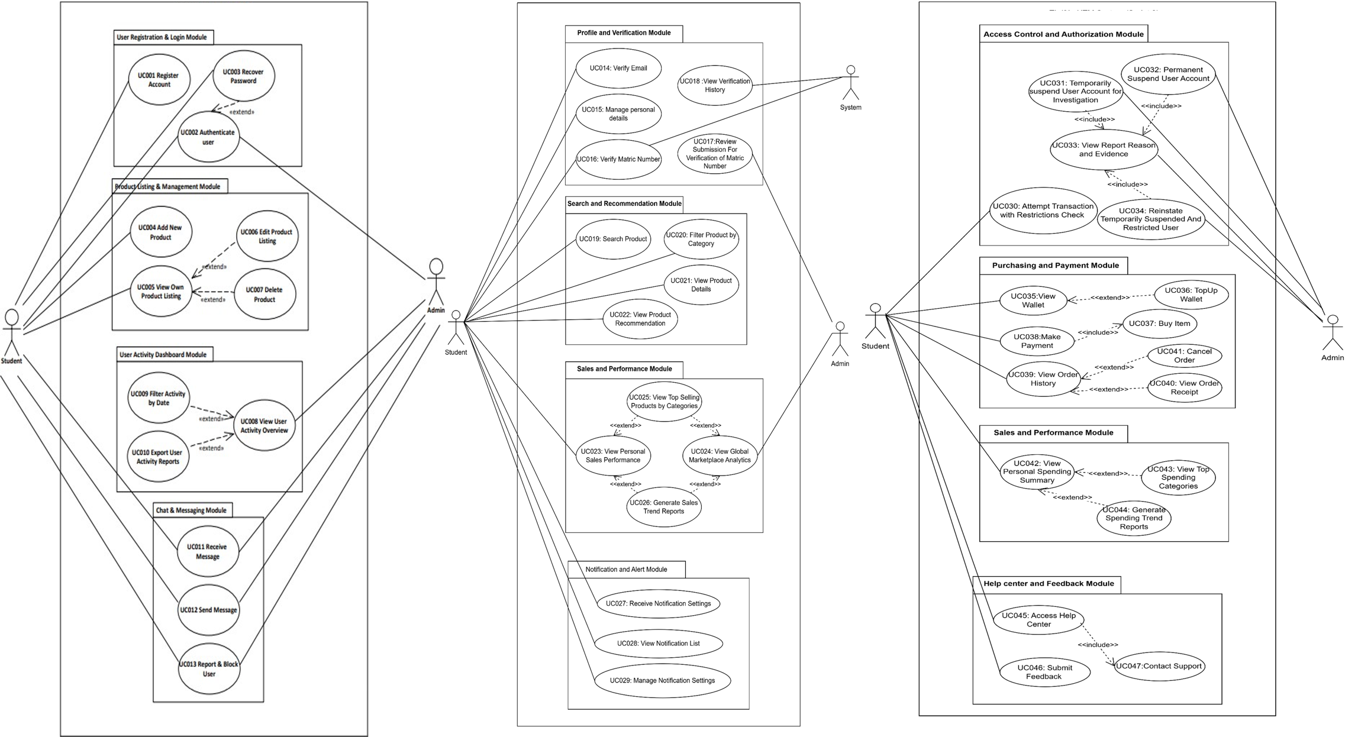

Figure 2.1: Use Case Diagram of ThriftIn UTM

USER MANAGEMENT SUBSYSTEM SPECIFICATION

3.1 USER REGISTRATION & LOGIN MODULE (ANGIE)
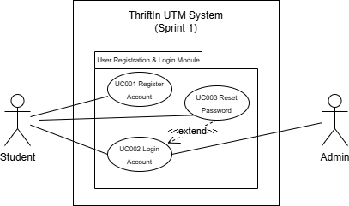

Figure 3.1：Package Diagram for User Registration and Login Module
The User Authentication and Account Management Module consists of three main use cases: UC001 Register Account, UC002 Login Account, and UC003 Reset Password. This module provides secure access control for the Thriftin UTM marketplace by managing student and admin authentication, ensuring that only authorized users can access the system. It serves as the foundation for maintaining user identity, account security, and system integrity throughout the application.

In the UC001 Register Account, students are required to provide their UTM student email (@graduate.utm.my), matric number, and a secure password to create an account. The system validates the email format, matric number structure (Foundation, Bachelor, Master, or PhD), and password strength requirements (minimum 8 characters containing both letters and numbers). Additionally, the system verifies the student's current enrollment status by calculating their estimated graduation year based on their matric number. Only current UTM students or recent graduates (within one year) are eligible to register. Once all validations pass, the system creates a user record in the database with an encrypted password and associates it with the student's academic information. If the email or matric number is already registered, the system prevents duplicate accounts and prompts the user to log in instead. This registration process ensures that only legitimate UTM students can access the marketplace while maintaining accurate user data.

Meanwhile,UC002 Login Account enables both students and admins to authenticate and access their respective interfaces. Users enter their registered email and password, which the system validates against stored credentials. The system implements multiple security measures to protect user accounts, inluding failed login attempt tracking, automatic account locking after five consecutive failed attempt, and temporary 30-minute lockout periods with email notifications. Upon successful

authentication, students are directed to the marketplace interface where they can browse and list products, while admins gain access to administrative dashboard for system management and moderation. The system maintains login history by recording the last successful login time and last failed login attempt for security monitoring purposes. This dual-role login mechanism ensures appropriate access control while safeguarding user accounts against unauthorized access through brute-force attacks.

For UC003 Reset Password, students who forget their passwords can securely reset them through a two-step verification process. This feature is exclusively available for student accounts, as admin password resets require contacting system administrators for additional security. The password reset process begins when a student requests a password reset by entering their registered email address. The system then generates a unique 6-digit verification code with a one-hour validity period and sends it to the student's UTM email. In the second step, the student enters the received verification code along with their new password on the reset password page. The system validates both the code's authenticity and expiration time, as well as the new password's strength requirements. Once all validations pass, the system encrypts the new password, updates it in the database, and clears the verification code. This two-step email verification process ensures that only the legitimate account owner can reset their password, preventing unauthorized password changes and maintaining account security.

Overall, this module establishes a secure and systematic approach to user authentication and account management. It provides seamless registration for eligible students, reliable login mechanisms with built-in security protections, and a safe password reset process. By separating student and admin access levels and implementing comprehensive security measures such as account locking, login attempt monitoring, and time-limited verification codes, the system ensures data protection and maintains the integrity of the Thriftin UTM marketplace platform.

3.1.1 UC001: REGISTER ACCOUNT

Use case: Register Account
ID: UC001
Actors:
Student
Preconditions:
- The user does not have an existing account in the system.
- The user has a valid UTM email and student ID.
Flow of events:
- The use case starts when the user selects ”Sign Up”.
- The student enters the required information: UTM email, password, matric number.
- The system validates the input to ensure the email format is correct, the matric number format is valid and that neither email nor matric number is already registered.

- The system validates the new password is at least 8 characters long and contains both letters and numbers.
- The system parses the matric number to determine the enrollment year.
- The system calculates the estimated graduation year based on the degree type’s default study duration (Foundation 1 year, Bachelor 4 years, Master 2 years, PhD 5 years).
- The system compares the current year with the estimated graduation year plus 1 year.
- If the student is still a current student or within 1 year after estimated graduation, the system creates a new account and stores the information securely.
- The system displays a success message:“Your account has been created successfully. You can now log in.”
Alternate Flows:
A1: Email or Matric Number Already Registered
- The system detects that the email or matric number is already in use.
- The system displays an error message: “This email or matric number is already registered. Please log in.”
- The student can try to log in.

A2: Invalid Email or Matric Number Format
- The system detects incorrect email format or invalid matric number format.
- The system displays an error message:”Invalid email format. Please enter a valid UTM email and matric number.”
- The student retries with valid information.

A3: Student Status Verification Failed
- The system calculates that the difference between the current year and the estimated graduation year exceeds 1 year.
- The system blocks the registration and displays a message: “Your student status cannot be verified. Only current UTM students or graduates within one year are allowed to register.”
- The student cannot proceed with registration.

A4: New Password Does Not Meet Security Requirements
- The student enters a password that does not meet the minimum security requirements.
- The system displays an error message: “Passwords must be at least 8 characters long and contain letters and numbers. Please try again.”
- The student reenters a valid password.
Postconditions:
- A new user account is created if the user is verified to be a current UTM student or within 1 year after estimated graduation based on the degree type and enrollment year.
- The student can log in using the registered email and password.
- The student who fails the student status verification cannot register.
Table 3.1：Use Case Description of UC001 Register Account

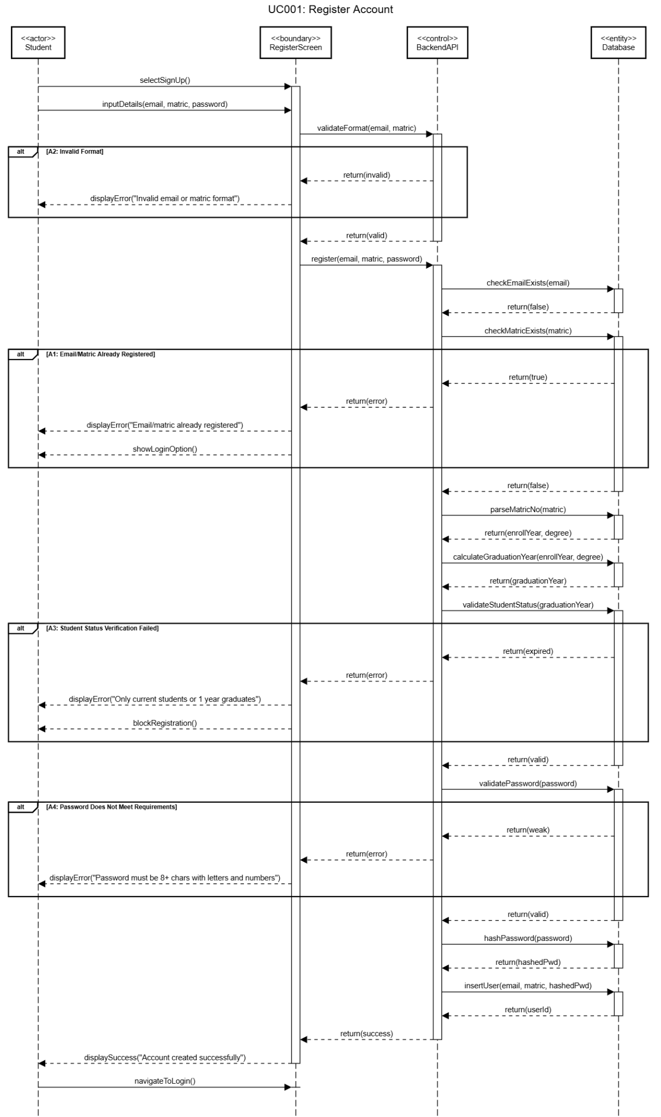
Figure 3.2: Sequence Diagram of UC001 Register Account

3.1.2 UC002: LOGIN ACCOUNT

Use case: Authenticate user
ID: UC002
Actors:
Student, Admin
Preconditions:
- The user must already create an account whether as a driver or a passenger.
Flow of events:
- The user is required to enter their registered UTM email and password.
- The system verifies whether the entered information matches any registered account.
- If the credentials are correct:
  - The system records a successful login.
  - The system redirects the user to the admin’s interface or the student’s interface, depending on account type.
Alternate Flows:
A1: Incorrect Email or Password
- The system detects that the email or password does not match any registered account.
- The system records the failed login attempt.
- The system displays an error message: “Incorrect email or password.”
- The user can choose to re-enter email and password or select “Forgot Password” to reset the password.
A2: Consecutive Failed Login
- The system detects that the credentials do not match any registered account.
- The system records a failed login attempt and updates the consecutive failed attempts count.
- If the number reaches 5 attempts, the system temporarily locks the account for 30 minutes.
- The system sends notification to the user via email with a message: “Your account has been temporarily locked for 30 minutes due to multiple failed login attempts. If this wasn’t you, please contact support.”
- The user can attempt login again after the lock period or select Forgot Password.
Postconditions:
- If login is successful, the user is directed to the appropriate interface (Passenger or Driver).
- Failed login attempts are recorded for security purposes.
- If login fails consecutively 5 times, the account is temporarily locked for 30 minutes and the user is notified.
Table 3.2: Use Case Description of UC002 Authenticate User

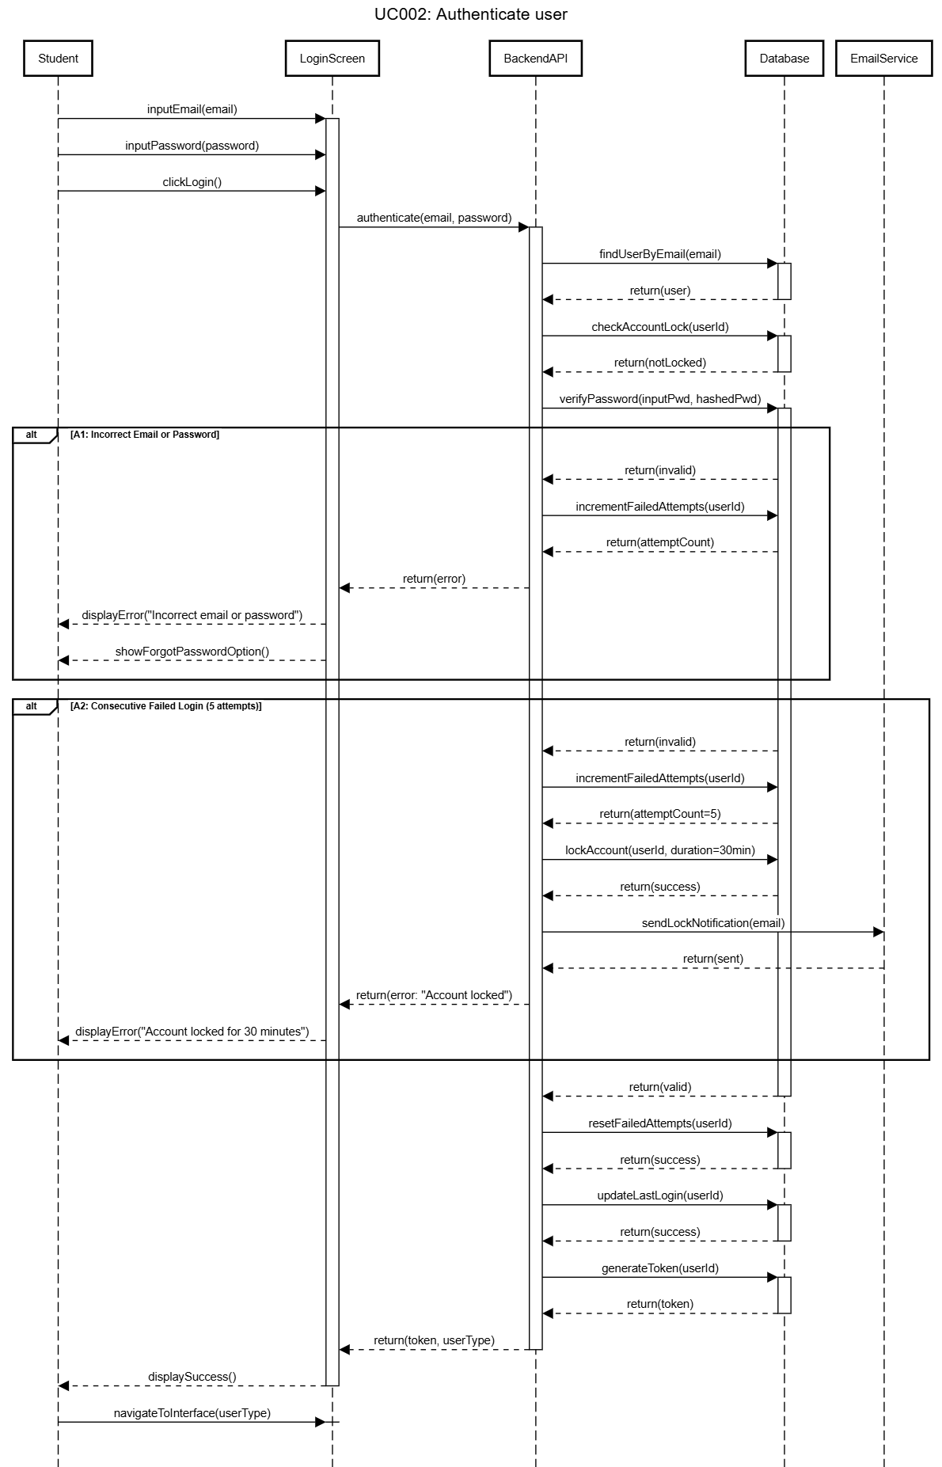

Figure 3.3: Sequence Diagram of UC002 Authenticate User

3.1.3 UC003: RECOVER PASSWORD

Use Case：Reset Password
ID: UC003
Actors:
Student
Preconditions:
- The user has already registered an account in the system.
- The user has access to the registered UTM email.
Flow of events:
- The student selects “Forgot Password” on the login screen.
- The student enters their registered UTM email.
- The system validates the email format and checks if it exists in the database.
- If the email exists, the system generates a 6-digit verification code and stores it in the database with an expiry time of 1 hour.
- The system sends the 6-digit verification code to the registered email.
- The system displays a message: "A 6-digit verification code has been sent to your email."
- The system redirects the student to the Reset Password page.
- The student enters their email, the 6-digit verification code, and a new password.
- The system validates the verification code (correct and not expired) and the new password against security rules.
- The system updates the password in the database, clears the verification code, and confirms success.
- The system displays a success message: "Your password has been reset successfully. You can now log in with your new password."
Alternate flows:
A1: Email Not Registered
- The system detects that the entered email is not associated with any account.
- The system displays an error message:“The email entered is not registered. Please check your email or register a new account.”
- The student can register an account.
A2: Invalid Email Format
- The system detects incorrect email format.
- The system displays an error message: “Invalid email format. Please enter a valid UTM email.”
- The student corrects the email and retries.
A3: New Password Does Not Meet Security Requirements
- The student enters a password that does not meet the minimum security requirements.
- The system displays an error message: “Password must be at least 8 characters long and contain letters and numbers. Please try again.”
- The student reenters a valid password.
Postconditions:
- The student has successfully set a new password.
- 2. The previous password is no longer valid.

Table 3.3: Use Case Description of UC003 Reset Password

I
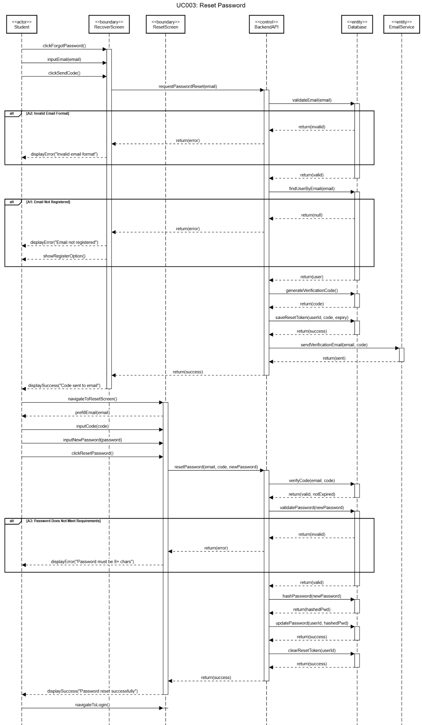
Figure 3.4: Sequence Diagram of UC003 Reset Password

3.2 PROFILE AND VERIFICATION MODULE (ANGIE)

The Student Identity Verification Module comprises five interconnected use cases: UC014 Verify Email, UC015 Manage Personal Details, UC016 Verify Matric Number, UC017 Review Submission for Verification of Matric Number, and UC018 View Verification History. This module establishes a comprehensive identity verification system for the Thriftin UTM marketplace by ensuring that all registered students are legitimate UTM community members through a multi-stage verification process. It serves as a critical security layer that validates student identity, maintains accurate user profiles, and provides administrative oversight for verification management throughout the platform.

In UC014 Verify Email, the system implements a mandatory email verification process to confirm that users have access to their registered UTM email addresses. Upon successful registration, the system automatically generates a unique verification token with a one-hour validity period and sends a verification email containing a clickable link to the student's registered email address. When students click the verification link, the system validates the token's authenticity and expiration status before marking the email as verified in the database. If students attempt to login before verifying their email, the system detects the unverified status and blocks access while displaying a "Resend verification email" button for convenience. This resend functionality implements rate limiting to prevent abuse, allowing only one resend request per minute per user. The system handles multiple edge cases including expired verification links, already-verified emails and failed email deliveries. This email verification process ensures that only users with valid UTM email addresses can access the marketplace, preventing fake accounts and maintaining the integrity of the UTM student community.

Meanwhile, UC015 Manage Personal Details provides students with comprehensive profile management capabilities while maintaining data integrity through strategic field restrictions. The system presents a dual-view profile interface where students can view their complete profile information on the Profile screen and edit specific fields on the Edit Details screen. The form distinguishes between editable fields (full name, phone number and address) and read-only fields (email and matric number, displayed in greyed-out style with explanatory helper text) to prevent critical identifier changes that could compromise account security. The profile picture upload functionality offers flexible image acquisition through both camera capture and gallery selection, with automatic image processing that crops to 1:1 aspect ratio, compresses to 500x500 pixels at 70% quality in JPEG format and enforces a strict 5MB file size limit. The system validates all inputs before submission, ensuring names are not empty and implementing comprehensive error handling for network interruptions, permission denials and invalid file formats. Upon successful updates, the system immediately reflects changes in the user interface, providing visual confirmation through success messages.

In UC016 Verify Matric Number, the system employs advanced Optical Character Recognition (OCR) technology combined with intelligent matching algorithms to verify student identity through

matric card validation. When students upload a photograph of their physical matric card, the system initiates a sophisticated multi-strategy OCR pipeline that processes the image through seven different preprocessing techniques combined with multiple Page Segmentation Modes to maximize extraction accuracy across various card conditions and image qualities. The OCR engine searches for valid UTM matric patterns including Foundation (F23SP1234), Bachelor (A23CS1234), Master (MCS221234) and PhD (PCS221234) formats. When the extracted matric number matches the student's registered matric number, the system automatically recognizes this as a high-confidence verification and immediately submits the request with an auto_match_success flag set to TRUE, allowing administrators to prioritize these pre-validated submissions. If the OCR extraction fails or produces a mismatched result, the system flags the submission for manual administrative review while providing students with options to either re-upload a clearer image or proceed with manual verification. The system implements comprehensive error handling for OCR timeouts (180-second limit), network failures, invalid file types and oversized files (enforcing 100MB maximum). This intelligent OCR-based verification system significantly reduces administrative workload by automatically pre-validating legitimate submissions while maintaining security through manual review of ambiguous cases.

For UC017 Review Submission for Verification of Matric Number, administrators are provided with a streamlined verification dashboard that prioritizes efficiency while maintaining thorough review standards. The system fetches all pending and flagged submissions and organizes them intelligently by displaying auto-matched submissions first (indicated by green "Matched" badges), followed by flagged submissions (marked with orange "Flagged" indicators) and finally other pending submissions. The dashboard presents real-time statistics showing the total count of pending verifications, number of auto-matched submissions requiring quick approval and count of flagged submissions needing careful attention. When administrators select a specific submission for review, the system presents a comprehensive detail view containing the student's profile information, registered matric number, OCR-extracted matric number, full-size zoomable matric card image, submission timestamp, auto-match status indicator and any flagging reasons. After examination, administrators make their decision by clicking either the "Approve" or "Reject" button, both of which trigger confirmation dialogs to prevent accidental actions. Upon approval, the system updates the verification status to "verified" in the database, records the reviewer's identity and timestamp for audit trail purposes and removes the submission from the pending queue. Upon rejection, the system updates the status to "rejected," preserves the existing flag reason for student reference and allows the student to resubmit with a new matric card. This administrative review interface balances thoroughness with efficiency, enabling quick processing of high-confidence auto-matched submissions while providing comprehensive tools for careful examination of flagged cases.

In UC018 View Verification History, administrators gain access to a comprehensive audit trail and historical record management system for all verification submissions regardless of their current status. The History interface presents a complete overview with detailed statistics showing total submissions count, number of approved verifications and count of rejected submissions. The system provides powerful filtering capabilities through status-based filter buttons (All, Verified, Rejected) that dynamically update both the submission list and statistics, along with a real-time search functionality that queries across student names, email addresses and matric numbers simultaneously.

Each submission card displays essential information including student name, matric number, current status badge with color coding, submission timestamp, review completion timestamp and the reviewing administrator's email address for accountability. When administrators click on a submission card, the system intelligently determines the appropriate action: for verified or rejected submissions, it opens a read-only detail view; for submissions still pending or flagged, it opens an editable review interface allowing administrators to complete the verification process directly from the history view. The system implements comprehensive error handling for empty result sets, server connectivity issues and data loading failures. This historical verification management system provides administrators with complete visibility into verification trends, reviewer performance metrics and audit trail documentation, supporting both operational oversight and compliance requirements.

SPECIFIC REQUIREMENT
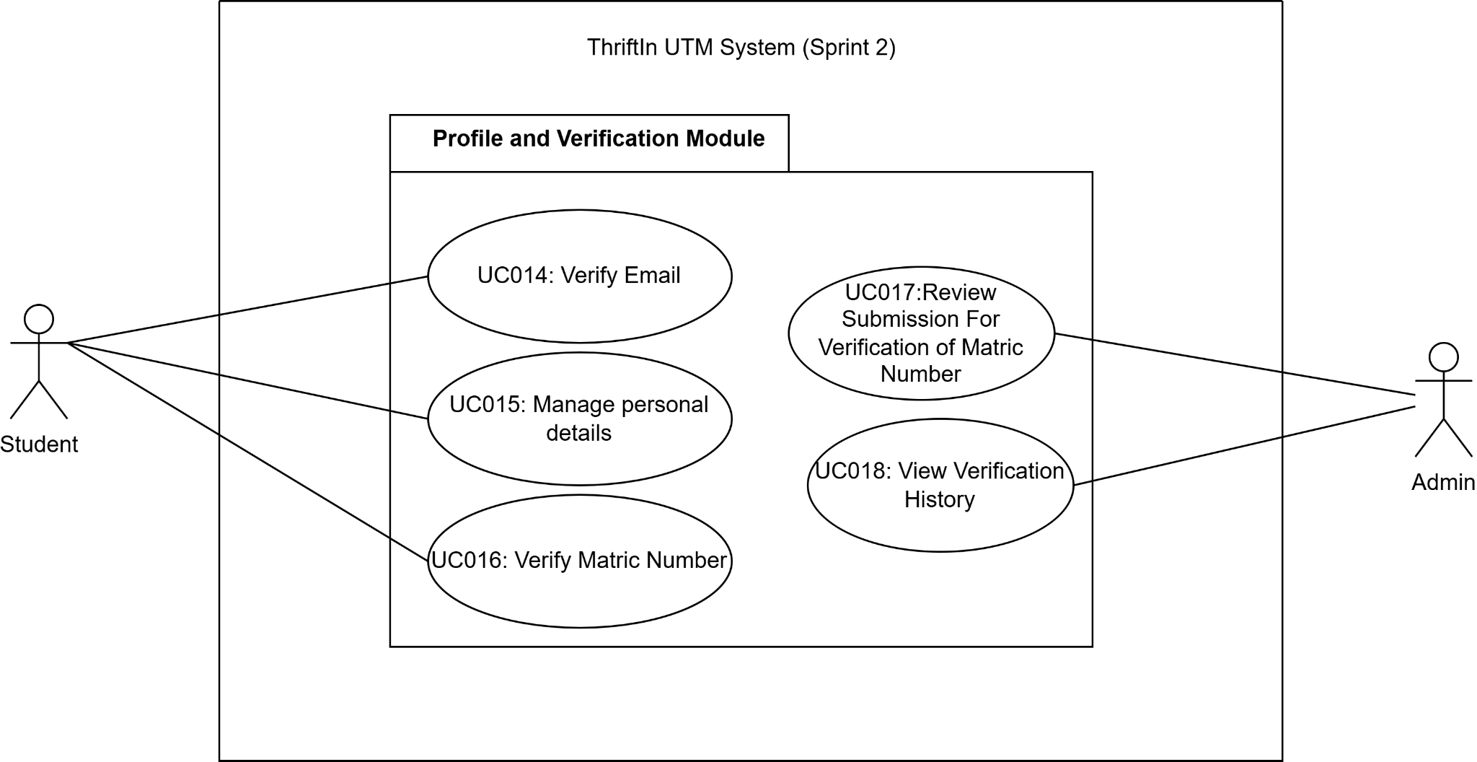

Figure 3.5：Package Diagram for Profile and Verification Module

3.2.1 UC014: VERIFY EMAIL

Use case: Verify Email
ID: UC014
Actors:
Student, System
Preconditions:
- Student has registered an account.
- Student is attempting to login with unverified email

Flow of events:
- Student has completed registration。
- System automatically sends verification email to user's registered email address.
- Student receives verification email with verification link.
- Student clicks verification link in email.
- System validates verification token.
- System marks user's email as verified in database.
- System displays a success message: "Email verified successfully!".
- Student navigates to login screen.
- Student logs in with verified credentials.
- System redirects the student to the Home screen.
Alternate Flows:
A1: User Attempts Login Without Verification
- Student attempts to login with unverified email.
- System validates credentials (email and password correct).
- System detects email is not verified.
- System displays error: "Please verify your email before logging in".
- System displays "Resend verification email" button.
- Student clicks "Resend verification email" button.
- System sends new verification email.
- System displays: "Verification email sent! Please check your inbox".
- Student clicks verification link in new email.
- System marks email as verified.
- Student navigates to login screen and logs in successfully.
A2: Verification Link Expired
- At step 6, if verification token has expired (>1 hours).
- System displays error: "Verification link has expired".
- System provides "Resend verification email" option.
- Student clicks resend.
- System sends new verification email with fresh token.
- Resume from step 5 of main flow.
A3: Resend Email Failed
- At step 7 (A1 flow), if email sending fails due to network or server error.
- System displays error: "Failed to send verification email. Please try again."
- Student clicks retry button.
- System attempts to resend email.
- Resume from step 7 of A1 flow.
A4: Email Already Verified
- At step 2 (A1 flow), if system detects email is already verified.
- System proceeds with normal login.
- System redirects to Home screen.

4. No resend button displayed.
Postconditions:
- Student's email marked as verified in database.
- Student can successfully login and access system.

Table 3.4：Use Case Description of UC014 Verify Email

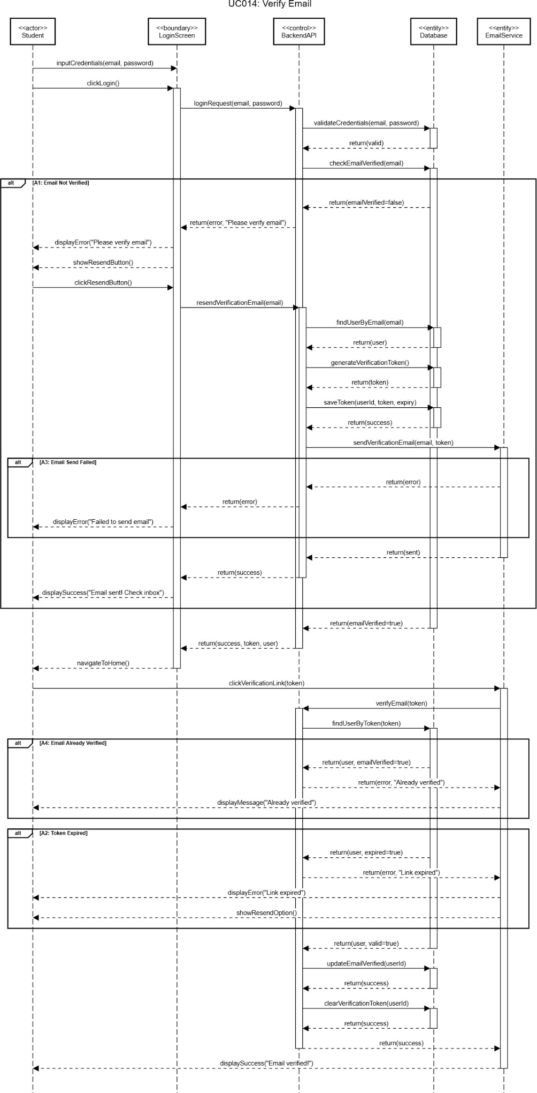
Figure 3.6: Sequence Diagram of UC014 Verify Email

3.2.2 UC015: MANAGE PERSONAL DETAILS

Use case: Manage Personal Details
ID: UC015
Actors:
Student, System
Preconditions:
- User is logged in
- User email is verified
Flow of events:
- Student navigates to Profile screen from main navigation.
- System fetches user data from database.
- System displays user profile information:
  - Profile picture (or initials if none)
  - Full name
  - Email address (read-only)
  - Matric number (read-only)
  - Degree type
  - Verification status badge (if status is pending or verified)
- Student clicks "My Details" from profile menu.
- System navigates to Edit Details screen.
- System displays editable form with:
  - Profile picture(uploadable)
  - Full name (editable text field)
  - Email address (read-only, greyed out)
  - Matric number (read-only, greyed out)
  - Phone number (editable text field)
  - Address (editable text area)
- Student modifies name, phone, or address.
- Student clicks "Save Changes" button.
- System validates input (name must not be empty).
- System sends update request to server.
- Server updates user record in database.
- System displays success alert: "Profile updated successfully".
- System navigates back to Profile screen.
- System displays updated information.
Alternate Flows:
A1: Upload Profile Picture
- At step 6, student clicks camera icon on profile picture.
- System displays options: "Take Photo" or "Choose from Gallery".
- Student selects preferred option.
- Student captures photo or selects image from gallery.
- System allows user to crop image (1:1 aspect ratio).
- System compresses image to 500x500 pixels, quality 70%, JPEG format.

- System checks file size (must be < 5MB).
- System uploads image to server.
- Server saves image and returns file path.
- System updates profile picture display.
- System shows success message: "Profile picture updated successfully".
- Resume from step 6 of main flow.
A2: Name Field Empty
- At step 9, Student leaves name field empty.
- System displays validation error: "Please enter your name".
- System highlights name field in red.
- Changes are not saved.
- Student remains on Edit Details screen.
- Student must enter name to proceed.
A3: Image Too Large
- At step 7 (A1 flow), the compressed image exceeds 5MB.
- System displays error: "Image must be smaller than 5MB".
- System cancels upload.
- Previous profile picture is retained.
- Student can select different image.
A4: Camera Permission Denied
- At step 4 (A1 flow), student denies camera or gallery permission.
- System displays alert: "Camera and gallery permissions are required".
- System provides link to app settings.
- Upload is cancelled.
- Student must grant permissions to proceed.
A5: Network Error During Save
- At step 10, network connection fails.
- System displays error: "Failed to update profile. Please check your connection".
- Changes are not saved.
- Student remains on Edit Details screen.
- Student can retry when connection restored.
A6: Profile Load Failed
- At step 2, server is unreachable or returns error.
- System displays error state with retry button.
- Student clicks retry button.
- System re-attempts to fetch profile data.
- Resume from step 2 of main flow.
A7: Invalid file format
- File format is invalid.

- System displays error: 'Only image files are allowed!'.
- Previous profile picture is retained.
Postconditions:
- Student details updated in database.
- Profile picture saved on server (if uploaded).
- Changes immediately reflected in the Detail screen.
- Student returned to the Profile screen.

Table 3.5: Use Case Description of UC015 Manage Personal Details

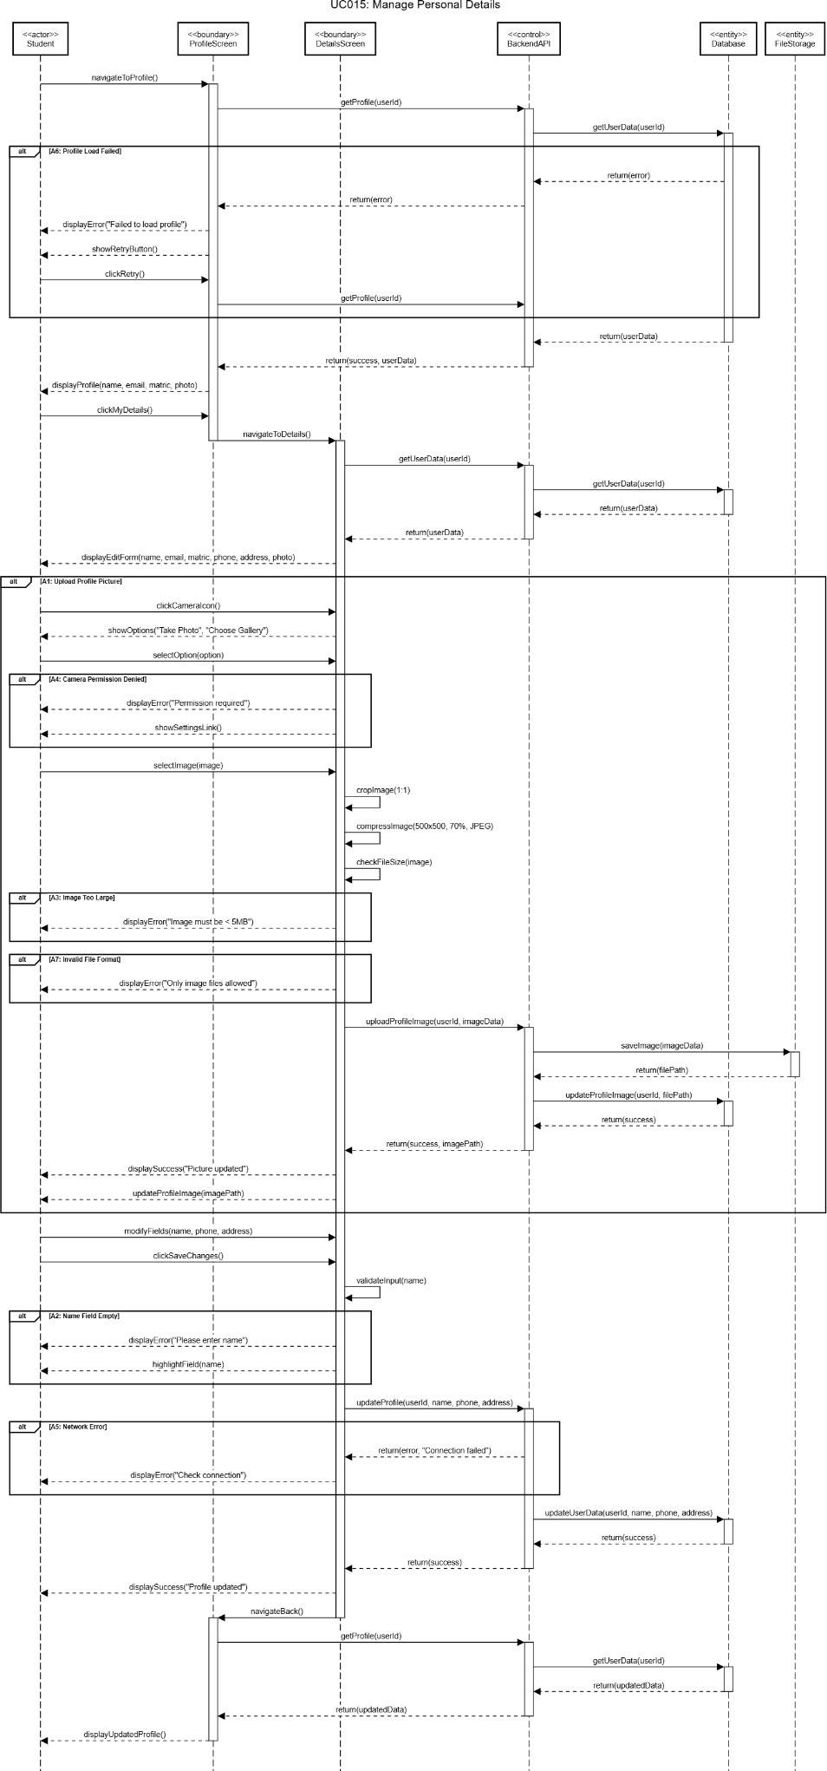
Figure 3.7: Sequence Diagram of UC015 Manage Personal Details

3.2.3 UC016: VERIFY MATRIC NUMBER

Use Case :Verify Matric Number
ID: UC016
Actors:
Student, System, OCR Service
Preconditions:
- Student is logged in.
- Student has matric number registered.
- Verification status is "pending" (not verified or rejected).
Flow of events:
- Student navigates to Verification screen from Profile menu.
- System displays current verification status banner.
- System displays student information (matric number, degree type).
- System displays upload area with message: "Click to upload matric card".
- Student clicks upload area.
- System displays options: "Take Photo" or "Choose from Gallery".
- Student selects option and provides matric card image.
- System uploads image to server.
- System displays: "Extracting and verifying matric number...".
- System sends image to OCR service for text extraction.
- OCR service processes image and extracts matric number.
- System receives extracted matric number from OCR.
- System compares extracted matric with registered matric number.
- Extracted matric MATCHES registered matric.
- System displays alert: "Match Found! Matric number [number] detected and matches your registered ID. Submitting for verification...".
- Student clicks "OK" on alert.
- System automatically submits verification request.
- Server saves matric card image and creates verification record.
- Server sets status to "pending" with auto_match_success = 1.
- System displays success alert: "Your verification has been automatically submitted for review!".
- System updates verification status banner to "Pending" (orange).
- System displays uploaded matric card image with green "✓ Match" indicator.
Alternate flows:
A1: Matric Number Mismatch
- At step 13, extracted matric does NOT match registered matric.
- System displays alert: "Mismatch Detected. Detected matric ([extracted]) does not match your registered matric ([registered]). You can: • Re-upload a clearer image • Submit anyway for manual review".
- Student chooses option:
  - If "Re-upload": Return to step 5 of main flow
  - If "Submit Anyway": Continue to step 4 below

- System submits for manual review.
- Server saves image and flags submission (status = "flagged").
- System displays: "Submission sent for manual review".
- System shows orange "⚠ Mismatch" indicator.
- Admin must review manually.
A2: OCR Extraction Failed
- At step 12, OCR service cannot extract any matric number.
- System displays alert: "No Matric Detected. Could not automatically extract matric number. You can: • Re-upload a clearer image • Submit for manual review".
- Student chooses option:
  - If "Re-upload": Return to step 5 of main flow
  - If "Submit Anyway": Continue to step 4 below
- System submits for manual review.
- Server saves image and flags submission (status = "flagged", reason = "OCR failed").
- Admin must review manually.
A3: Re-upload Matric Card
- At any point after upload, student clicks "Reupload" button.
- System returns to step 5 of main flow.
- New image replaces previous upload.
- OCR extraction runs again on new image.
A4: Already Verified
- At step 3, if verification status is "verified".
- System disables upload area.
- System displays green status banner: "Your identity has been verified".
- Upload and submit buttons are disabled.
- Student cannot resubmit.
A5: Verification Rejected
- At step 3, if verification status is "rejected".
- System displays red status banner: "Verification rejected. Please upload a valid matric card".
- System enables upload area for re-submission.
- Student can upload new matric card.
- Resume from step 5 of main flow.
A6: OCR Service Timeout
- At step 11, if OCR processing exceeds 180 seconds.
- System displays error: "Processing timeout. Please try again with a clearer image".
- Student can retry upload.
- Return to step 5 of main flow.

A7: Network Error During Upload
- At step 8 or 17, network connection fails.
- System displays error: "Upload failed. Please check your connection".
- Student can retry when connection restored.
- Return to step 5 of main flow.
A8: Invalid File Type
- At step 7, the student selects file that is not an image or PDF.
- System validates file type on backend.
- System rejects file with error: "Invalid file type. Only PNG, JPG, JPEG, and PDF are allowed."
- System displays error alert to user.
- Upload is cancelled.
- Student must select valid file type.
- Return to step 5 of main flow.
A9: File Size Exceeded
- At step 8, uploaded file exceeds 100MB size limit.
- System validates file size on backend.
- System rejects upload with error: "File too large. Maximum size is 100MB."
- System displays error alert to user.
- Upload is cancelled.
- Student must compress image or select smaller file.
- Return to step 5 of main flow.
Postconditions:
Success (Auto-matched):
- Matric card image saved on server.
- Verification status = "pending".
- Extracted matric number stored in database.
- Auto_match_success flag = TRUE.
- Submission visible in admin's "Auto-matched" category.
- Awaiting admin approval.
Success (Manual review):
  - Matric card image saved on server.
  - Verification status = "flagged".
  - Reason for flag recorded (mismatch or no extraction).
  - Submission visible in admin's "Flagged" category.
  - Requires admin manual review.

Table 3.6: Use Case Description of UC016 Verify Matric Number

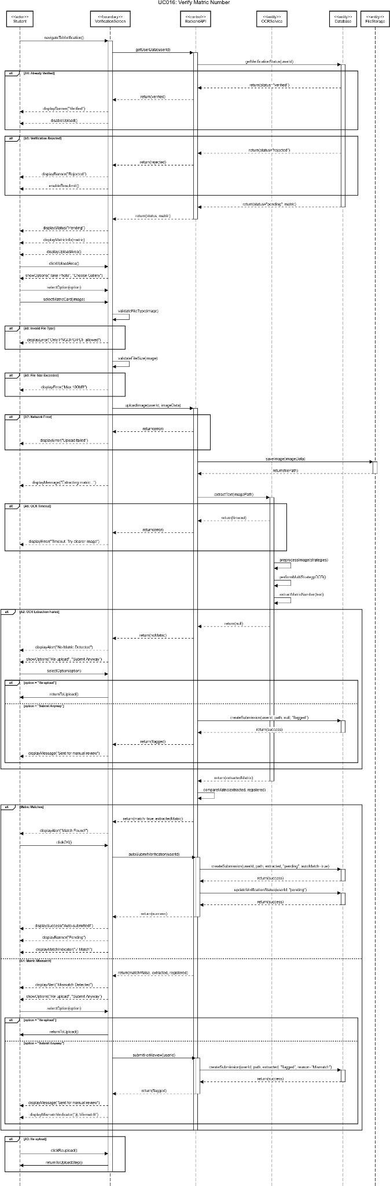

Figure 3.8: Sequence Diagram of UC016 Verify Matric Number

3.2.4 UC017: REVIEW SUBMISSION FOR VERIFICATION OF MATRIC NUMBER

Use Case：Review Submission For Verification of Matric Number
ID: UC017
Actors:
Admin, System
Preconditions:
- Admin is logged in.
- There are pending or flagged submissions to review.
Flow of events:
- Admin logs in to system.
- System validates admin credentials.
- System redirects to Admin Review screen.
- System fetches all pending and flagged submissions from database.
- System calculates and displays statistics:
  - Total: Count of all pending submissions
  - Auto-matched: Count where auto_match_success = TRUE
  - Flagged: Count where status = "flagged"
- System displays list of submissions.
- Admin reviews list and clicks on a submission card.
- System navigates to ReviewSubmission detail screen.
- System displays detailed information:
  - Student profile and contact info
  - Registered matric number
  - Extracted matric number (if available)
  - Match status indicator
  - Full-size matric card image (zoomable)
  - Submission timestamp
  - Auto-match flag
  - Reason for flagging (if flagged)
- Admin examines matric card image for authenticity and clarity.
- Admin verifies if matric number on card matches registered matric.
- Admin makes decision by clicking "Approve/Verify" button (if valid) or "Reject" button (if invalid).
- System displays confirmation dialog.
- Admin confirms decision.
- System sends approval/rejection to server.
- Server updates verification record.
- System displays success message.
- System navigates back to Admin Review screen.
- Reviewed submission is removed from pending list.
- Statistics are updated automatically.
Alternate flows:
A1: Review Failed - Server Error

- At step 15, server returns error or network fails.
- System displays error: "Failed to update verification. Please try again".
- Admin remains on detail screen.
- Admin can click retry button.
- System re-attempts submission.
- Resume from step 15 of main flow.
Postconditions:
Success (Approved):
- Verification status = "verified" in database.
- Student can access verified-only features.
- Review timestamp and reviewer recorded.
- Submission moved to history.
- Statistics updated.
Success (Rejected):
  - Verification status = "rejected" in database.
  - Student can resubmit with new matric card.
  - Review timestamp and reviewer recorded.
  - Submission moved to history with rejection reason.
  - Statistics updated.

Table 3.7: Use Case Description of UC017 Review Submission For Verification of Matric Number

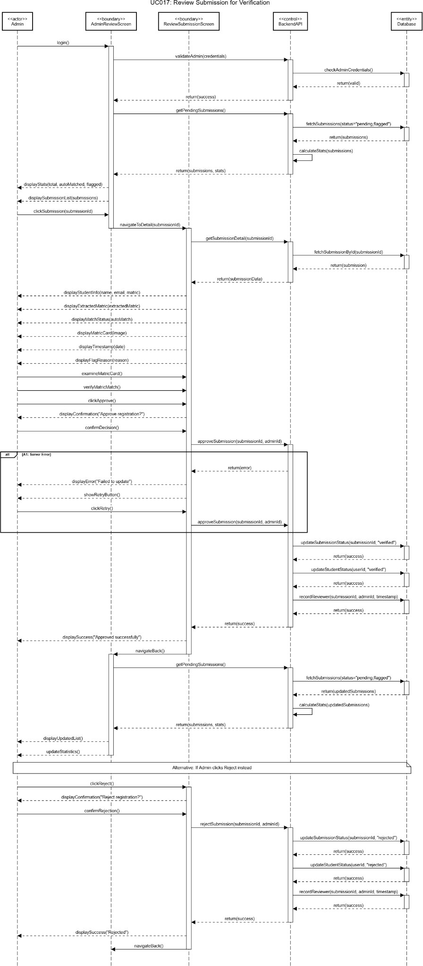

Figure 3.9: Sequence Diagram of UC017 Review Submission For Verification of Matric Number

3.2.5 UC018: VIEW VERIFICATION HISTORY

Use Case：View Verification History
ID: UC018
Actors:
Admin, System
Preconditions:
- Admin is logged in.
- There are completed reviews (verified or rejected submissions) in database.
Flow of events:
- Admin is on Admin Review screen.
- Admin clicks history icon (clock icon) in header.
- System navigates to Admin History screen.
- System fetches all submissions from database based on selected filter.
- System calculates and displays statistics:
  - Total: All submissions ever made
  - Verified: Count of approved submissions
  - Rejected: Count of rejected submissions
- System displays filter buttons: "All", "Verified", "Rejected".
- System displays search bar with placeholder: "Search by name, email or matric...".
- System sets default filter to "All".
- System displays all submissions in list.
- Admin can browse through history list.
- Admin can click on any submission card to view details.
- System navigates to ReviewSubmission screen (read-only mode).
- System displays full submission details.
- Admin can view but cannot modify past decisions.
Alternate flows:
A1: No History Found
- At step 4, database contains no submissions.
- System displays empty state.
- Statistics show 0 for all categories.
- No submission cards displayed.
A2: View Reviewed Submission from History
- At step 11, admin clicks submission with status "verified" or "rejected".
- System navigates to ReviewSubmission screen in READ-ONLY mode.
- System displays all details but disables approve and reject buttons.
- System shows review information.
- Admin can only view, cannot modify.
- Admin clicks back to return to history.
A3: Load Failed

- At step 4, server error or network error occurs.
- System displays error message with retry button.
- Admin clicks retry button.
- System re-attempts to fetch history data.
- Resume from step 4 of main flow.
Postconditions:
- History data displayed accurately.
- Filters and search working correctly.
- Statistics reflect current filter state.
- Admin can view complete audit trail.
- Pagination or infinite scroll working (if implemented).

Table 3.8: Use Case Description of UC018 View Verification History

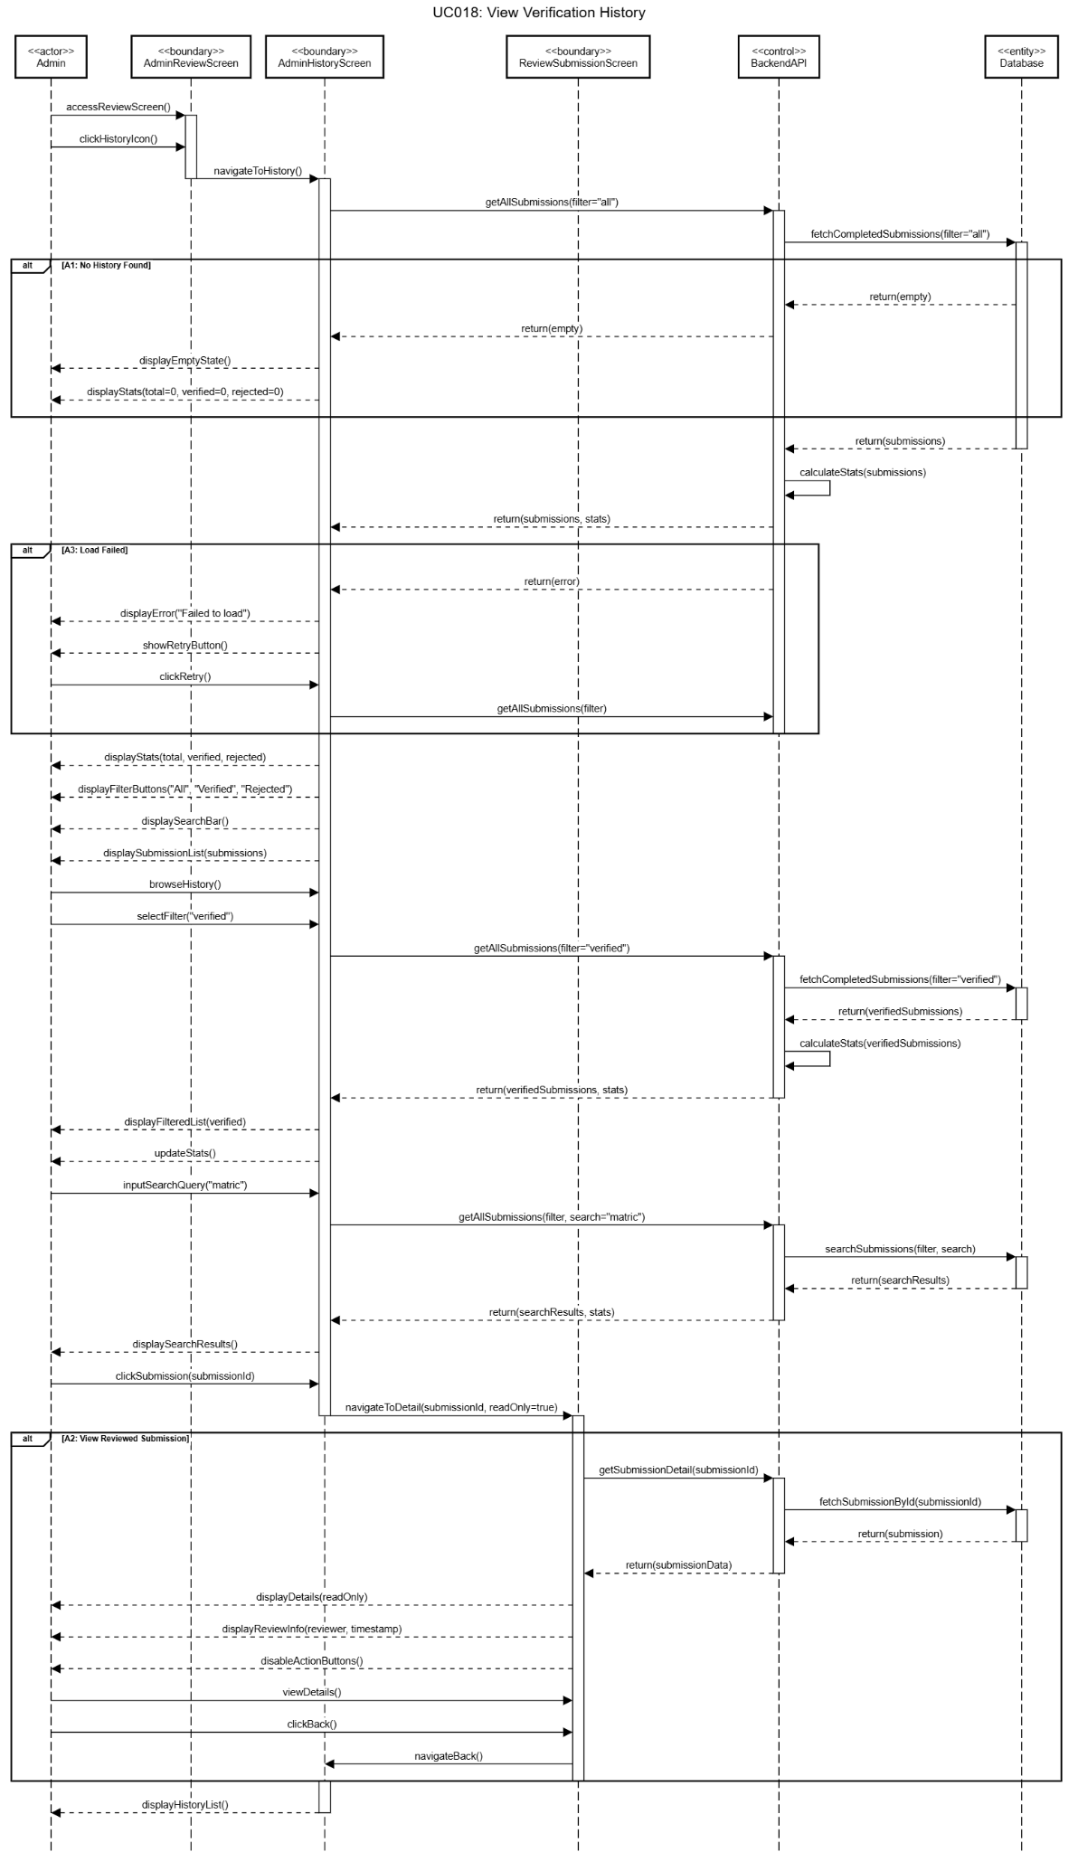

Figure 3.10: Sequence Diagram of UC018 View Verification History

3.3 ACCESS CONTROL AND AUTHORIZATION MODULE (ANGIE)

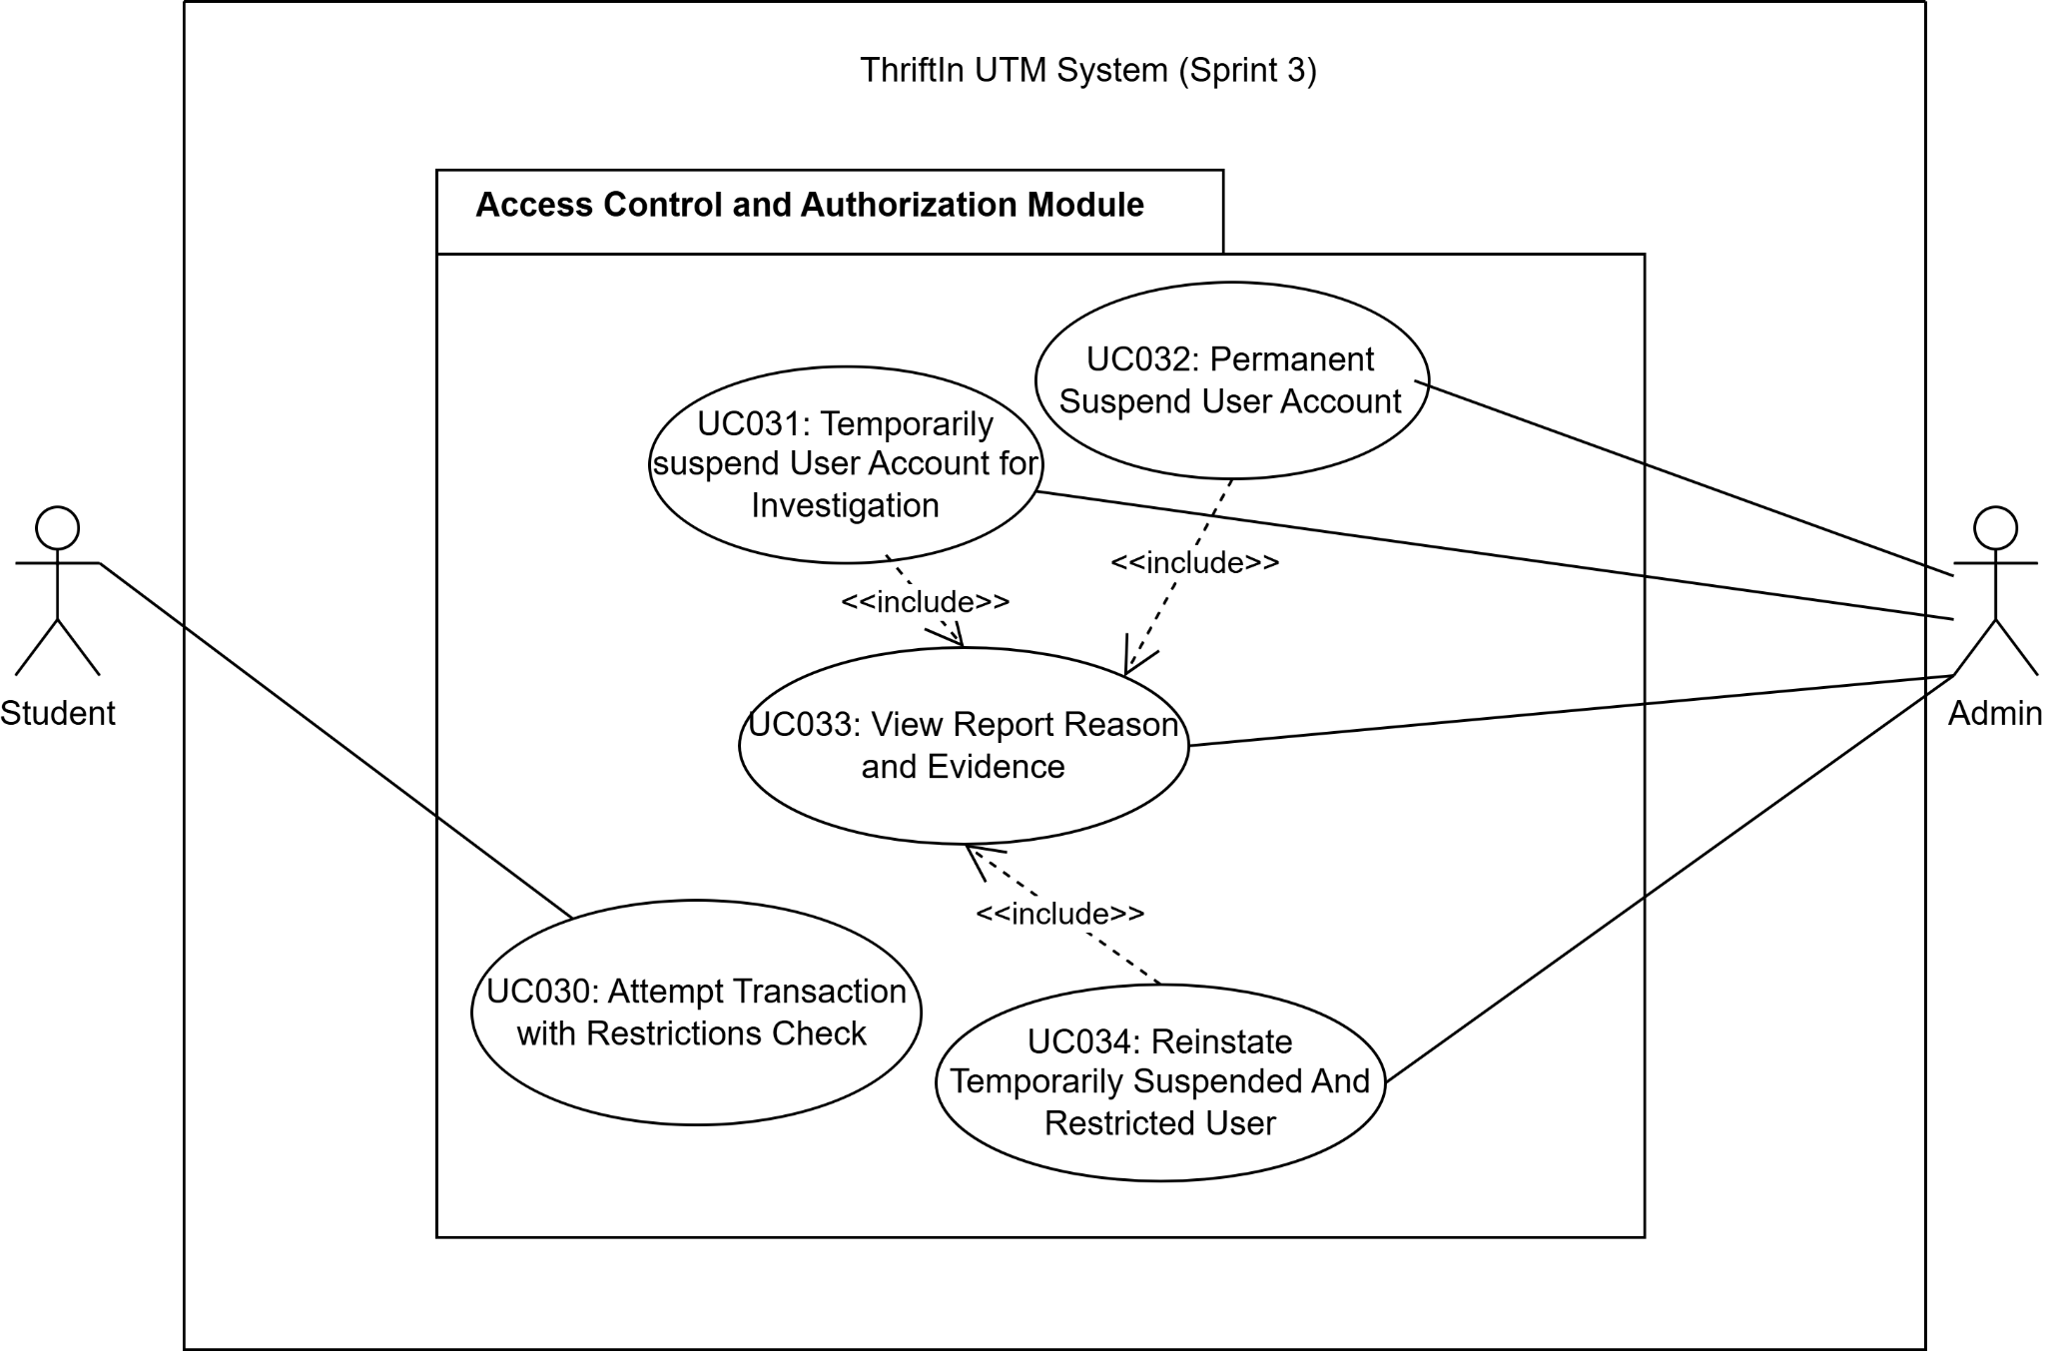
Figure 3.11: Package Diagram of Access Control And Authorization Module

SPECIFIC REQUIREMENT
The User Access Control Module consists of five use cases: Attempt Transaction with Restrictions Check, Temporarily Suspend User Account, Permanently Suspend User Account, View Report Reason and Evidence, and Reinstate User Account. It ensures that only compliant and verified students can perform transactions while giving administrators full control to manage user access based on reports and platform rules.
Before any buy or sell action, the system performs real-time validation to verify the user’s authentication status, email verification, and account restrictions. Restricted or unverified users are blocked from transactions and shown clear messages explaining the reason. All blocked attempts are logged for audit purposes.
Administrators can temporarily suspend users under investigation, immediately blocking login and transactions while recording the action for auditing. For serious or repeated violations, administrators may apply a permanent suspension, which irreversibly blocks all platform access. All suspension actions are logged, and user data is preserved for compliance. Administrators can review detailed user reports, including violation reasons, reporter information, and supporting evidence (images or documents). This centralized view provides full context before taking enforcement actions. Administrators can reinstate temporarily suspended or restricted users once issues are resolved. The system restores full access, clears restrictions, and logs the reinstatement action. Permanently suspended users cannot be reinstated. Overall, this module maintains marketplace security and fairness by enforcing access restrictions, supporting evidence-based administrative decisions, and allowing controlled restoration of user access with full audit trails.

3.3.1 UC030: ATTEMPT TRANSACTION WITH RESTRICTIONS CHECK

Use Case Name: Attempt Transaction with Restrictions Check
Use Case ID: UC030
Actors: Student
Preconditions:
- Students must be logged in.
- A student's email must be verified (email_verified = 1).
- Student’s account status must be active.
- Students with suspended or permanently_suspended status cannot log in.
Flow of Events:
- Students attempt to perform buy or sell actions.
- The system validates JWT tokens and retrieves student account information.
- The system checks account_status and email_verified.
- If a student is temporarily suspended or permanently_suspended, the system blocks the action.
- The system displays a message: "Your account is suspended. You cannot perform this action."
Alternative Flow:
A1: User Attempts Action While Suspended
- The student attempts an action while the account is suspended.
- The system blocks the action and displays the restriction message.
A2: Email Not Verified
- Students attempt an action with unverified email.
- The system blocks the action and displays: "Please verify your email before performing actions."
A3: System Error During Check
- The system encounters an error while checking account status.
- System displays: "Action temporarily unavailable. Please try again."
- Student retries action.
Post-conditions:
- Unsuspended and verified students can perform the buy or sell action.
- Suspended or unverified students cannot perform the action.
- The system logs all attempts made by restricted students.
Table 3.9: Use Case Description of UC030 Attempt Transaction with Restrictions Check

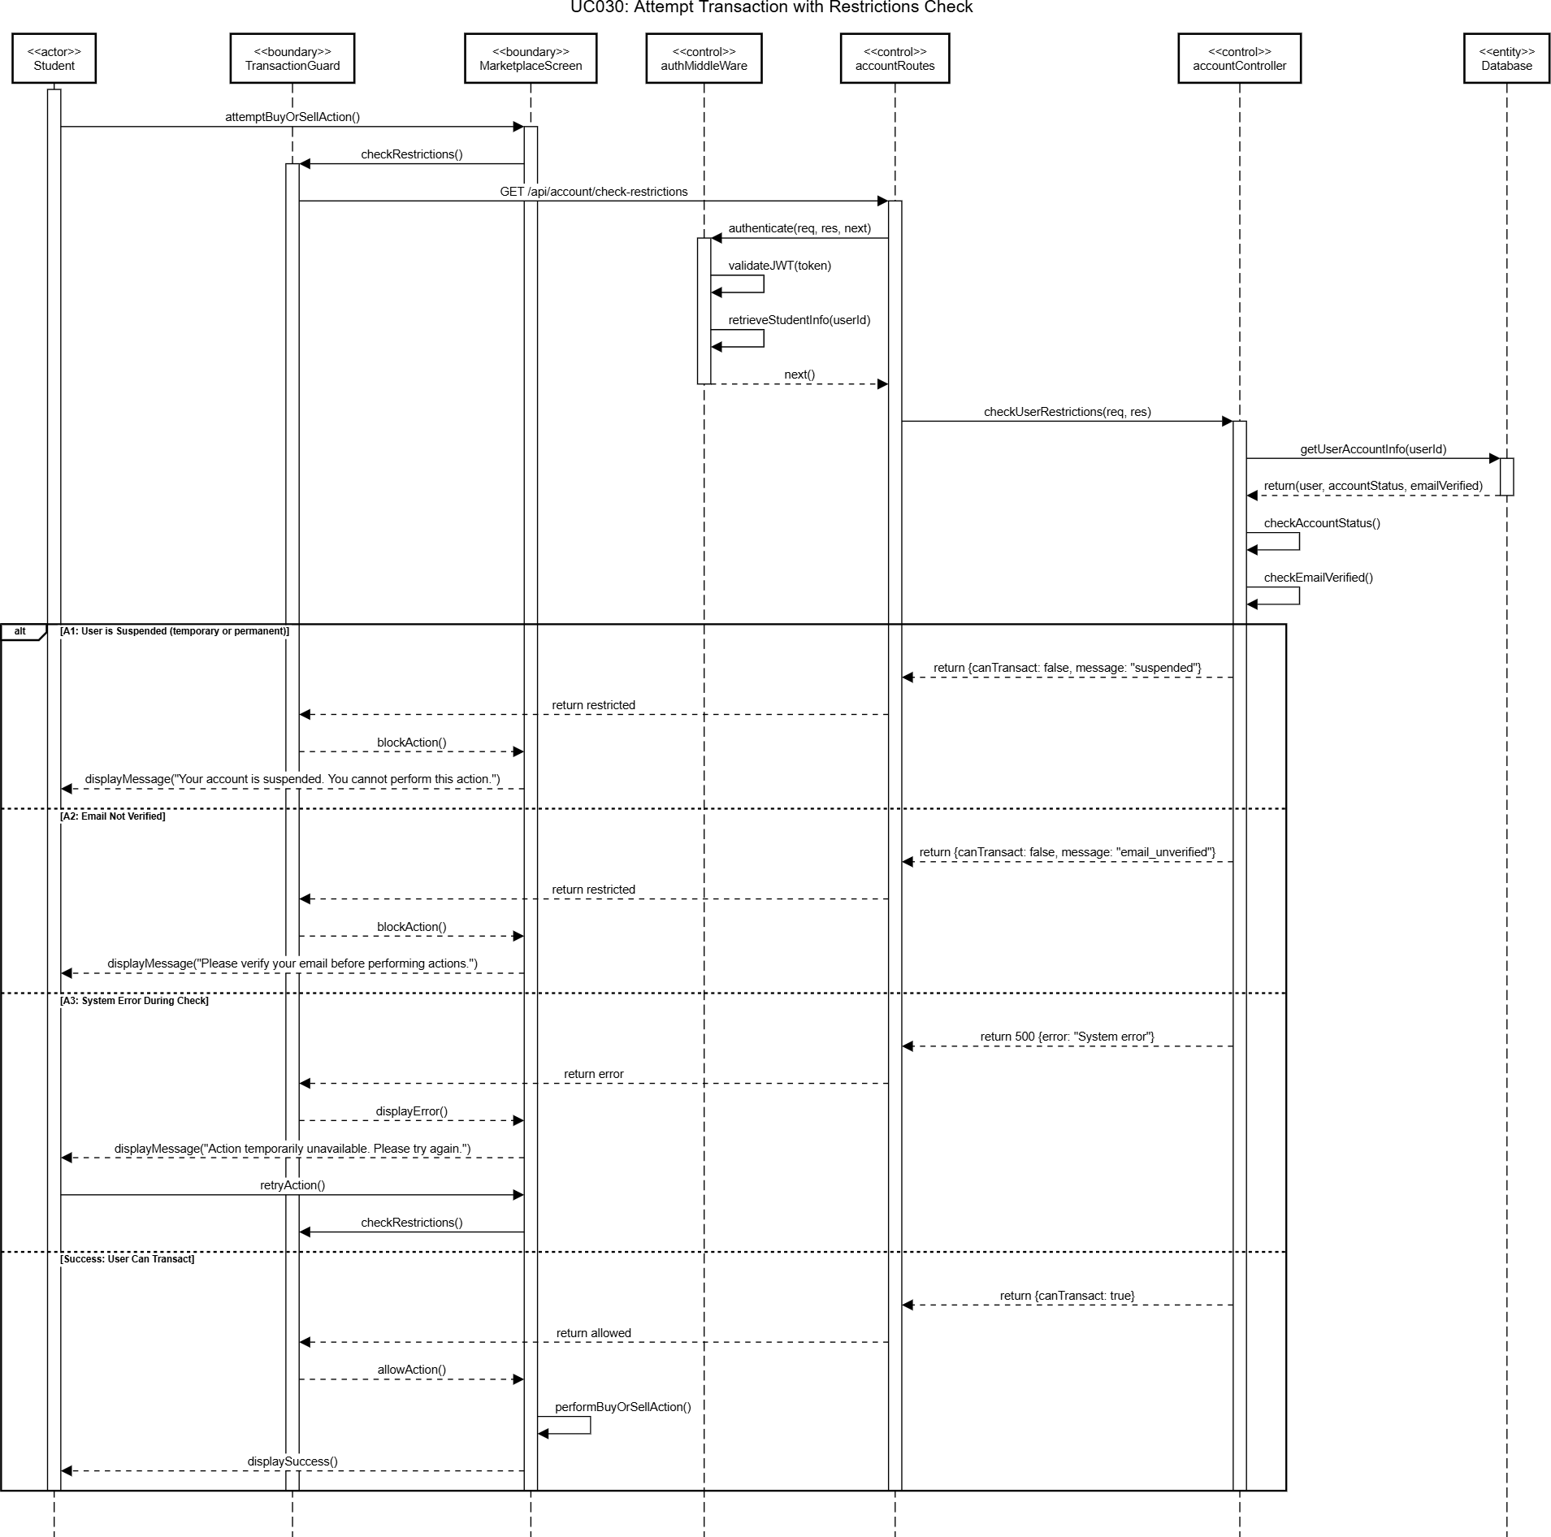
Figure 3.12: Sequence Diagram of UC030 Attempt Transaction with Restriction Check

3.3.2 UC031: TEMPORARILY SUSPEND USER ACCOUNT FOR INVESTIGATION

Use Case Name: Temporarily Suspend User Account for Investigation
Use Case ID: UC031
Actors: Admin
Preconditions:
- Users have been reported or flagged.
- Admin has privileges to suspend accounts.
Flow of Events:
- Admin selects a reported or flagged user.
- Admin chooses the “Suspend Account” option.
- System sets account_status = suspended.
- Suspended users cannot login, buy, sell, or perform any platform actions.
- Admin may later decide to Reinstate or escalate to Permanent Suspension.
Alternative Flow:
A1: User Already Permanently Suspended
- The system blocks temporary suspension and displays: "User is already permanently suspended."
A2: System Error During Suspension
- System shows error: "Failed to suspend account. Please try again." Admin retries.
A3: Admin Cancels Action
- No changes made; the user remains in original state.
Post-conditions:
- The user account is temporarily disabled.
Table 3.10: Use Case Description of UC031 Temporarily Suspend User Account for Investigation

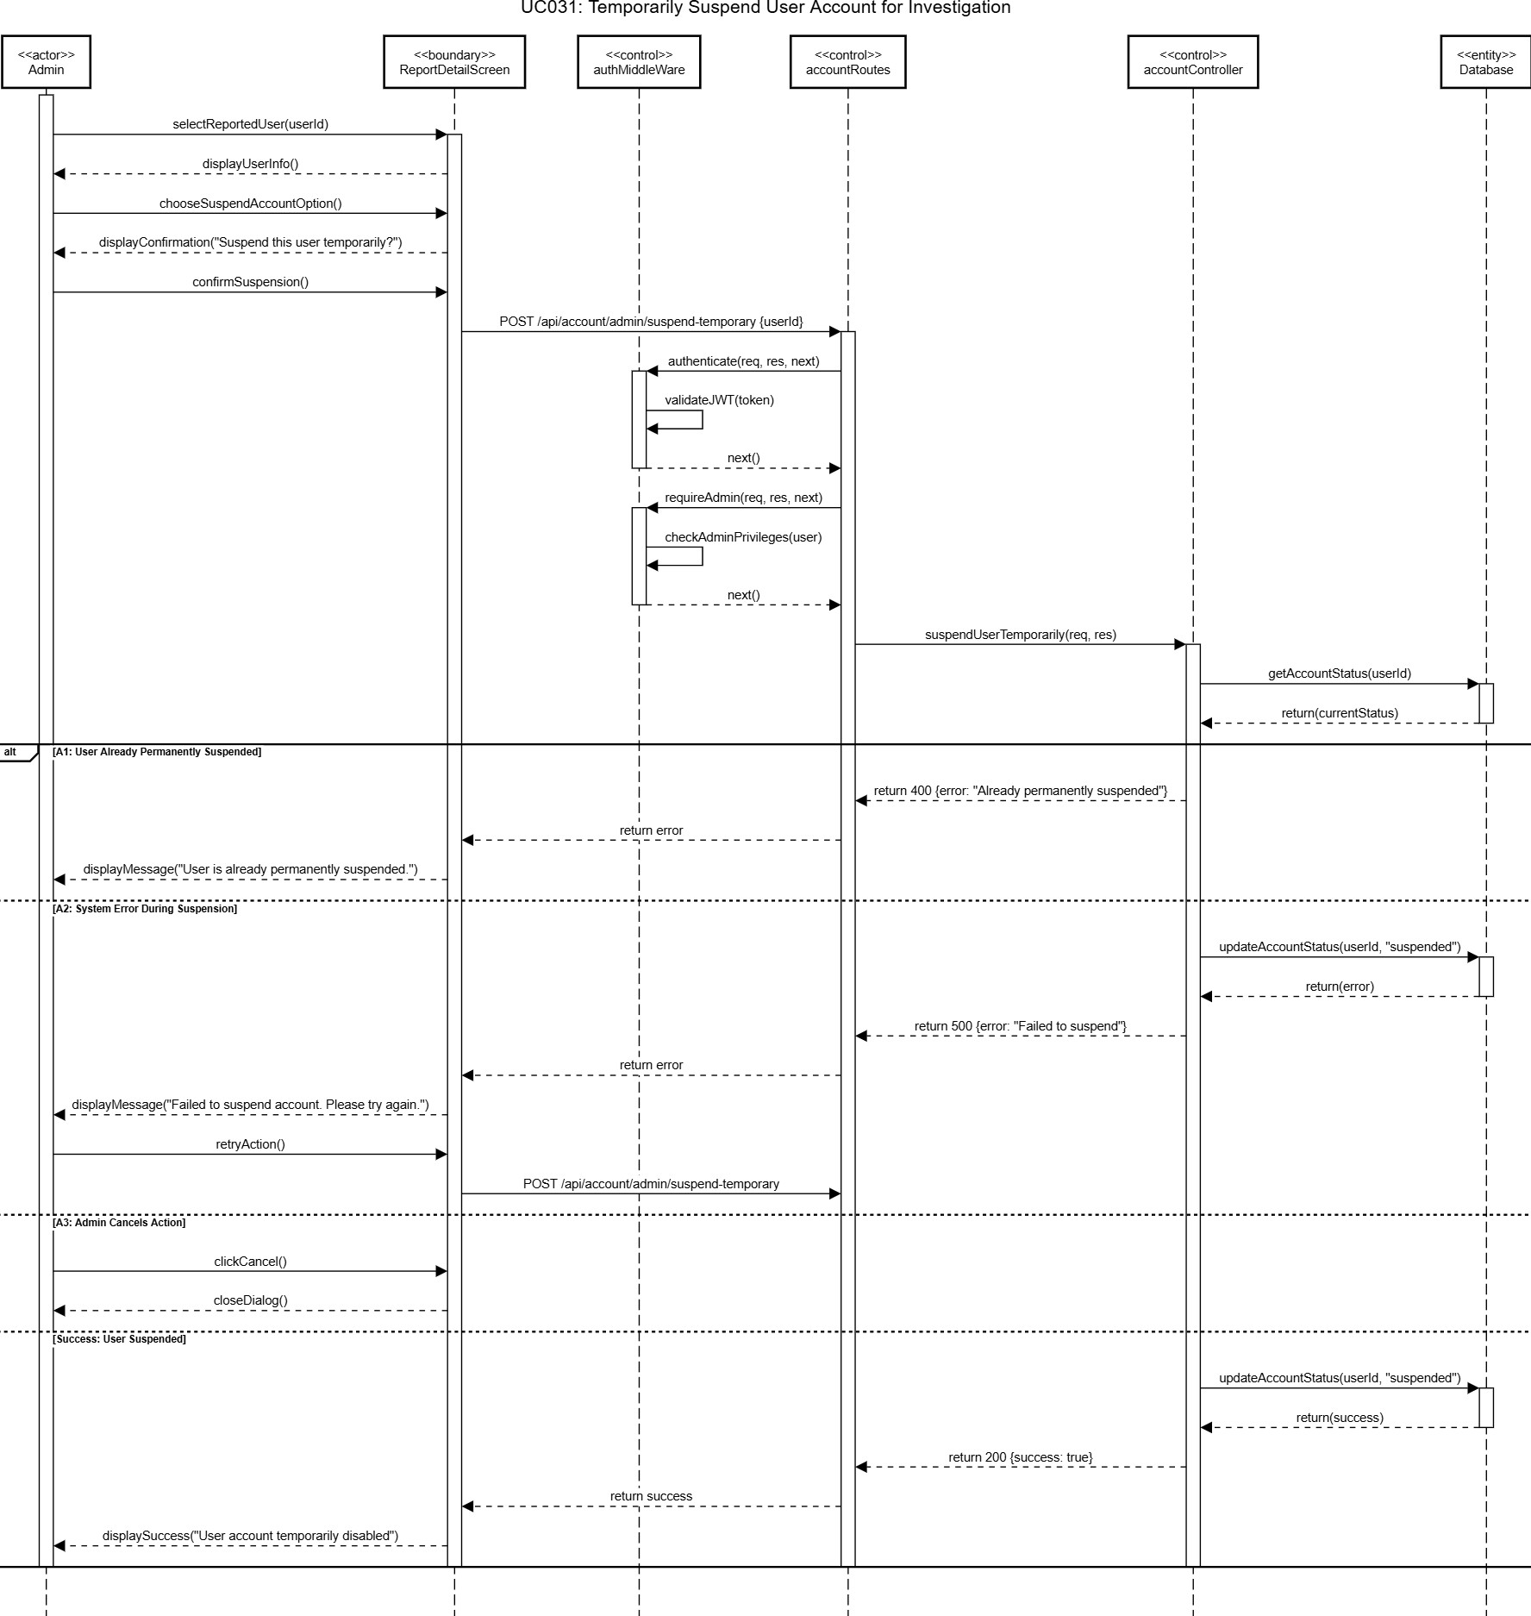
Figure 3.13: Sequence Diagram of UC031 Temporarily Suspend User Account for Investigation

3.3.3 UC032: PERMANENT SUSPEND USER ACCOUNT

Use Case Name: Permanent Suspend User Account
Use Case ID: UC032
Actors: Admin
Preconditions:
- The user has an account.
- Investigation confirms serious violation or misconduct.
Flow of Events:
- Admin selects the user for permanent suspension.
- Admin confirms action in admin panel.
- System sets account_status = permanently_suspended.
- Users cannot login or perform any platform actions.
- If a user attempts login, the system displays: "Your account has been permanently suspended due to violation of platform rules."
Alternative Flow:
A1: User Already Suspended Temporarily
- System upgrades account_status to permanently_suspended.
A2: System Error
- System shows error: "Failed to suspend account. Please try again."
- Admin retries.
A3: Admin Cancels Action
- No changes made.
Post-conditions:
- Users are permanently blocked from the platform.
- Account data and history remain in the database for auditing.
Table 3.11: Use Case Description of UC032 Permanent Suspend User Account

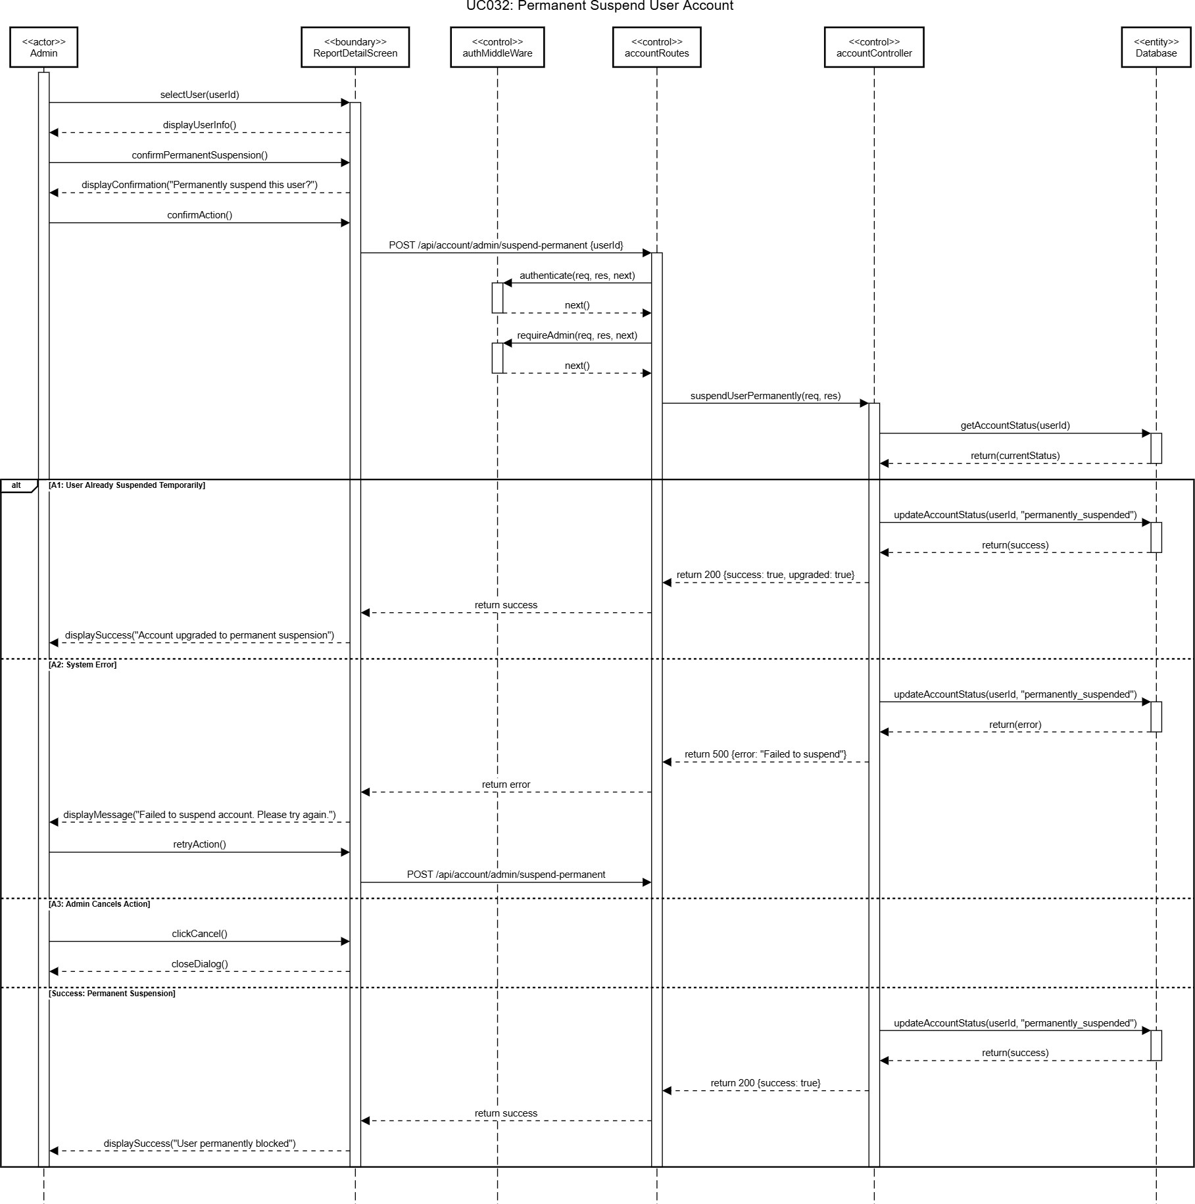
Figure 3.14: Sequence Diagram of UC032 Permanent Suspend User Account

3.3.4 UC033: VIEW REPORT REASON AND EVIDENCE

Use Case Name: View Report Reason and Evidence
Use Case ID: UC033
Actors: Admin
Preconditions:
- Users have been reported.
- Admin has privileges to review reports.
Flow of Events:
- Admin selects a reported user.
- System displays: report reason, reporter info, and uploaded evidence.
- Admin reviews information and decides whether to suspend temporarily, permanently, or take no action.
Alternative Flow:
A1: System Error Displaying Evidence
- System shows error: "Failed to load report details. Please try again."
- Admin retries.
A2: No Evidence Uploaded
- The system displays a message: "No evidence available for this report."
Post-conditions:
- Admin has all information to make access control decisions.
Table 3.12: Use Case Description of UC033 View Report Reason And Evidence

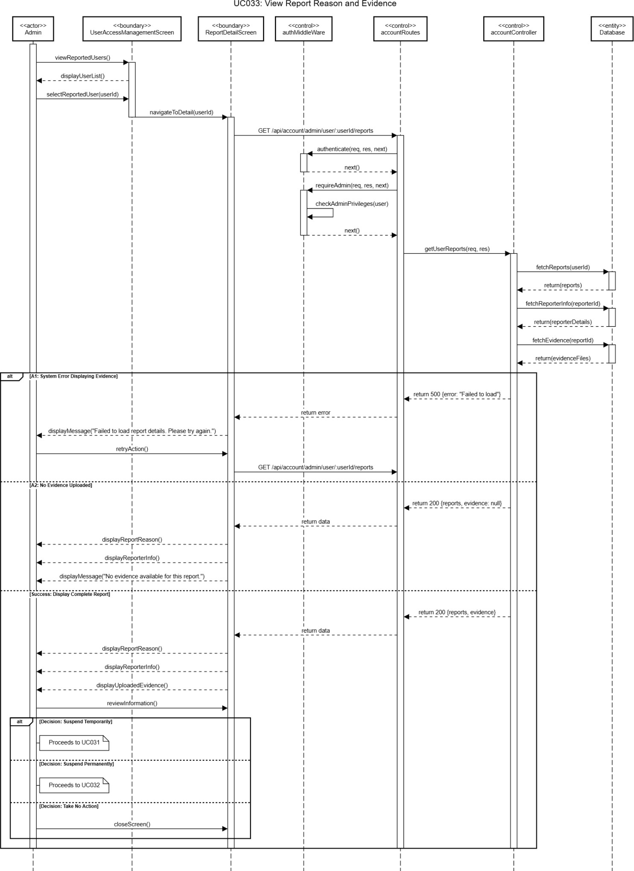
Figure 3.15: Sequence Diagram of UC033 View Report Reason And Evidence

3.3.5 UC034: REINSTATE TEMPORARILY SUSPENDED AND RESTRICTED USER

Use Case Name: Reinstate Temporarily Suspended And Restricted User
Use Case ID: UC034
Actors: Admin
Preconditions:
- The user account is in a restricted or suspended state.
- Admin has valid administrative privileges.
Flow of Events:
- Admin selects a restricted user.
- Admin chooses the “Reinstate” option.
- Account status is updated to active.
- The user regains full platform access.
- Reinstatement action is recorded for auditing.
Alternative Flow:
A1: System Error
- Reinstatement fails due to system or database error.
- Error message is displayed: "Failed to reinstate account. Please try again."
- Admin retries the action.
A2: Admin Cancels Action
- Admin cancels the reinstatement.
- No changes are made.
- Users remain restricted.
Post-conditions:
- User account status is active.
- Users can log in and perform all platform actions.
Table 3.13: Use Case Description of UC034 Reinstate Temporarily Suspended And Restricted User

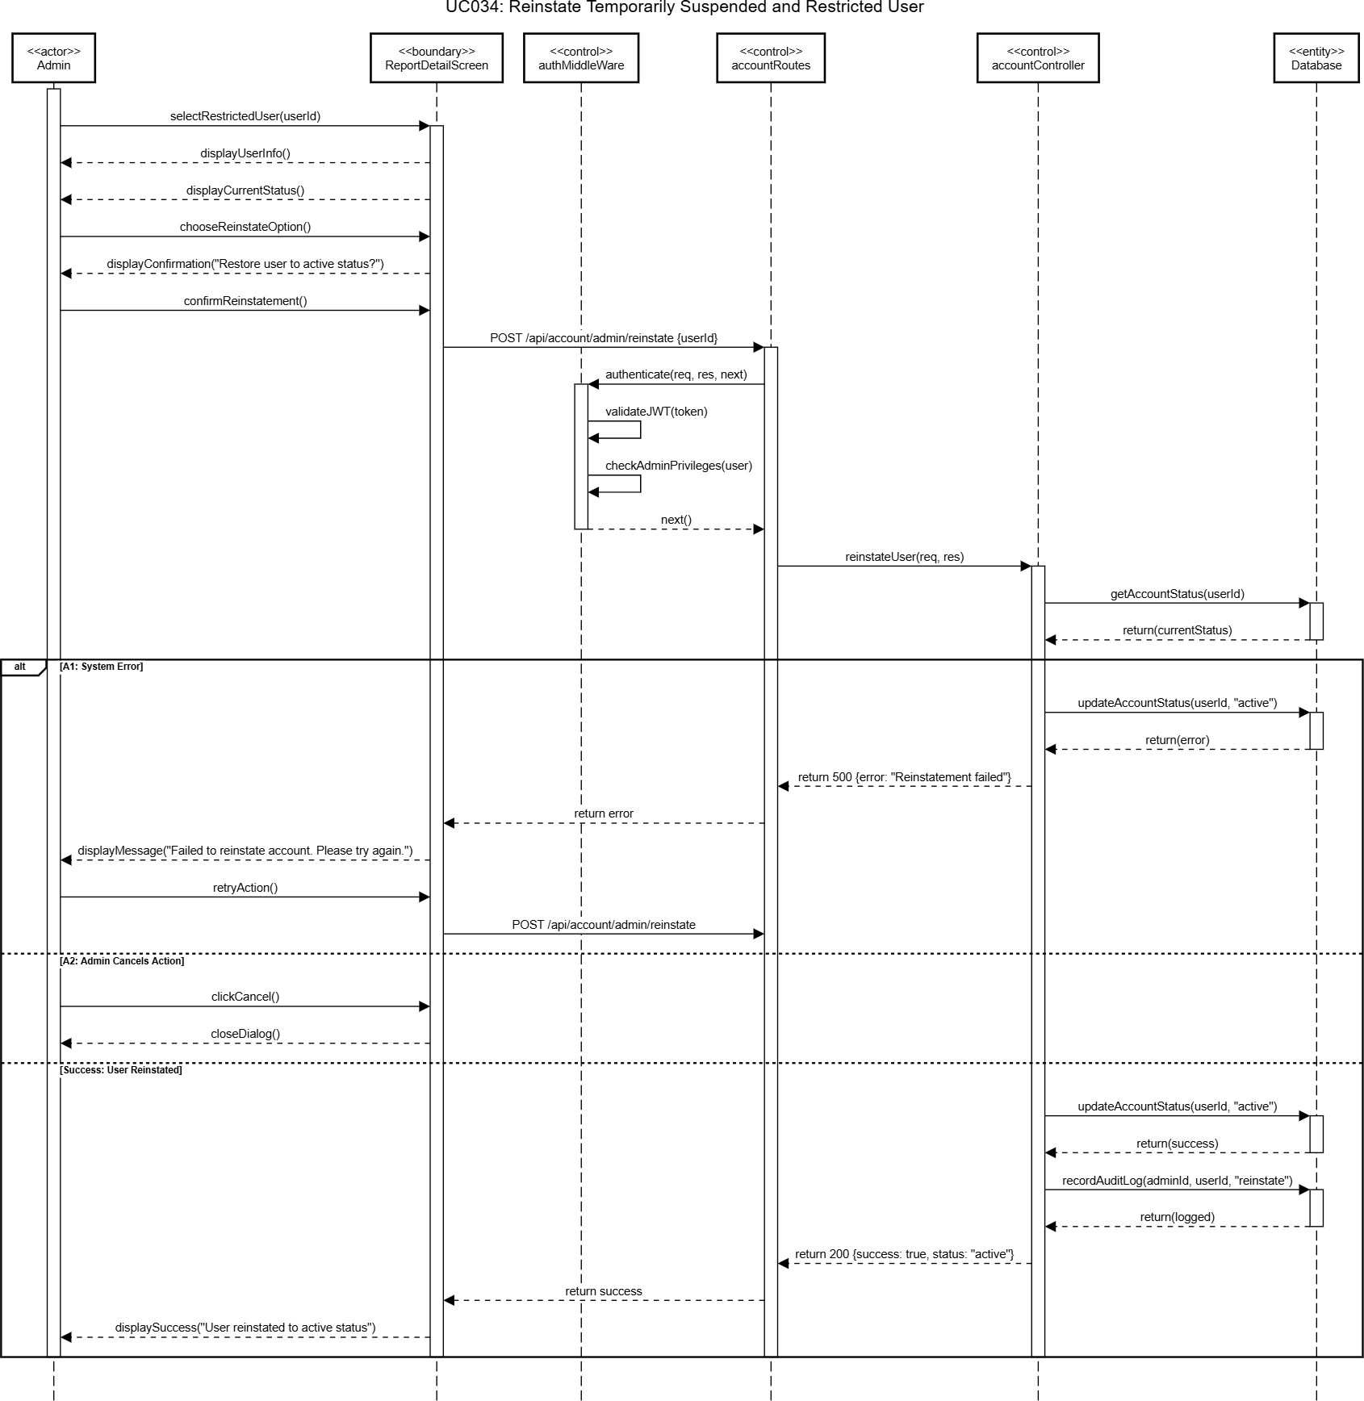
Figure 3.16: Sequence Diagram of UC034 Reinstate Temporarily Suspended And Restricted User

4.0 PRODUCT AND MARKET SUBSYSTEM SPECIFICATION

4.1 PRODUCT LISTING & MANAGEMENT MODULE (AINA ZAFIRAH)

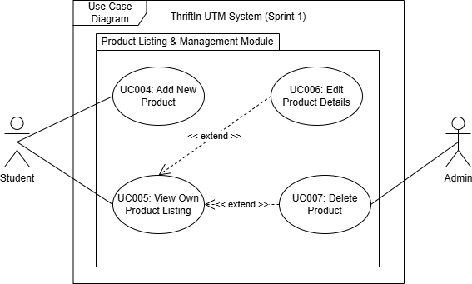

Figure 4.1: Package Diagram of Product Listing and Management Module

The Product Listing and Management Module consist of four main use cases, which are UC004 Add New Product, UC005 View Own Product Listing, UC006 Edit Product Details and UC007 Delete Product. This module enables students (sellers) to manage their thrift product listings in the application by adding, updating and removing items. It serves as the core part of the marketplace where all products are organized, displayed and maintained.

In UC004 Add New Product, the student is required to provide complete product information before posting it to the marketplace. The required details include product name, category, description, price, condition and at least one product image. Once the students submit the form, the system will validate the entered details and save them into the product database. If the validation is successful, the product will be added to the student’s listing and made visible to potential buyers in the marketplace.

Meanwhile, UC005 View Own Product Listing enables students to view all the products they have listed on the platform. This page displays a summary of each item. From this interface, the student can also choose to edit or delete products easily, as these actions are linked to their respective use cases (UC006 and UC007). This provides a convenient and centralized location for sellers to manage their items efficiently.

a form that can be edited and once submitted, the system validates and updates the product data in the database. This ensures that all product listings remain accurate and up to date. Lastly, UC007 Delete Product enables students to remove products. When the seller selects a product to delete, the system will prompt confirmation to prevent accidental deletion. After confirmation, the product record will be permanently removed from the system database. As a result, the product will no longer appear in the marketplace or in the student’s product listing. Admin can delete inappropriate product posting for moderation purposes.

Overall, this module ensures that all products displayed in the marketplace are managed systematically by their respective sellers. It provides a seamless experience for students to maintain their listings, while ensuring that buyers can always view accurate and up-to-date information about available thrift products.

4.1.1 UC004: ADD NEW PRODUCT

Use Case Name: Add New Product
Use Case ID: UC004
Actors: Student (Seller)
Preconditions:
- The student must be logged into their account.
- The system is connected to the product database.
Flow of Events:
- The students select “Add” from the navigation bar.
- The system displays a form for product details such as product name, category, condition, price and description.
- The student enters the required details and uploads at least one product image.
- The students click on “Add Product” to submit products to the product listing.
- The system validates the input fields to ensure the mandatory details are filled and images are valid.
- The system saves the product information into the database.
Alternative Flow:
A1: Invalid Data
- If any mandatory field is missing or invalid, the system displays an error message and prompts the student to correct the input.
Post-conditions:
- The new product listing is successfully stored in the system and becomes visible in the student’s product listing list.
Table 4.1: Use Case Description of UC004

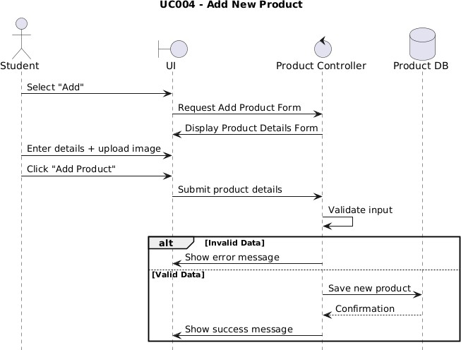

Figure 4.2: Sequence Diagram for UC004 Add New Product

4.1.2 UC005: VIEW OWN PRODUCT LISTING

Use Case Name: View Own Product Listing
Use Case ID: UC005
Actors: Student (Seller)
Preconditions:
- The student must be logged in.
- The system must have stored at least one product listing for the student.
Flow of Events:
- The student selects “My Items” from the navigation bar.
- The system retrieves all product listings belonging to the logged-in student.
- The system displays each product’s summary such as name, image, price, category and condition.
- The student can choose to edit, or delete specific listings (extends UC006 and UC007).
Alternative Flow:
A1: No Listings Found
- If the student has no products listed, the system displays a message such as “No products listed yet”
Post-conditions:
- The student successfully views their list of products with available options for management actions.
Table 4.2: Use Case Description of UC005 View Own Product Listing
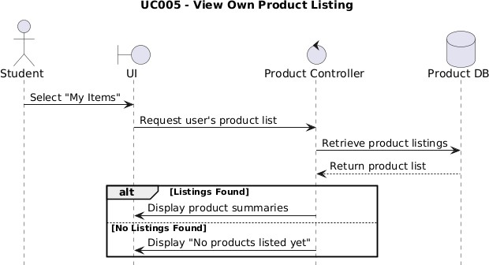

Figure 4.3: Sequence Diagram for UC005 View Own Product Listing

4.1.3 UC006: EDIT PRODUCT LISTING

Use Case Name: Edit Product Details
Use Case ID: UC006
Actors: Student (Seller)
Preconditions:
- The student must be logged in.
- The product to be edited must already exist and belong to the logged-in student.
Flow of Events:
- The student navigates to “My Items”.
- The system displays all the student’s active product listings.
- The student selects a product to edit by choosing the product's “Edit” button.
- The system displays the product details form pre-filled with existing information.
- The student modifies one or more fields such as description, price, image, or category.
- The student submits the updated information.
- The system validates the new details and updates the record in the database.
Alternative Flow:
A1: Invalid Edits
- If the edited data fails validation such as negative price or missing description, the system displays an error message and requests correction.
Post-conditions:
- The product’s details are successfully updated in the system and reflected in the product listing.
Table 4.3: Use Case Description of UC006 Edit Product Details

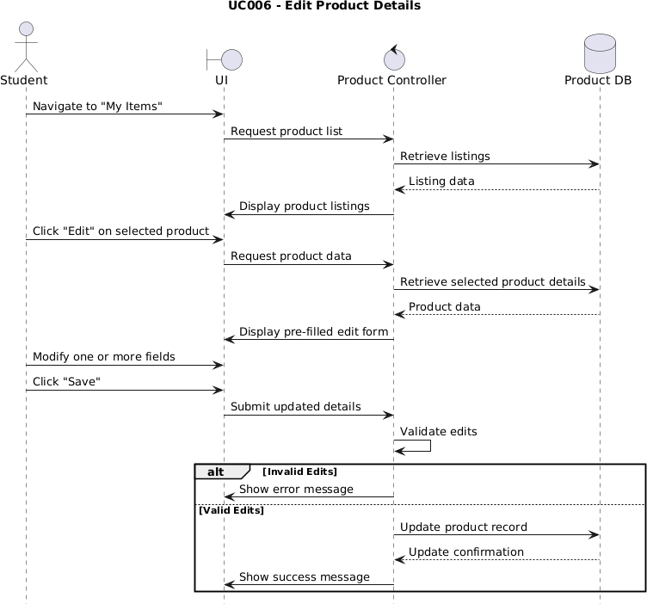

Figure 4.4: Sequence Diagram for UC006 Edit Product Details

4.1.4 UC007: DELETE PRODUCT

Use Case Name: Delete Product
Use Case ID: UC007
Actors: Student (Seller), Admin (for moderation)
Preconditions:
- The student must be logged in.
- The product must exist in the system and belong to the student.
Flow of Events:
- The student navigates to “My Items” using the navigation bar.
- The students select a specific product to delete by pressing the product’s “Delete” button.
- The system prompts the student “Are you sure you want to delete this product?” for confirmation.
- The students confirm deletion.
- The system removes the product from the database.
Alternative Flow:
A1: Admin Deletes Product
- If the Admin found an inappropriate product, Admin can delete the product and the product is no longer visible in the owner’s product listing.
Post-conditions:
- The product is permanently deleted or marked as inactive and is no longer visible to buyers.
Table 4.4: Use Case Description of UC007 Delete Product

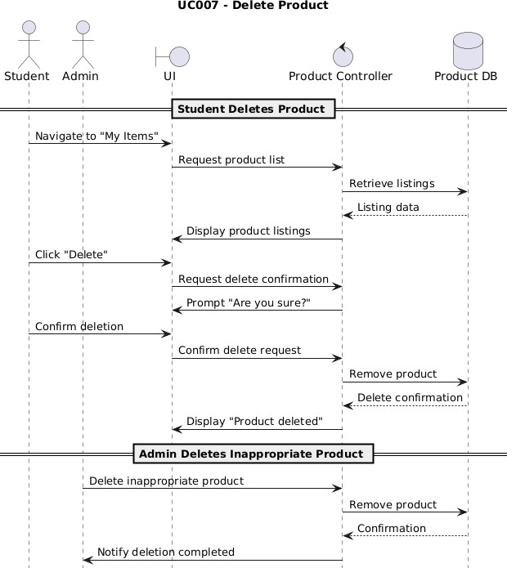

Figure 4.5: Sequence Diagram for UC007 Delete Product

PRODUCT AND MARKET SUBSYSTEM: SEARCH AND RECOMMENDATION MODULE (AINA ZAFIRAH)
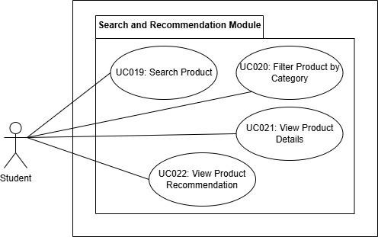
Figure 4.6: Package diagram for Search and Recommendation Module

SPECIFIC REQUIREMENT
The Search and Recommendation Module consists of five main use cases which are UC019 Search Product, UC020 Filter Product by Category, UC012 View Product Details and UC022 View Product Recommendation. This module enables students to discover, search and browse available secondhand or preloved products in the ThriftIn UTM marketplace. It serves as the core browsing and discovery interface where buyers can find items from other students.

In this module, students can view all active products listed by other sellers in the marketplace. The system displays products in a grid layout showing product images, name, prices, categories and conditions. In UC019 Search products enable students to search for specific items using keywords. When a student types a search query and submits, the system searches through product names and descriptions to find matching items. The search is case insensitive and supports partial matching. The system also saves search queries to help improve future recommendations and understand user preferences.

Meanwhile, in UC020 Filter Product by Category, students can narrow down products by selecting category chips displayed below the search bar. Available categories include Books, Electronics, Fashion, Furniture and Others. Students can select one category at a time or choose “All” to view all products.

In UC021 View Product details, when a student taps on any product card, the system navigates to a dedicated Product Details screen. This screen displays comprehensive information on all product images, full product description, price, condition, category, view count and seller information. The system also tracks this view interaction for recommendation purposes and increments the product’s view count.

Lastly, UC022 View Product Recommendations provides personalized product suggestions based on the student’s browsing history. The system analyzes which categories the student has viewed most frequently and recommends similar products from those categories. If the student has no viewing history yet, the system displays popular products based on view counts. The recommendation appears in a horizontal scrolling section titled “Recommended for You” on the home screen.

Overall, this module ensures the student can efficiently discover and explore available preloved items through an intuitive marketplace interface. It combines search functionality, filtering capabilities, detailed product views and recommendations to enhance the buying experience and help students find exactly what they need.

4.2.1 UC019: SEARCH PRODUCT

Use Case Name: Search Product
Use Case ID: UC019
Actors: Student
Preconditions:
- The student must be logged into their account.
- The system is connected to the product database.
Flow of Events:
- The student opens the application.
- The system displays the Home screen with the marketplace.
- The system retrieves all active products excluding those owned by the logged-in student.
- The system displays products in a 2-column grid layout showing product images, names, prices, categories and conditions. (AF1)
- The student taps on the search bar and enters a search query such as “algorithm”.
- The student submits the search by pressing the search button or keyboard enter key. (AF2)
- The system searches for products where the query matches product names or descriptions.
- The system saves the search query and results count to the search history table.
- The system displays matching products with the search query highlighted. (AF3)
- The student can clear the search to return to viewing all products.
Alternative Flow:
AF1: No Products Available
- If there are no products from other sellers, the system displays “No products found”.
- The system suggests the students to check back later or be the first to list an item.

AF2: Empty Search Query
- If the student submits an empty search, the system displays an error message.
- The system prompts the student to enter a search term.

AF3: No Search Result
- If no products match the search query, the system displays a “No products found” message.
- The system suggests the students try a different search term.

Post-conditions:
- All available products from other sellers are displayed successfully.
- Product view counts and interaction data are prepared for tracking.
- Matching products from search query are displayed to the student
- The search query is saved in the search_history table for analytics and recommendations.
Table 4.5: Use Case Specification for UC019 Search Product

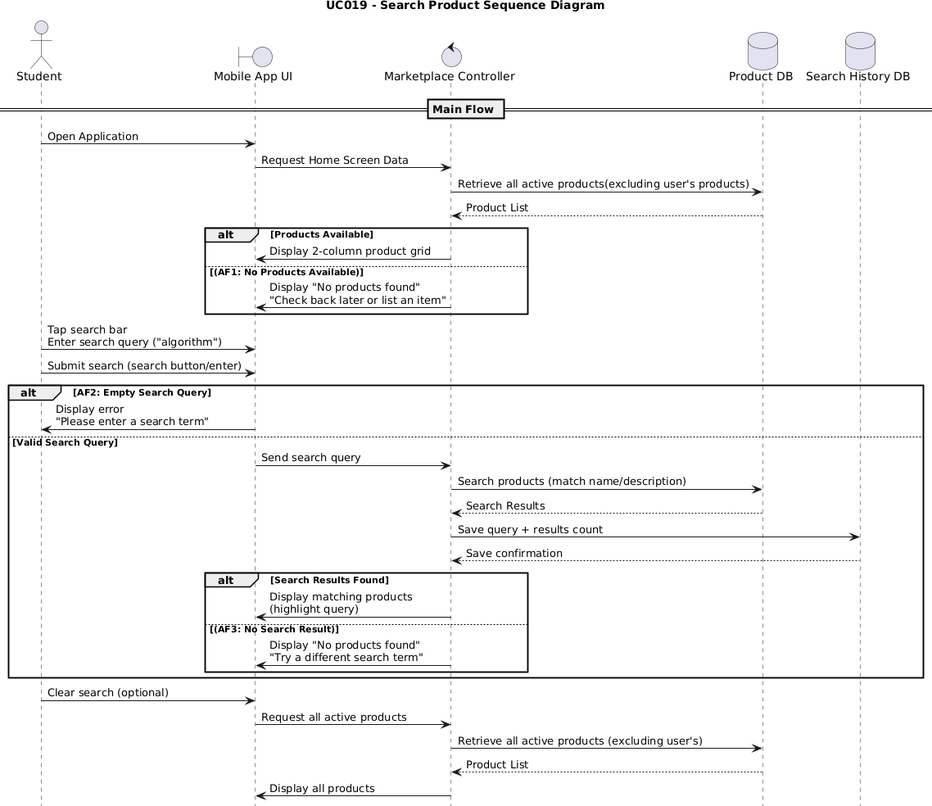
Figure 4.7: Sequence diagram for UC019 Search Product

4.2.2 UC020: FILTER PRODUCT BY CATEGORY

Use Case Name: Filter Product By Category
Use Case ID: UC020
Actors: Student
Preconditions:
1. The student must be logged in into ThriftIn UTM.

2. Products must be available in the marketplace.
Flow of Events:
- The student is on the Home screen.
- The system displays category filter chips below the search bar: All, Books, Electronics, Fashion, Furniture and Others.
- The student taps on a category chip, for example “Books”.
- The system highlights the selected category chip with active styling.
- The system filters and displays only products belonging to the selected category. (AF1)
- The system can select “All” to view all products again.
- The student can select a different category to change the filter.
Alternative Flow:
AF1: No Products in Category
- If the selected category has no products, the system displays “No products found in this category”.
- The system suggests the student to try a different category.
Post-conditions:
- Products are filtered and displayed according to the selected category.
- The selected category remains highlighted for visual feedback.
Table 4.6: Use Case Specification for UC020 Filter Product by Category
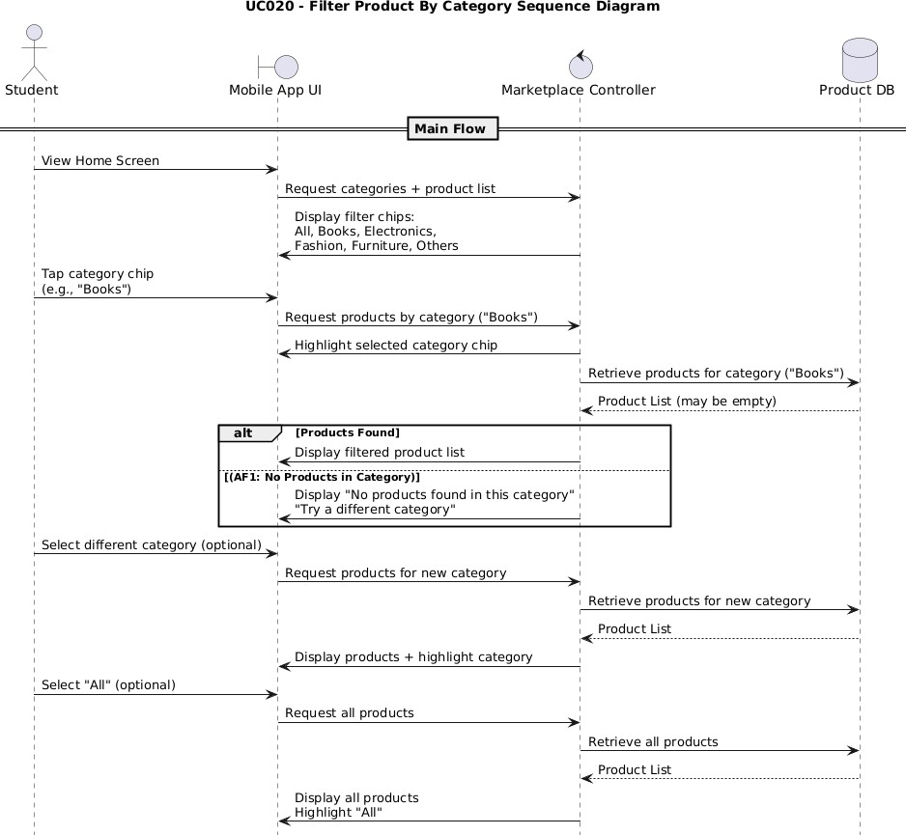
Figure 4.8: Sequence diagram for UC020 Filter Product by Category

4.2.3 UC021: VIEW PRODUCT DETAILS

Use Case Name: View Product Details
Use Case ID: UC021
Actors: Student
Preconditions:
- The student must be logged in into ThriftIn UTM.
- The product must exist and have status “active”.
Flow of Events:
- The student is browsing products on the Home screen.
- The student taps on a product card.
- The system navigates to the Product Details screen.
- The system increments the product’s view count by 1.
- The system records a ‘view’ interaction in the user_interactions table for recommendations.
- The system displays all product images, product name, price, category, condition badge, full product description, view count, seller information and other product details. (AF1)
- The student can swipe through multiple product images.
- The student can tap the back button to return to the marketplace.
Alternative Flow:
AF1: Products Not Found
- If the product no longer exists or is inactive, the system displays a “Product not found” message.
- The system automatically navigates back to the Home screen.
Post-conditions:
- Product details are displayed successfully.
- View count is incremented in the products table.
- Interaction is recorded in the user_interaction table.
- Students can navigate back to browsing.
Table 4.7: Use Case Specification for UC021 View Product Details

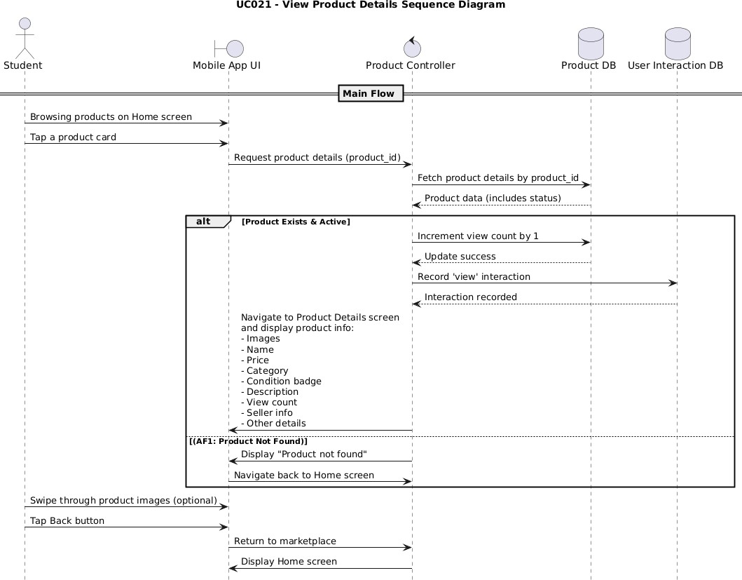
Figure 4.9: Sequence diagram for UC021 View Product Details

4.2.4 UC022: VIEW PRODUCT RECOMMENDATION

Use Case Name: View Product Recommendation
Use Case ID: UC022
Actors: Student
Preconditions:
- The student must be logged in into ThriftIn UTM.
- The system must have access to user interaction data.
Flow of Events:
- The student opens the Home screen.
- The system analyzes the student’s viewing history from the user_interaction table. (AF1)
- The system identifies the top 3 categories the student has viewed most recently.
- The system retrieves products from those categories that are active and available and belong to other sellers.
- The system orders recommendations by popularity through view count.
- The section is labeled “Recommended for You” and appears below the search and filter area. (AF2)
- The student can scroll through recommendations and tap any product to view details.

Alternative Flow:
AF1: No Viewing History
- If the student has no viewing history, the system falls back to showing popular products.
AF2: No Available Recommendations
- If no suitable recommendations are found, the system hides the recommendations section.
- The student sees only the main marketplace products.
Post-conditions:
- Personalized product recommendations are displayed to the student.
- Recommendations are updated as the student views more products.
- The student can interact with recommended products like any other product.
Table 4.8: Use Case Specification for UC022 View Product Recommendation

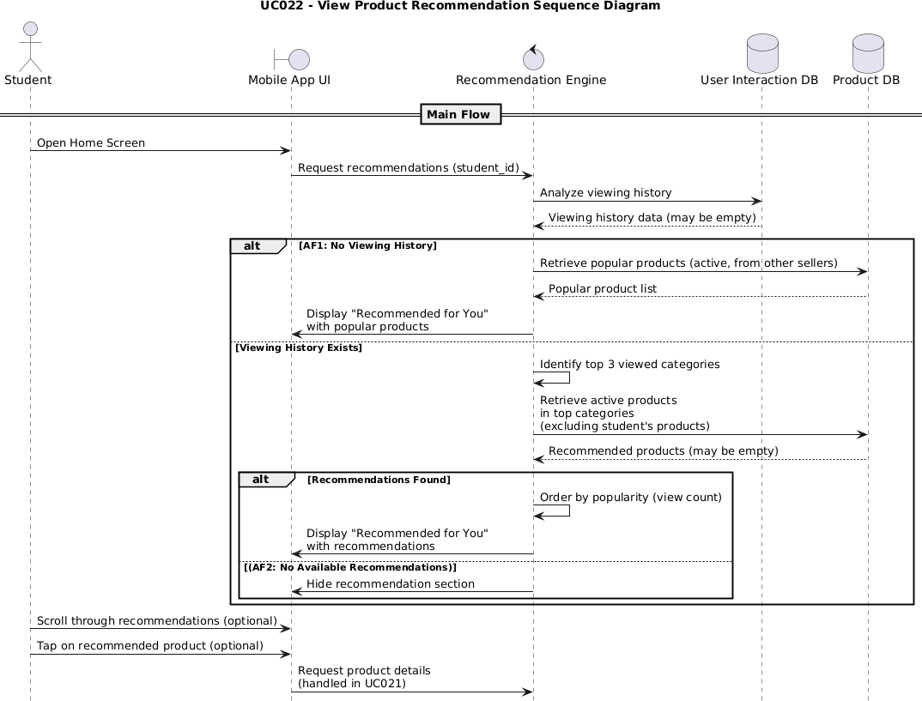

Figure 4.10: Sequence diagram for UC022 View Product Recommendation

4.3 PURCHASING AND PAYMENT MODULE (AINA ZAFIRAH)

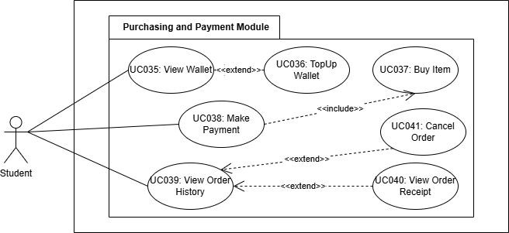
Figure 4.11: Package Diagram for Purchasing and Payment Module

SPECIFIC REQUIREMENT
The Purchasing and Payment Module consists of seven main use cases which are Buy Item, Top Up Wallet, Make Payment, View Wallet, View Order History, View Order Receipt, and Cancel Order. This module enables students to manage a virtual wallet, purchase preloved items using a Buy Now feature and track all financial and order-related activities through a centralized system.

The module uses a MyWallet system where students must top up their wallet before making purchases. Wallet top-ups are done through three mock payment methods which are Credit Card, E-Wallet and Online Banking. All purchases are paid exclusively using the wallet balance for a streamlined transaction flow. Students can top up amounts between RM10.00 and RM5000.00 through mock payment interfaces. After input validation and simulated processing, the wallet balance and transaction records are updated securely. The Wallet screen shows the current balance, total top-ups, spending, refunds and a complete transaction history.

Students can purchase items directly from the product page using Buy Now. The system validates item availability and ownership, then displays a checkout summary. During payment, the system checks wallet balance and either completes the transaction or redirects the student to top up if funds are insufficient. Successful payment atomically updates the wallet balance, order record, product status, transaction history and receipt. Order History displays all purchases in reverse chronological order, allowing students to view detailed receipts for each order.

Order receipts include full purchase, seller and payment details and can be shared for coordination. Students may cancel an order within 24 hours, after which the system refunds the wallet balance, updates the order status, and reactivates the product. Overall, the module provides a secure, user-friendly transaction system with centralized wallet management, complete transparency through transaction and order records, detailed receipts and fair cancellation policies. Database transactions
ensure data integrity and prevent duplicate or inconsistent purchases.

4.3.1 UC035 VIEW WALLET

Use Case Name: View Wallet
Use Case ID: UC035
Actors: Student
Preconditions:
- The student must be logged in to ThriftIn UTM.
Flow of Events:
- The student taps the “Wallet” tab in the bottom navigation.
- The system retrieves or creates the student’s wallet.
- The system retrieves wallet balance and transaction statistics.
- The system displays MyWallet screen showing:
  - Current wallet balance (large, prominent display)
  - “Top Up” button
  - Statistics cards showing total topped up amount and total spent amount
  - Transaction history section (newest first)
- For each transaction in history, the system displays:
  - Transaction icon
  - Transaction type (Top Up / Purchase / Refund)
  - Description or product name
  - Date and time
  - Amount (+ for top-up/refund, - for purchase)
  - Balance after transaction
- The student can scroll through transaction history.
- The student can pull down to refresh wallet data.
- The student can tap “Top Up” to add funds.
Alternative Flow:
AF1: No Transactions Yet
- If the wallet has never been topped up or used, the system displays an empty state.
- The system shows the message “No transactions yet”.
- The system shows “Top up your wallet to start shopping!” message.
- Statistics show all zeros.
Post-conditions:
- Wallet balance is displayed accurately.
- Complete transaction history is accessible.
- Statistics reflect all wallet activities.
- The student can access top-up or view transaction details.
Table 4.9: Use Case Specification for UC035 View Wallet

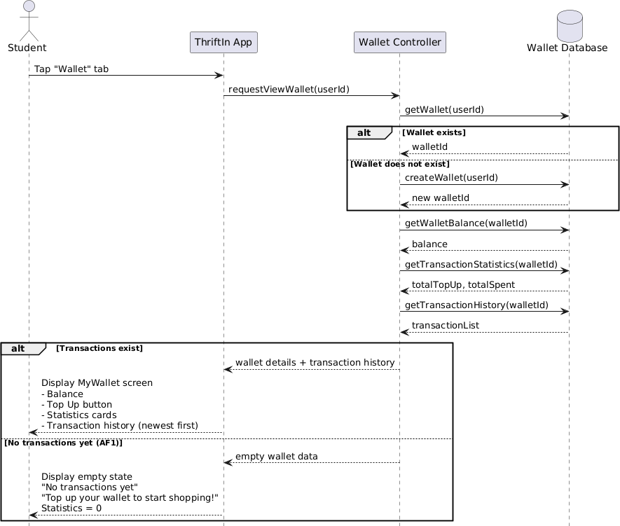
Figure 4.12: Sequence Diagram for UC035 View Wallet

4.3.2 UC036 TOP UP WALLET

Use Case Name: Top Up Wallet
Use Case ID: UC036
Actors: Student
Preconditions:
- The student must be logged in to ThriftIn UTM.
- The student has access to the Wallet screen.
Flow of Events:
- The student navigates to the Wallet tab or taps “Top Up” from the MyWallet screen
- The system displays the Top Up screen showing current wallet balance.
- The student enters the amount they want to top up (or selects a quick amount: RM 50, 100, 200, 500).

- The system validates the amount:
  - Minimum: RM 10.00
  - Maximum: RM 5000.00
- The student selects a payment method from three options:
  - Credit/Debit Card
  - E-Wallet
  - Online Banking
- The system displays mock payment interface based on the selection:
  - Credit Card: Card number (16 digits), Expiry (MM/YY), CVV (3 digits), Cardholder name
  - E-Wallet: Phone number, PIN (6 digits)
  - Banking: Bank selection dropdown, Account number, TAC code (6 digits
- The student fills in the mock payment details.
- The student taps the “Top Up [Amount]” button.
- The system validates input format.
- The system displays “Processing Top-Up…” loading screen.
- The system simulates 2-second payment processing delay.
- The system performs atomic transaction:
  - Updates wallet balance by adding the top-up amount
  - Creates a transaction record in wallet_transactions table with type ‘top_up’
  - Records payment method and timestamp
- The system displays a success message showing a new balance.
- The system navigates back to the MyWallet screen showing updated balance.
Alternative Flow:
AF1: Invalid Amount
- The student enters an amount less than RM 10.00 or more than RM 5000.00.
- The system displays validation error “Minimum top-up amount is RM 10.00” or “Maximum top-up amount is RM 5000.00”.
- The student must correct the amount to proceed.
AF2: Invalid Payment Details
- The student enters invalid format (e.g., 15-digit card number instead of 16-digit).
- The system shows a validation error message “Please enter a valid card number”.
- The payment field is highlighted.
- The student must correct the input to proceed.
AF3: Student Cancels Top Up
- The student taps the back button on the top-up screen.
- The system returns to the MyWallet screen.
- No transaction is created and wallet balance remains unchanged.
Post-conditions:
- Wallet balance is increased by the top-up amount.
- A transaction record is created showing the top-up.
- The student can now use the balance for purchases.

4. Transaction appears in wallet history.
Table 4.10: Use Case Specification for UC036 Top Up Wallet

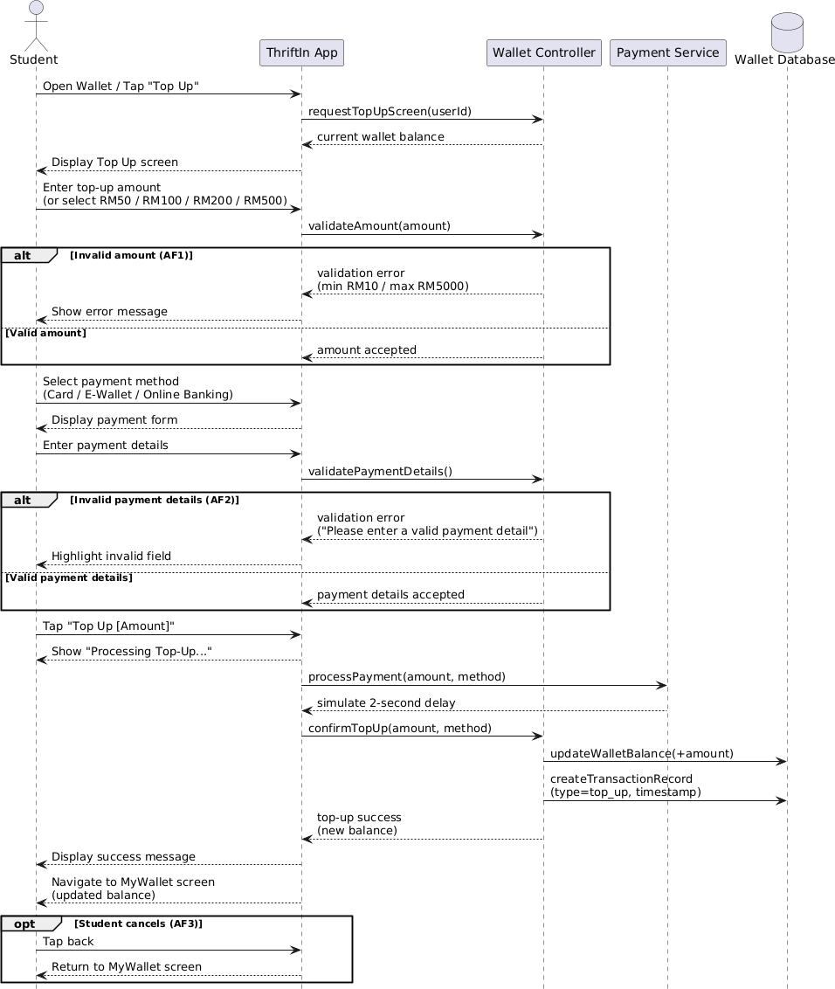
Figure 4.13: Sequence Diagram for UC036 Top Up Wallet

4.3.3 UC037 BUY ITEM

Use Case Name: Buy Item
Use Case ID: UC037
Actors: Student
Preconditions:
- The student must be logged in into ThriftIn UTM.
- The student is viewing item details of an available item.
- The item status is ‘active’ and not owned by the student.
Flow of Events:
- The student is on the Product Details screen viewing the item they want to buy.
- The student taps the “Buy Now” button at the bottom of the screen.
- The system validates item availability:
  - Checks item status is still “active”.
  - Confirms the item is not owned by the student.
  - Verifies no other transaction is in progress for this item.
- The system navigates to the Checkout screen.
- The system displays order summary showing item image, item name and description, item price, condition, seller name and total amount.
- The student reviews the order details.
- The student can tap “Proceed to Payment” or “Cancel”.
Alternative Flow:
AF1: Product No Longer Available
- The system detects item status has changed to ‘sold’ between viewing and clicking “Buy Now”.
- The system displays an error alert message “Sorry, this item was purchased by another buyer”.
- The system refreshed Product Details screen showing “SOLD” status.
- “Buy Now” button is disabled.
AF2: Student Cancels Checkout
- The student taps the “Cancel” or back button on the Checkout screen.
- The system returns to the Product Details screen.
- No transaction is created.
Post-conditions:
- The student sees a complete order summary on the Checkout screen.
- The item remains ‘active’ until payment is confirmed.
- The student can proceed to payment or cancel the transaction.
Table 4.11: Use Case Specification for UC037 Buy Item

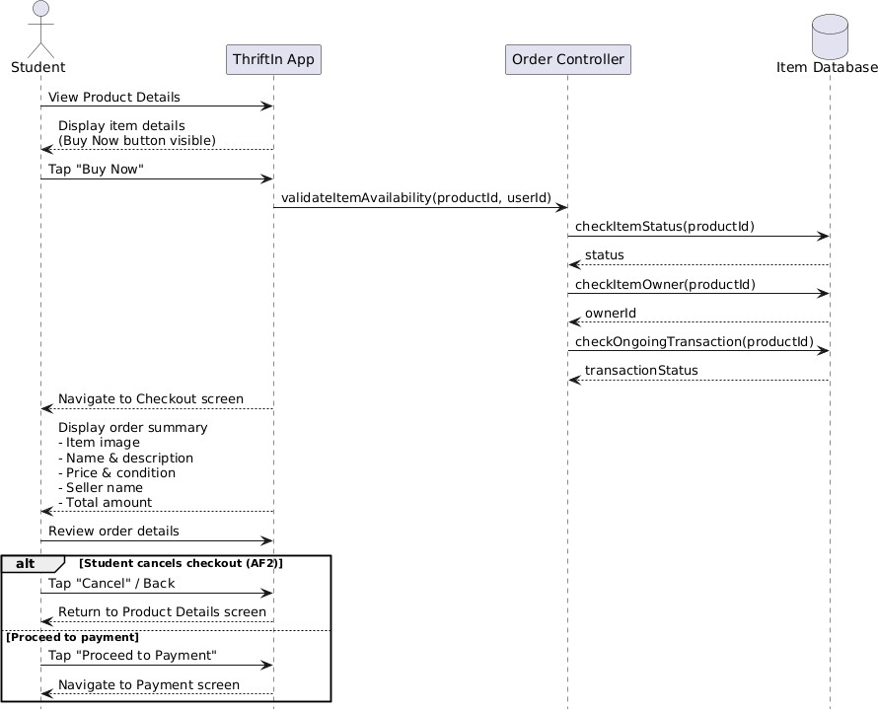
Figure 4.14: Sequence Diagram for UC037 Buy Item

4.3.4 UC038 MAKE PAYMENT

Use Case Name: Make Payment
Use Case ID: UC038
Actors: Student
Preconditions:
- The student must be logged in to ThriftIn UTM.
- The student is on the Checkout screen with a valid item.
- The item status is still ‘active’.
- The student has a wallet.
Flow of Events:
- The student is on the Checkout screen and taps the “Proceed to Payment” button.
- The system retrieves the student's current wallet balance.
- The system displays Payment screen showing:
  - Current wallet balance
  - Order amount
  - Balance status (sufficient/insufficient)

- Balance after payment (if sufficient) or shortage amount (if insufficient)
- If balance is sufficient:
  - The system displays “Pay RM [amount]” button
  - The student taps “Pay RM [amount]”
  - The system displays confirmation dialog showing amount to be deducted and new balance
- If balance is insufficient:
  - The system displays shortage amount
  - The system shows “Top Up RM [shortage]” button
  - The student can tap to navigate to Top Up screen
- The student confirms payment in the confirmation dialog.
- The system displays “Processing Payment…” loading screen.
- The system simulates 2-second payment processing delay.
- The system performs atomic transaction:
  - Locks wallet and product records
  - Verifies wallet has sufficient balance
  - Deducts amount from wallet balance
  - Creates wallet transaction record with type ‘purchase’
  - Creates new order in orders table with payment_method = ‘wallet’
  - Creates order item record in order_items table
  - Updates item status from ‘active’ to ‘sold’
  - Records order and transaction timestamps
- The system displays a success message with order ID and “View Receipt” button.
- The system automatically navigates to the Order Receipt screen.
Alternative Flow:
AF1: Insufficient Wallet Balance
- The system detects that the wallet balance is less than the order amount.
- The system displays a warning: “Insufficient Balance. You need RM [shortage] more.”
- The system disables the “Pay” button and shows “Top Up” button instead.
- The student taps “Top Up” to add funds.
- After successful top-up, the student returns to the payment screen with updated balance.
AF2: Student Cancels Payment
- The student taps “Cancel” on the confirmation dialog.
- The dialog closes and the system remains on the payment screen.
- No transaction is performed and wallet balance remains unchanged.
Post-conditions:
- The order is successfully created with a unique order ID.
- Wallet balance is reduced by the purchase amount.
- Wallet transaction record shows the purchase.
- Item status is updated to ‘sold’.
- The item no longer appears in the marketplace for other buyers.
- Order receipt is generated and displayed.
- The buyer can view the receipt and contact the seller.

Table 4.12: Use Case Specification for UC038 Make Payment

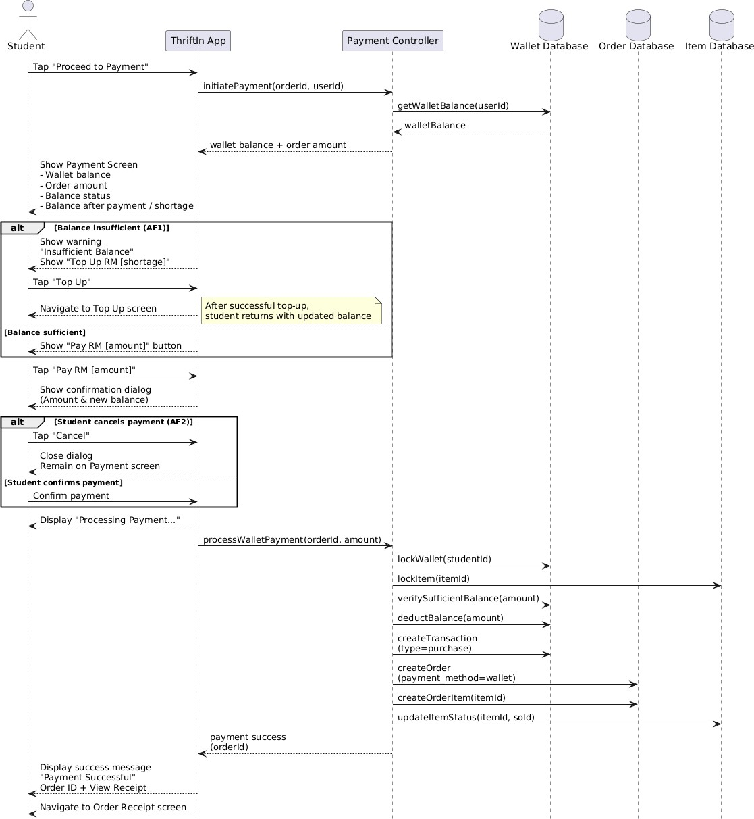
Figure 4.15: Sequence Diagram for UC038 Make Payment

4.3.5 UC039 VIEW ORDER HISTORY

Use Case Name: View Order History
Use Case ID: UC039
Actors: Student
Preconditions:
- The student must be logged in into ThriftIn UTM.
Flow of Events:
- The student navigates to the Profile tab and taps “My Orders”.
- The system retrieves all orders where the student is the buyer.
- The system displays orders in reverse chronological order (newest first).
- Each order card displays:
  - Item thumbnail image
  - Item name
  - Order ID
  - Order date and time
  - Total amount
  - Payment method
  - Order status badge (Completed/Cancelled)
- The student scrolls through the order history list.
- The student taps any order card to view a detailed receipt.
Alternative Flow:
AF1: No Order History
- If a student has never made a purchase, the system displays an empty state.
- The system shows an illustration and the message “No orders yet”.
- The system shows “Start shopping and your purchases will appear here” message.
- The system shows a “Start Shopping” button that navigates to the Home screen.
Post-conditions:
- All student’s orders are displayed in chronological order.
- The student can access detailed receipts for any order by tapping it
- Order statuses are clearly indicated with visual badges.
Table 4.13: Use Case Specification for UC039 View Order History

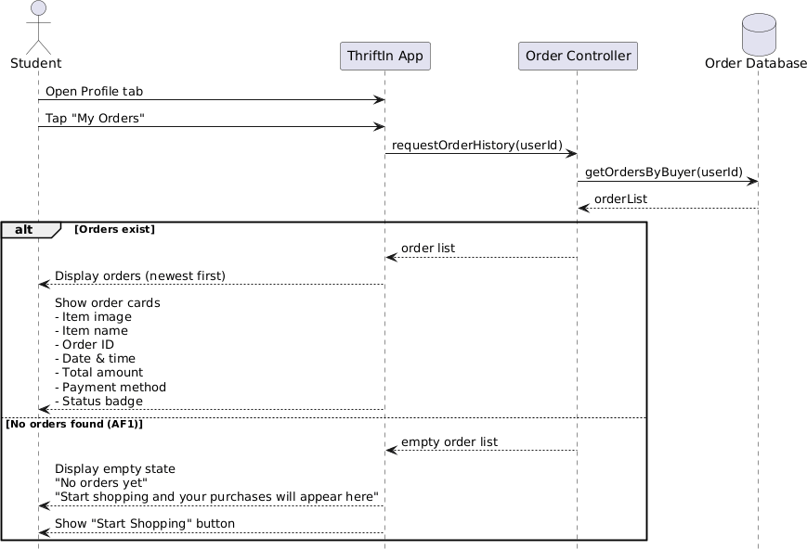
Figure 4.16: Sequence Diagram for UC039 View Order History

4.3.6 UC040 VIEW ORDER RECEIPT

Use Case Name: View Order Receipt
Use Case ID: UC040
Actors: Student
Preconditions:
- The student must be logged in into ThriftIn UTM.
- Order must exist and belong to the student.
Flow of Events:
- The student taps on an order from Order History, OR
- The student is redirected here after successful payment.
- The system retrieves complete order details including:
  - Order record from orders table
  - Product details snapshot from order_items table
  - Seller information
  - Wallet transaction record
- The system calculates if order can be cancelled (within 24 hours).

- The system displays receipt screen showing:
  - “Order Receipt” title
  - Order ID in large font
  - Status Badge: Green “✓ Completed” or Red “✕ Cancelled”
  - Product section with image, name, category, condition, description
  - Order Information: Purchase date/time, payment method
  - Seller Information: Name, email, contact button
  - Payment Summary: Item price, total paid
  - Next Steps instructions (if completed)
  - Cancellation notice (if cancelled)
- The student can tap “Contact Seller” to contact the seller.
- The student can tap “Share Receipt” to share through chat or email.
- The student can tap “Cancel Order” if within a 24-hour window.
Alternative Flow:
AF1: Order Not Found
- If the order doesn’t exist or doesn’t belong to the student, the system shows error with error message “Order not found”.
- The system navigates back to Order History.
AF2: Order is Cancelled
- If order status is ‘cancelled’, receipt shows:
  - Red “✕ Cancelled” status badge
  - Cancellation date and time
  - Cancelled notice card explaining item returned to marketplace and amount refunded
  - “Cancel Order” button is hidden
  - All other information remains visible for record-keeping
Post-conditions:
- Complete order receipt is displayed with all purchase details.
- The student has proof of purchase for coordination with the seller.
- The student can share receipt or cancel order if eligible.
- Cancellation eligibility is clearly indicated.
Table 4.14: Use Case Specification for UC040 View Order Receipt

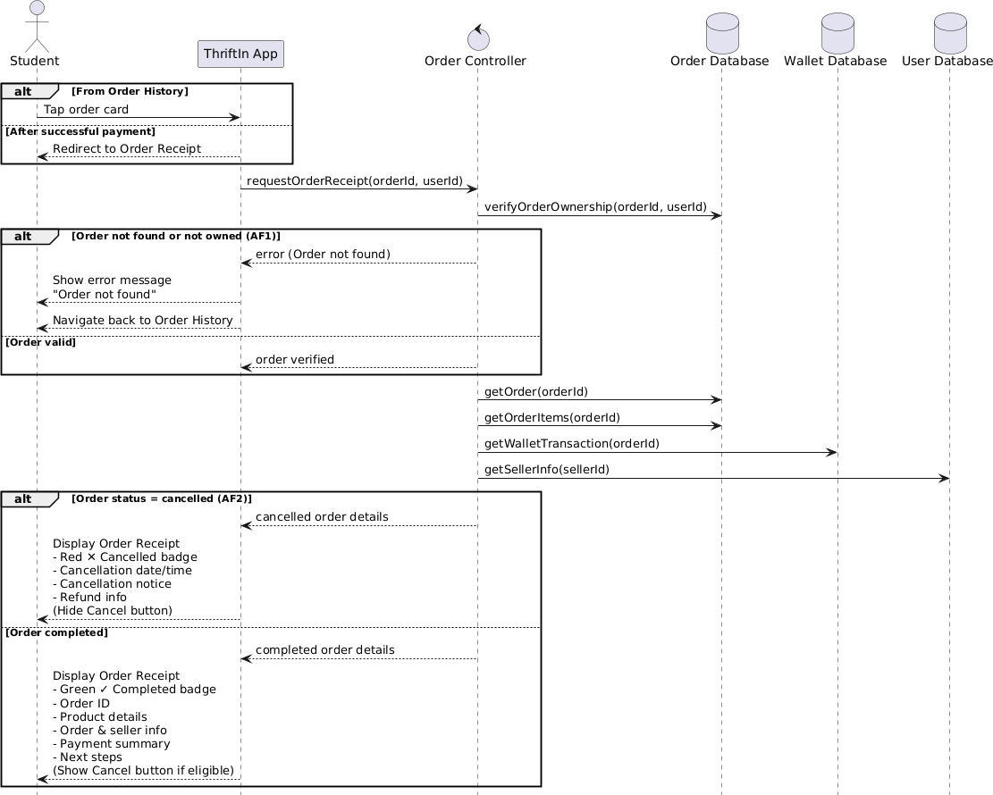
Figure 4.17: Sequence Diagram for UC040 View Order Receipt

4.3.7 UC041 CANCEL ORDER

Use Case Name: Cancel Order
Use Case ID: UC041
Actors: Student
Preconditions:
- The student must be logged in and viewing an order receipt.
- The order must belong to the student.
- The order was placed within the last 24 hours.
- Order status must be ‘completed’ (not already ‘cancelled’).
Flow of Events:
- The student is viewing the Order Receipt screen.
- The system calculates time since order was placed.
- If less than 24 hours, “Cancel Order” button is visible and enabled.
- The student taps the “Cancel Order” button.

- The system displays confirmation dialog:
  - Title: “Cancel Order?”
  - Message: “Are you sure you want to cancel this order? The item will be returned to the marketplace and other buyers can purchase it.”
  - Two buttons: “No, Keep Order” and “Yes, Cancel”
- The student taps “Yes, Cancel” to confirm.
- The system performs atomic transaction:
  - Updates order status from ‘completed’ to ‘cancelled’ in orders table
  - Records cancellation timestamp in cancelled_at field
  - Updates item status from ‘sold’ back to ‘active’ in products table
  - Refunds full amount to student's wallet
  - Creates wallet transaction record with type ‘refund’
- The system displays a success message: “Order cancelled successfully. Amount refunded to your wallet. Items returned to the marketplace.”
- The system refreshes the receipt screen showing updated ‘Cancelled’ status.
- The item immediately appears back in the marketplace for other buyers.
- Wallet balance is increased by the refund amount.
Alternative Flow:
AF1: Cancellation Period Expired
- The system calculates orders older than 24 hours.
- “Cancel Order” button is disabled or hidden.
- The small text below displays: “Cancellation period expired (24 hours)”.
- The student cannot cancel the order.
AF2: Student Declines Confirmation
- The student taps “No, Keep Order” on the confirmation dialog.
- The dialog closes and the system remains on the receipt screen.
- No changes are made to order or item status.
Post-conditions:
- Order status is updated to ‘cancelled’.
- Order receipt displays “Cancelled” status badge.
- Cancellation timestamp is recorded.
- Item status returns to ‘active’.
- The item appears in the marketplace again for other buyers.
- The full amount is refunded to the student’s wallet.
- Wallet transaction shows the refund.
- “Cancel Order” button is no longer available for this order.
Table 4.15: Use Case Specification for UC041 Cancel Order

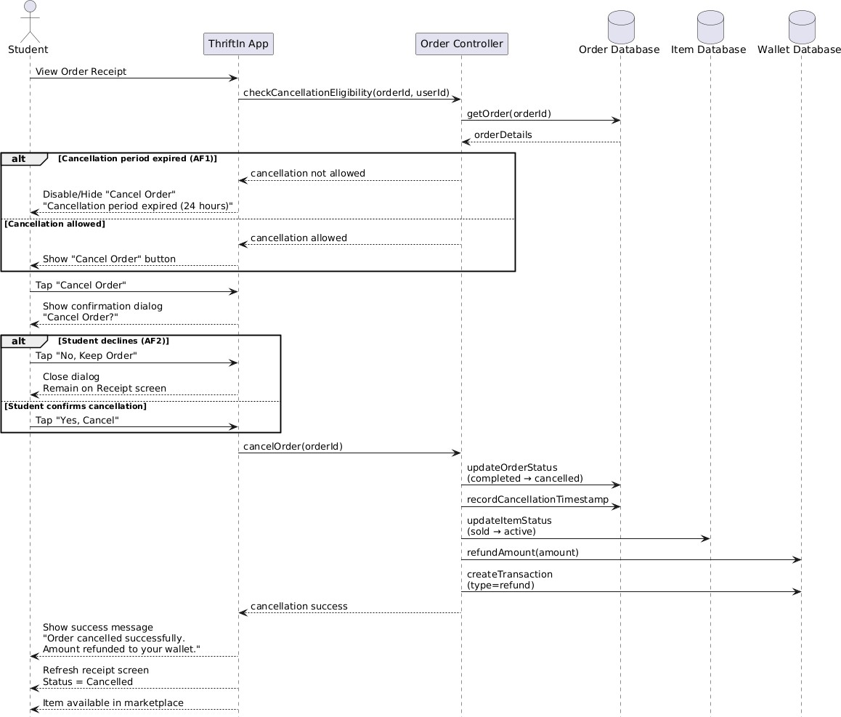
Figure 4.18: Sequence Diagram for UC041 View Order Receipt

5.0 ANALYTICS AND INSIGHTS SUBSYSTEM SPECIFICATION

5.1 USER ACTIVITY DASHBOARD MODULE (ASILAH)

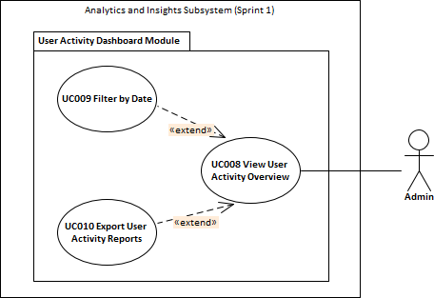

Figure 5.1 Use case diagram User Activity Dashboard Module

The Analytics and Insights Subsystem includes the User Activity Dashboard Module, which consists of three main use cases, UC008 View User Activity Overview, UC009 Filter by Date, and UC010 Export User Activity Reports. This module is exclusively accessible to Admin users and is designed to provide real-time analytical insights into user behavior within the ThriftIn UTM platform. It serves as a monitoring tool to help administrators understand system usage trends, user engagement levels, and overall platform activity for evaluation and improvement purposes.

For UC008 View User Activity Overview, the system retrieves real-time data from processed summary tables in the database to ensure fast and efficient data presentation without overloading the system with raw log processing. The displayed analytics include the total number of registered users, the number of active users, and the total number of login sessions. In this context, active users are defined as users who have logged into the application within the past seven days, while login sessions represent the total number of times users open and access the application (each app launch is counted as one login session). These metrics are visually presented in the form of a monthly login trend graph, allowing the Admin to observe user activity patterns, growth trends, and system engagement over time.

Next, UC009 Filter by Date allows the Admin to customize the displayed analytics based on

different time ranges, namely “Today”, “This Month”, and “All Time”. When a filter is applied, the system dynamically updates the dashboard by retrieving real-time processed data corresponding to the selected period. The Admin also has the option to reset the filter, which refreshes the dashboard and reloads the most current data from the database. This feature enables more focused analysis by helping the Admin compare user activity across different time frames.

Finally, UC010 Export User Activity Reports allows the Admin to generate and download a complete report of the user activity analysis in PDF format. The exported report contains only tabular data such as total users, active users, and login session counts based on the selected filter, without including graphical charts. This feature is useful for documentation, reporting, and offline analysis. Since access to this module is restricted to Admin users, no additional verification step is required before exporting the report, keeping the process simple while still maintaining system security through role-based access control.

Overall, the User Activity Dashboard Module provides a structured and efficient way for administrators to monitor user engagement. By offering real-time analytics, flexible filtering options, and downloadable reports, this module supports informed decision-making and contributes towards improving the performance and user experience of the ThriftIn UTM marketplace.

5.1.1 UC008: VIEW USER ACTIVITY OVERVIEW

Use Case: View User Activity Overview
ID: UC008
Actor: Admin
Preconditions:
- Admin must be authenticated and authorized to access the dashboard.
- User activity data must be stored and updated in the system database.
Flow of events:
- Admin selects “User Activity Dashboard” from the analytics menu.
- The system retrieves and aggregates user activity data from the database.
- Dashboard displays:
  - Total number of users
  - Total active users monthly and daily
  - Login frequency per user
  - User composition by year of study
  - Average session duration or interaction count
- Admin can interact with charts, tables, or graphs for more insight.

Alternate Flows:
1. If no data is available, the system shows “No activity data available.”
Postconditions:
1. Admin successfully views activity summary and analytics visuals.
Table 5.1 Use Case Description View User Activity Overview
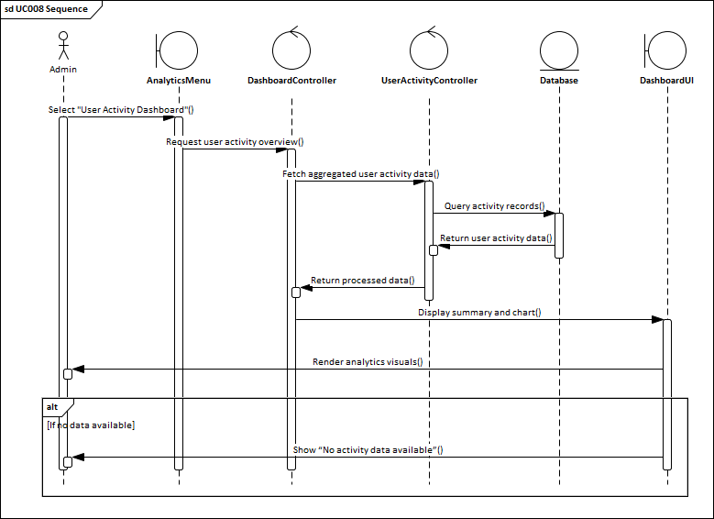
Figure 5.2 Sequence Diagram UC008 View User Activity Overview

5.1.2 UC009: FILTER ACTIVITY BY DATE

Use Case: Filter Activity by Date
ID: UC009
Actor: Admin
Preconditions:
- Admin is currently viewing the dashboard (UC008).
Flow of events:
- Admin selects the date filter option.
- Admin chooses predefined things such as “This month” or “Today”.
- The system retrieves and updates dashboard analytics to show only activities within the selected period.
Postconditions:

1. Dashboard refreshes with filtered data.

Table 5.2 Use Case Description Filter Activity by Date

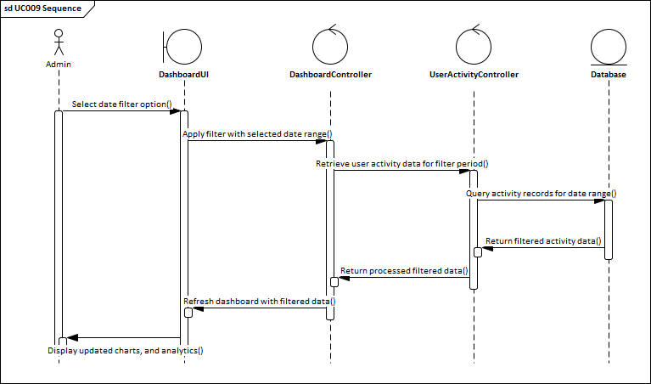
Figure 5.3 Sequence Diagram UC009 Filter Activity by Date

5.2.3 UC010: EXPORT USER ACTIVITY REPORTS

Use Case: Export User Activity Reports
ID: UC010
Actor: Admin
Preconditions:
- Admin is currently viewing the dashboard (UC008).
- Filtered or full data is loaded.
Flow of events:
- Admin clicks “Export Report.”
- The system generates reports with all analytics and timestamps in PDF format.
- The system downloads the file to the admin's device.
Alternate Flows:
- If the system detects no data currently displayed (UC008 is in alternate flow), the “Export Report” button is displayed in a disabled or lighter color to indicate inactivity.
- Admin must perform UC008 again to refresh data before exporting.
Postconditions:
- The report is generated and downloaded.
Table 5.3 Use Case Description Export User Activity Reports

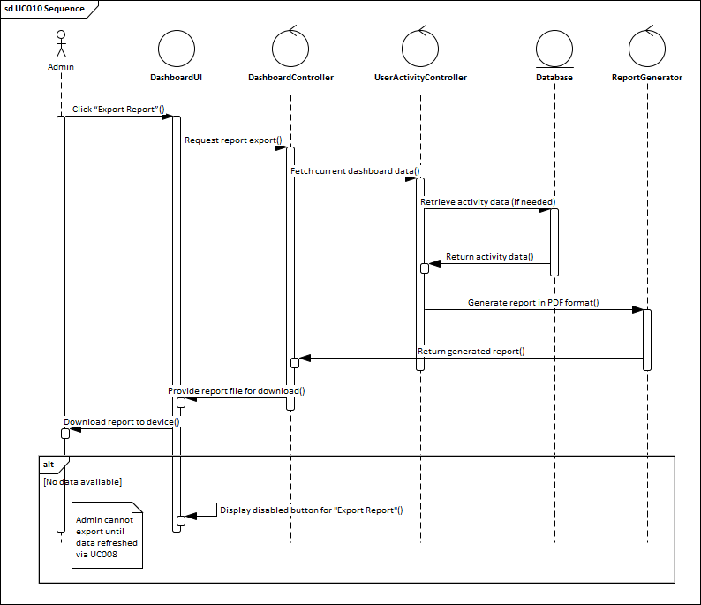
Figure 5.4 Sequence Diagram UC010 Export User Activity Reports

5.2 SALES & PERFORMANCE MODULE (ASILAH)

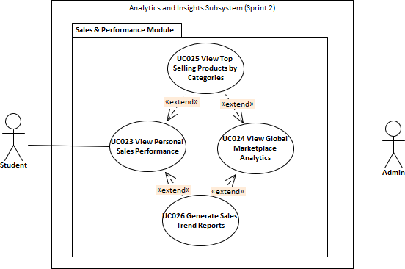

Figure 5.5 Use case diagram Sales and Performance Module

The Sales & Performance Module includes four main use cases, UC023 View Personal Sales Performance, UC024 View Global Marketplace Analytics, UC025 View Top Selling Products by Category, and UC026 Generate Sales Trend Reports. This module is accessible to both Students and Admins, with UC023 primarily for Students and UC024 primarily for Admins. It is designed to provide comprehensive insights into sales performance, product trends, and marketplace analytics, enabling users to monitor revenue, track product performance, and make data-driven decisions.
For UC023 View Personal Sales Performance, the system retrieves real-time sales data specific to the logged-in student from the database to present an accurate overview of individual performance. The displayed analytics include total revenue, total items sold, and sales trends over time. These metrics are visually represented using charts and tables, allowing students to track their performance patterns, identify top-selling products in their own listings, and evaluate growth over time.

Next, UC024 View Global Marketplace Analytics allows Admin users to access aggregated sales data across the entire marketplace. The system processes and summarizes sales records to provide efficient and responsive analytics without overloading the database. The displayed metrics include total marketplace revenue, overall sales trends, and category-level performance. This use case helps Admins monitor overall marketplace activity, identify high-performing sellers or categories, and make strategic decisions based on global trends.
UC025 View Top Selling Products by Category extends UC023 and UC024 by providing detailed insights into the highest-selling products within each category. For students, this includes their own top-selling items, while Admins see marketplace-wide top products. The system dynamically generates lists of top products based on sales volume and revenue, enabling both Students and Admins to recognize best-performing items and optimize sales strategies accordingly.
Finally, UC026 Generate Sales Trend Reports also extends UC023 and UC024, allowing Students and Admins to generate and download detailed sales trend reports in PDF format. The reports include metrics such as revenue trends, top-selling products, and category performance over selected time periods. This feature supports offline analysis, documentation, and strategic planning. Access is granted based on the user role, ensuring that reports are generated only for relevant data without additional verification steps.
Overall, the Sales & Performance Module provides a structured and efficient way for both students and administrators to monitor sales activity. By offering personalized performance views, global marketplace analytics, top-product insights, and downloadable reports, this module supports informed decision-making and contributes toward improving sales outcomes and marketplace management within the ThriftIn UTM platform.

5.2.1 UC023: VIEW PERSONAL SALES PERFORMANCE

Use Case: View Personal Sales Performance
ID: UC023
Actor: Student
Preconditions:
- Student is successfully logged in.
- Student has sales data available in the database.
Flow of events:
- Student selects “View Personal Sales Performance” from the dashboard.
- The system fetches sales data for the logged-in student.
- The system fetches sales trends for the student.
- Dashboard displays:
  - Total revenue.
  - Total items sold.
  - Top categories with items sold and revenue.
  - Sales trend chart with interactive tooltips.
- Student can tap a category to view detailed products in that category.
Alternate Flows:
- If no student ID is provided or no data exists, display a message: “No student selected. Contact admin or select a student to view personalized data.”
Postconditions:
- Student successfully views up-to-date sales performance metrics and trends.
Table 5.4: Use Case Description View Personal Sales Performance

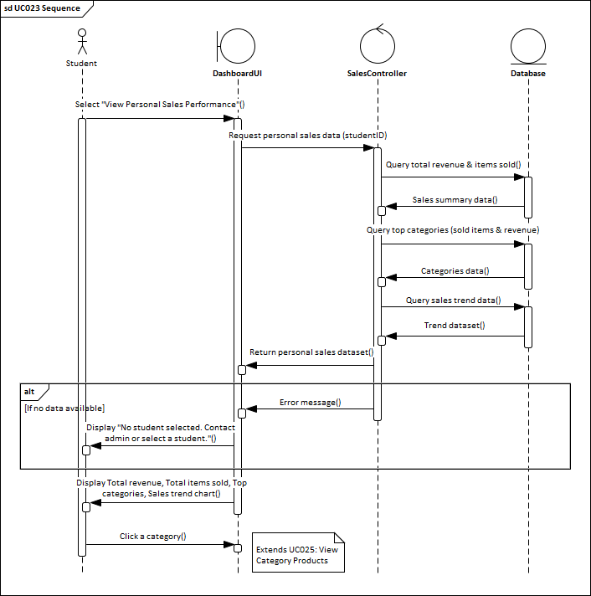
Figure 5.6 Sequence Diagram UC023 View Personal Sales Performance

5.2.2 UC024: VIEW GLOBAL MARKETPLACE ANALYTICS

Use Case: View Global Marketplace Analytics
ID: UC024
Actor: Admin
Preconditions:
- Admin is successfully logged in.
- Sales and user data exist in the database.
Flow of events:
- Admin selects “View Global Marketplace Analytics” from the dashboard.
- The system fetches all sales data.
- The system fetches global sales trends.
- Dashboard displays:
  - Total revenue.
  - Total items sold.
  - Top categories with items sold and revenue.
  - Top sellers with items sold and revenue.
  - Global sales trend chart with interactive tooltips.
- Admin can tap a category to view detailed products in that category.
Alternate Flows:
- If no sales exist, dashboard shows empty states with appropriate messages.
Postconditions:
- Admin successfully views global sales analytics and can drill down into categories and products.
Table 5.5: Use Case Description View Global Marketplace Analytics

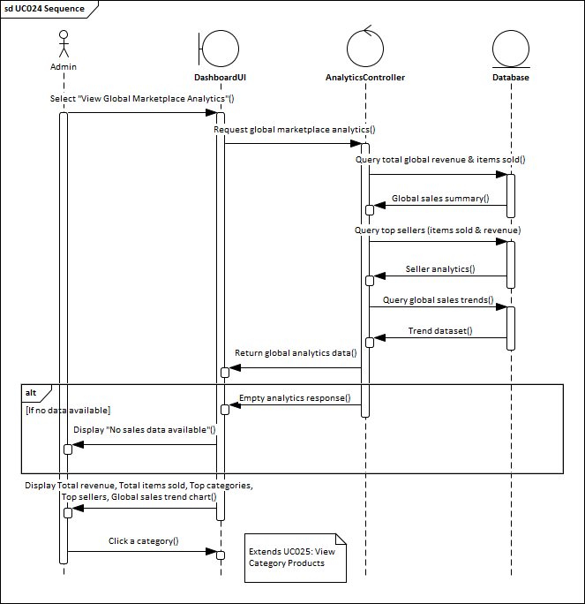
Figure 5.7 Sequence Diagram UC024 View Global Marketplace Analytics

5.2.3 UC025: VIEW TOP SELLING PRODUCTS BY CATEGORIES

Use Case: View Top Selling Products by Categories
ID: UC025
Actor: Admin, Student
Preconditions:
- User is currently viewing the dashboard (UC023).
- Sales data exists for the category.
Flow of events:
- User click on a category in the dashboard.
- The system navigates to the Category Products page.
- The system fetches products for the selected category.
- Page displays:
  - Category name.
  - Total number of products in the category.
  - Total revenue from the category.
  - List of products with sold count and revenue.
Postconditions:
1. User successfully views category-level product performance and sales metrics.
Table 5.6: Use Case Description View Top Selling Products by Categories

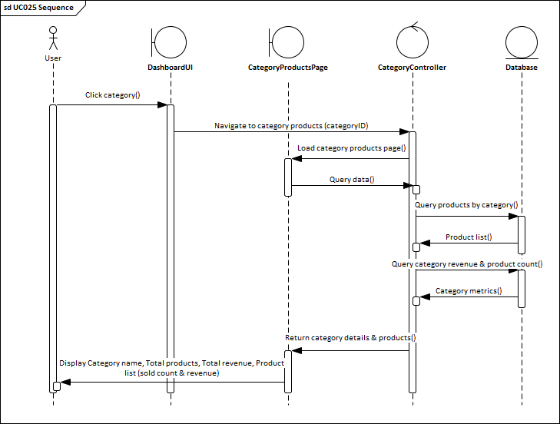
Figure 5.8: Sequence Diagram UC025 View Top Selling Products by Categories

5.2.4 UC026: GENERATE SALES TREND REPORTS

Use Case: Generate Sales Trend Reports
ID: UC026
Actor: Admin, Student
Preconditions:
- User is currently viewing the dashboard (UC023).
- Sales data exists for the user or marketplace.
- Device supports sharing or saving files.
Flow of events:
- User taps the “Export Report”.
- System generates a PdF report containing:
  - Total revenue.
  - Total items sold.
  - Top categories.
  - Top sellers (if admin).
  - Sales trend chart image.
5. The system downloads the file to the admin's device.
Alternate Flows:
- If the system detects no data currently displayed (UC008 is in alternate flow), the “Export Report” button is displayed in a disabled or lighter color to indicate inactivity.
- Admin must perform UC008 again to refresh data before exporting.
Postconditions:
- The report is generated and downloaded.
Table 5.7: Use Case Description Generate Sales Trend Reports

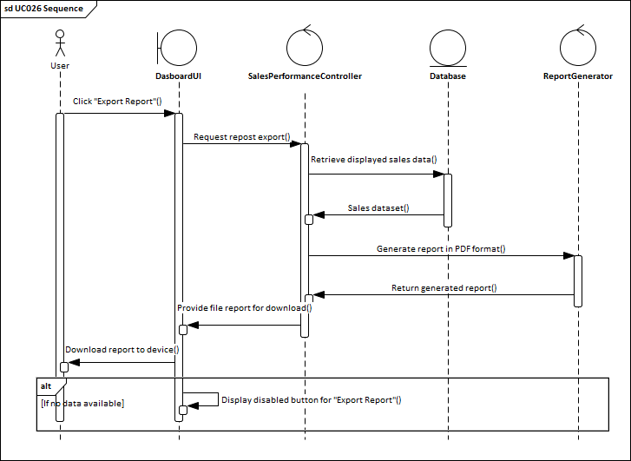
Figure 5.9 Sequence Diagram UC026 Generate Sales Trend Reports

5.3 BUYER SPENDING SUMMARY MODULE (ASILAH)
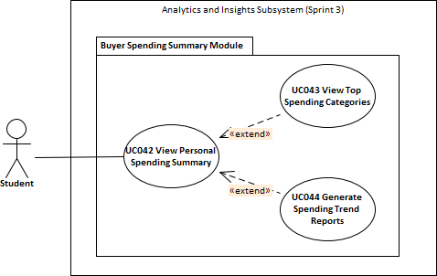
Figure 5.10: Package Diagram of Buyer Spending Summary Module

SPECIFIC REQUIREMENT
The Analytics and Insights Subsystem includes the Personal Spending Dashboard Module, which consists of three main use cases, UC042 View Personal Spending Summary, UC043 View Top Spending Categories, and UC044 Generate Spending Trend Reports. This module is exclusively accessible to Student users and is designed to provide personalized insights into individual spending behavior within the ThriftIn UTM platform. It serves as a self-monitoring tool to help students understand their spending patterns, track expenses, and make informed purchasing decisions.

For UC042 View Personal Spending Summary, the system retrieves the student’s spending data from processed summary tables in the database to ensure fast and efficient data presentation. The dashboard displays total spending, total items bought, top spending categories with items purchased and total spending, and a spending trend chart with interactive tooltips. Students can also tap a category to view detailed products within that category. If no spending data exists for the student, a message is displayed: “No data available.” This ensures clarity and prevents confusion when personalized data is unavailable. The module updates the displayed analytics in real-time to reflect the most current spending behavior.

Next, UC043 View Top Spending Categories allows students to focus on category-specific spending patterns. By tapping a category on the dashboard, the system navigates to the Category Products page, fetching and displaying products associated with the selected category along with total

spending and number of items purchased. The dashboard also continues to provide the overall spending summary and trend chart for context. If no spending categories exist, a message “No categories available” is displayed to inform the student. This feature enables students to quickly identify their highest spending categories and manage their budgets more effectively.

Finally, UC044 Generate Spending Trend Reports allows students to export a complete summary of their spending behavior in PDF format. The exported report contains total spending, total items bought, top categories, and a snapshot of the spending trend chart. The report can be saved or shared for personal reference, financial planning, or documentation purposes. If the system detects no spending data, the “Export Report” button is displayed in a disabled state to indicate inactivity. Access to this feature is restricted to the logged-in student, ensuring that personal spending data remains private and secure.

Overall, the Personal Spending Dashboard Module provides a structured and interactive interface for students to monitor and analyze their spending patterns. By offering personalized summaries, category-specific insights, interactive trend visualization, and downloadable reports, this module supports financial awareness and informed decision-making, enhancing the user experience of the ThriftIn UTM marketplace.

5.3.1 UC042 : VIEW PERSONAL SPENDING SUMMARY
Use Case Name: View Personal Spending Summary
Use Case ID: UC042
Actors: Student
Preconditions:
- The student is successfully logged in.
- Students have spending data available in the database.
Flow of Events:
- The student selects “View Personal Spending Summary” from the dashboard.
- The system fetches spending data for the logged-in student.
- Dashboard displays:
  - Total spending.
  - Total items bought.
  - Top categories with items bought and total spending.
  - Spending a trend chart with interactive tooltips.
- Students can tap a category to view detailed products in that category.
- Students can tap Export Report to export PDF reports.
Alternative Flow:
- If no student ID is provided or no data exists, display a message: “No student selected. Contact admin or select a student to view personalized data.”
Post-conditions:
- Students successfully view up-to-date personal spending metrics and trends.
Table 5.8: Use Case Description View Personal Spending Summary

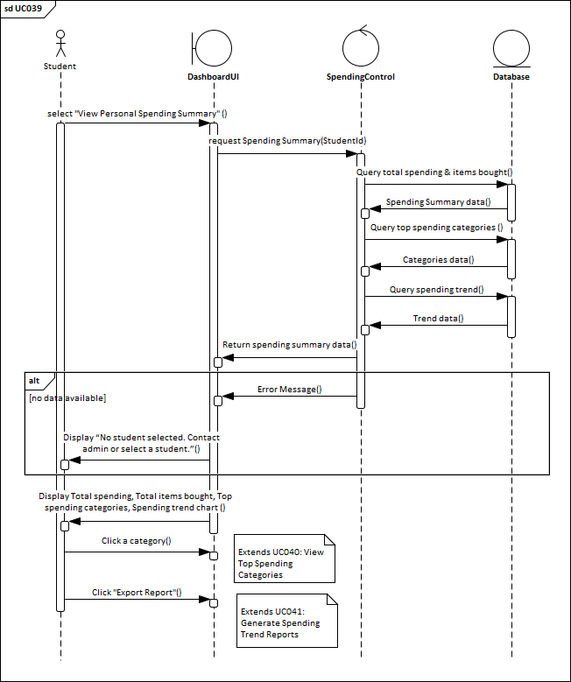
Figure 5.11 Sequence Diagram UC042 View Personal Spending Summary

5.3.2 UC043 : VIEW TOP SPENDING CATEGORIES

Use Case Name: View Top Spending Categories
Use Case ID: UC043
Actors: Student
Preconditions:
1. The user is currently viewing the dashboard (UC039).

2. Spending data exists for the category.
Flow of Events:
- Users click on a category in the dashboard.
- The system navigates to the Category Products page.
- The system fetches products for the selected category.
- The dashboard displays a list of categories with spending details.
- The system fetches spending data for the logged-in student.
- Dashboard displays:
  - Total spending.
  - Total items bought.
  - Top categories with items bought and total spending.
  - Spending a trend chart with interactive tooltips.
- Students can tap a category to view detailed products in that category.
- Students can tap Export Report to export PDF reports.
Alternative Flow:
- If no spending categories are available, display “No categories available.”
Post-conditions:
- Students successfully view category-specific spending details.
Table 5.9: Use Case Description View Top Spending Categories

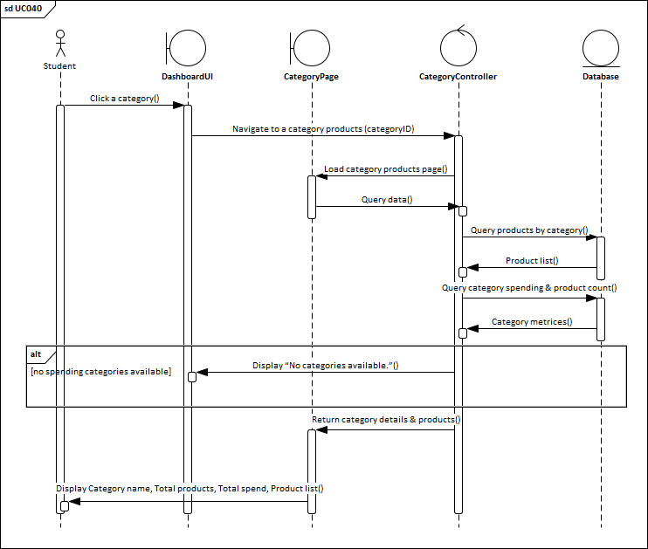
Figure 5.12: Sequence Diagram UC043 View Top Spending Categories

5.3.3 UC044 : GENERATE SPENDING TREND REPORTS
Use Case Name: Generate Spending Trend Reports
Use Case ID: UC044
Actors: Student
Preconditions:
- The user is currently viewing the dashboard (UC039).
- Spending data exists for the student.
- The device supports sharing or saving files.
Flow of Events:
- The user taps the “Export Report”.
- System generates a PdF report containing:
  - Total spending.
  - Total items bought.
  - Top categories.
  - Spending trend chart image.

3. The system downloads the file to the admin's device.
Alternative Flow:
1. If the system detects no data currently displayed (UC039 is in alternate flow), the “Export Report” button is displayed in a disabled or lighter color to indicate inactivity.
Post-conditions:
1. The report is generated and downloaded.
Table 5.10: Use Case Description Generate Spending Trend Reports

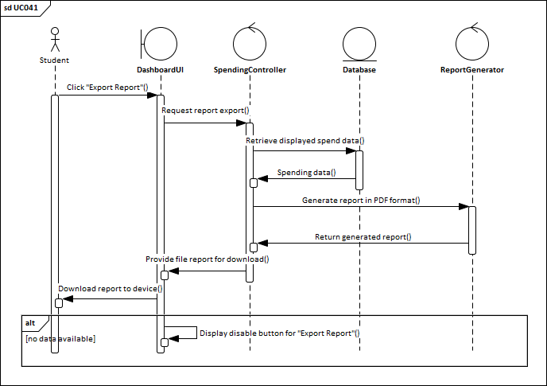
Figure 5.13: Sequence Diagram UC044 Generate Spending Trend Reports

6.0 COMMUNICATION AND SUPPORT SUBSYSTEM SPECIFICATION

6.1 CHAT & MESSAGING MODULE (JIA YING)

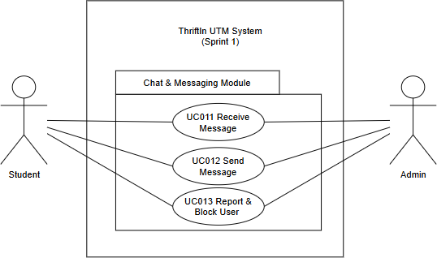
Figure 6.1: Packaging Diagram for Chat and Messaging Module

The Chat and Messaging Module consists of three main use cases: UC011 Receive Message, UC012 Send Message, and UC013 Report and Block User. This module facilitates secure communication between buyers and sellers in the Thriftin UTM textbook marketplace by providing real-time messaging capabilities,
AI-powered shopping assistance, and user safety features. It serves as the primary communication channel for negotiating prices, arranging meetups, and asking questions about textbook listings while maintaining a safe environment through comprehensive reporting and blocking mechanisms.

In UC011 Receive Message, users receive messages from other students, sellers, or the AI Shopping Assistant in real-time. The chat list displays conversation previews with blue unread badges and timestamps (Just now, 2h ago, Yesterday), automatically repositioning recent conversations to the top. When viewing conversations, new messages appear in white bubbles on the left, are marked as read, and the view auto-scrolls. Users see color-coded avatars, green online dots, and "Last seen" times. The AI Assistant , pinned at top, provides instant responses. Security checks prevent blocked users from communicating by silently rejecting messages.
UC012 Send Message enables users to compose text messages up to 1,000 characters using the input field, with the red send button (➤) enabled for non-empty content. Messages transmit to the backend API, appear in red bubbles on the right with timestamps, then clear the input field. For AI conversations, keyword analysis provides textbook suggestions for budget queries and negotiation tips within 500 milliseconds. Error handling
retains failed messages for retry, shows loading indicators, and displays appropriate alerts for network failures or blocked recipients.

UC013 Report and Block User provides safety features through the three-dot menu (⋮). Reporting requires selecting one of five reasons (Spam, Scam, Harassment, Inappropriate, Other) with optional details, stores
reports as 'pending' status, and displays success confirmation without notifying reported users. Blocking shows consequence warnings, requires a reason, displays confirmation dialog, then removes the conversation from chat list. Blocking is one-directional with silent message rejection, no notifications to blocked users, and complete visibility control for blockers.

Overall, this Chat and Messaging Module establishes a comprehensive communication framework balancing functionality, security, and user experience. It provides seamless real-time messaging for buyer-seller interactions, intelligent AI assistance responding within one second to queries about textbooks and negotiation, and robust safety through reporting and blocking features. The system implements secure transmission, input validation, unread tracking, and modern chat UI conventions. The AI Assistant offers always-available help while one-directional blocking ensures user safety. Database integrity maintains foreign key constraints, creating a trustworthy platform for Thriftin UTM marketplace interactions.

6.1.1 UC011: RECEIVE MESSAGE

Use Case: Receive message
ID: UC011
Actor: User (Buyer/Seller)
Preconditions:
- User is logged in.
- User has an existing conversation.
- User is viewing either chat list or chat detail page.
- Network connection is available.
Flow of events:
- Another user or AI sends a message.
- System receives and validates the message.
- System stores the message with timestamp.
- System updates conversation and marks message as unread.
- If user is in chat list: system shows unread badge and moves chat to top.
- If user is in chat detail: system displays the message in real-time and marks it as read.
Alternate Flows:
AF1: User Offline
System stores message and delivers it when user reconnects.

AF2: Sender Blocked
System rejects message; user is not notified.

AF3: Network Lost
System queues delivery and retries when connection returns.

AF4: Receiving From AI
System adds AI styling and handles AI-specific logic.

AF5: Invalid Conversation System rejects the message.
Postconditions:
Success
Message stored and visible to user. Conversation updated and unread count applied.

Failure
Message is not stored. No notification delivered.
Table 6.1: Use case Specification for UC011

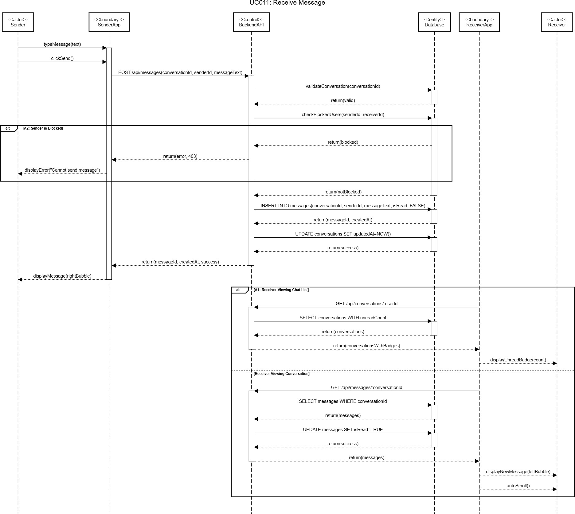
Figure 6.2: Sequence Diagram of UC011 Receive Message

6.1.2 UC012: SEND MESSAGE

Use Case: Send Message
ID: UC012
Actor: User (Buyer/Seller)
Preconditions:
- User is logged in.
- User has an active or new conversation.
- User is on the chat detail screen.
- Receiver has not blocked the sender.
- Network connection available.
Flow of events:
- User types a message.
- User taps the send button.
- System validates the message.
- System sends the message to backend.
- Backend stores the message and updates the conversation.
- System displays the message in user’s chat.
- If chatting with AI, system triggers AI response (handled in UC011).
Alternate Flows:
AF1: Empty Message
System disables send button; message is not sent.

AF2: Network Error
System shows error; user may retry.

AF3: Receiver Blocked Sender
Backend rejects message; system alerts user.

AF4: AI Quick Action Triggered
System pre-fills message and sends automatically.

AF5: Message Too Long
System truncates message to limit and warns user.

AF6: Database Error
System fails to save message; user may retry.

AF7: Invalid Conversation
The backend creates a new conversation before sending.
Postconditions:
Success
Message stored and displayed.

Conversation updated.
Failure
Message not stored.
The user sees an error and may retry.

Table 6.2: Use case Specification for UC012

I I

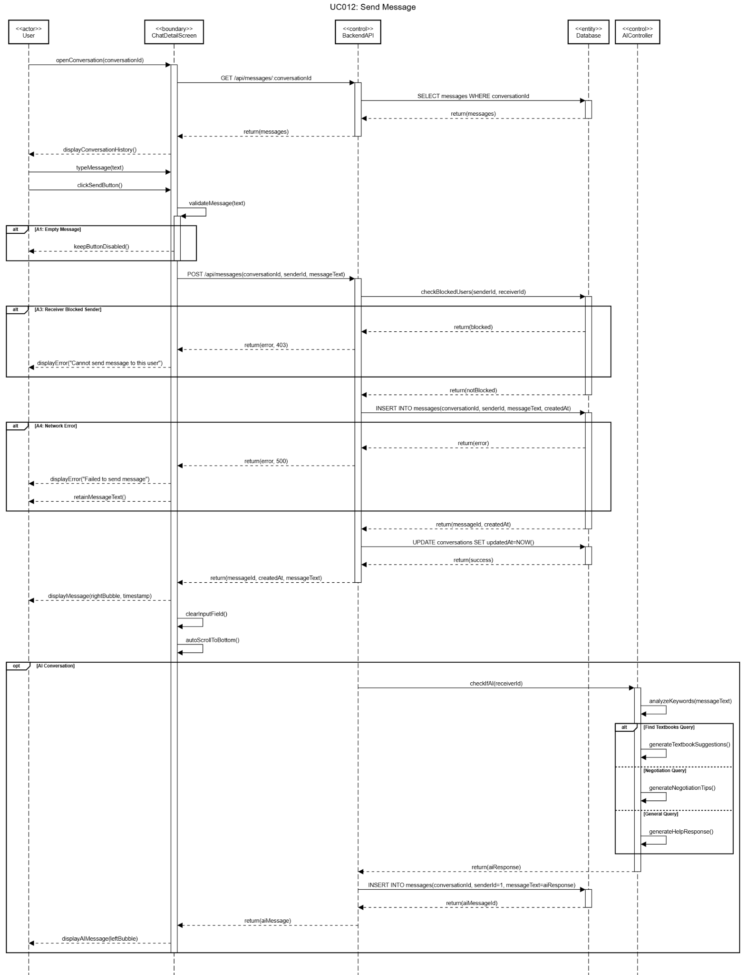
Figure 6.3: Sequence Diagram of UC012 Send Message

6.1.3 UC013: REPORT AND BLOCK USER

Use Case: Receive message
ID: UC011
Actor: User (Buyer/Seller)
Preconditions:
- The user is logged in.
- The user is inside an active conversation.
- The target user is not the AI Assistant.
- Network connection is available.
Flow of events:
Report User
- The user opens the menu in the conversation.
- User selects Report User.
- The user selects a reason and submits.
- The system validates and sends reports to the backend.
- The backend stores the report.
- The user sees confirmation.
Block User
- User selects Block User from the menu.
- The user provides a reason and confirms the block.
- The system sends a block request to the backend.
- Backend stores block records.
- Conversation is removed from the chat list.
- The user sees a success message.
Alternate Flows:
AF1: Missing Report Reason
The system prompts the user to select a reason.

AF2: Missing Block Reason
The system asks the user to enter a valid reason.

AF3: User Cancels Action
Report/block process stops; no data saved.

AF4: Network Error
The system shows error and allows retry.

AF5: User Already Blocked
The system shows a message and returns to the chat list.

AF6: Reporting/Blocking AI

The system does not show report/block options.
AF7: Target User Deleted
Backend returns error; user is informed.
Postconditions:
Success (Report)
Report saved for admin review.
Success (Block)
Block record saved; conversation removed; communication disabled.
Failure
No report/block created; user remains in chat.
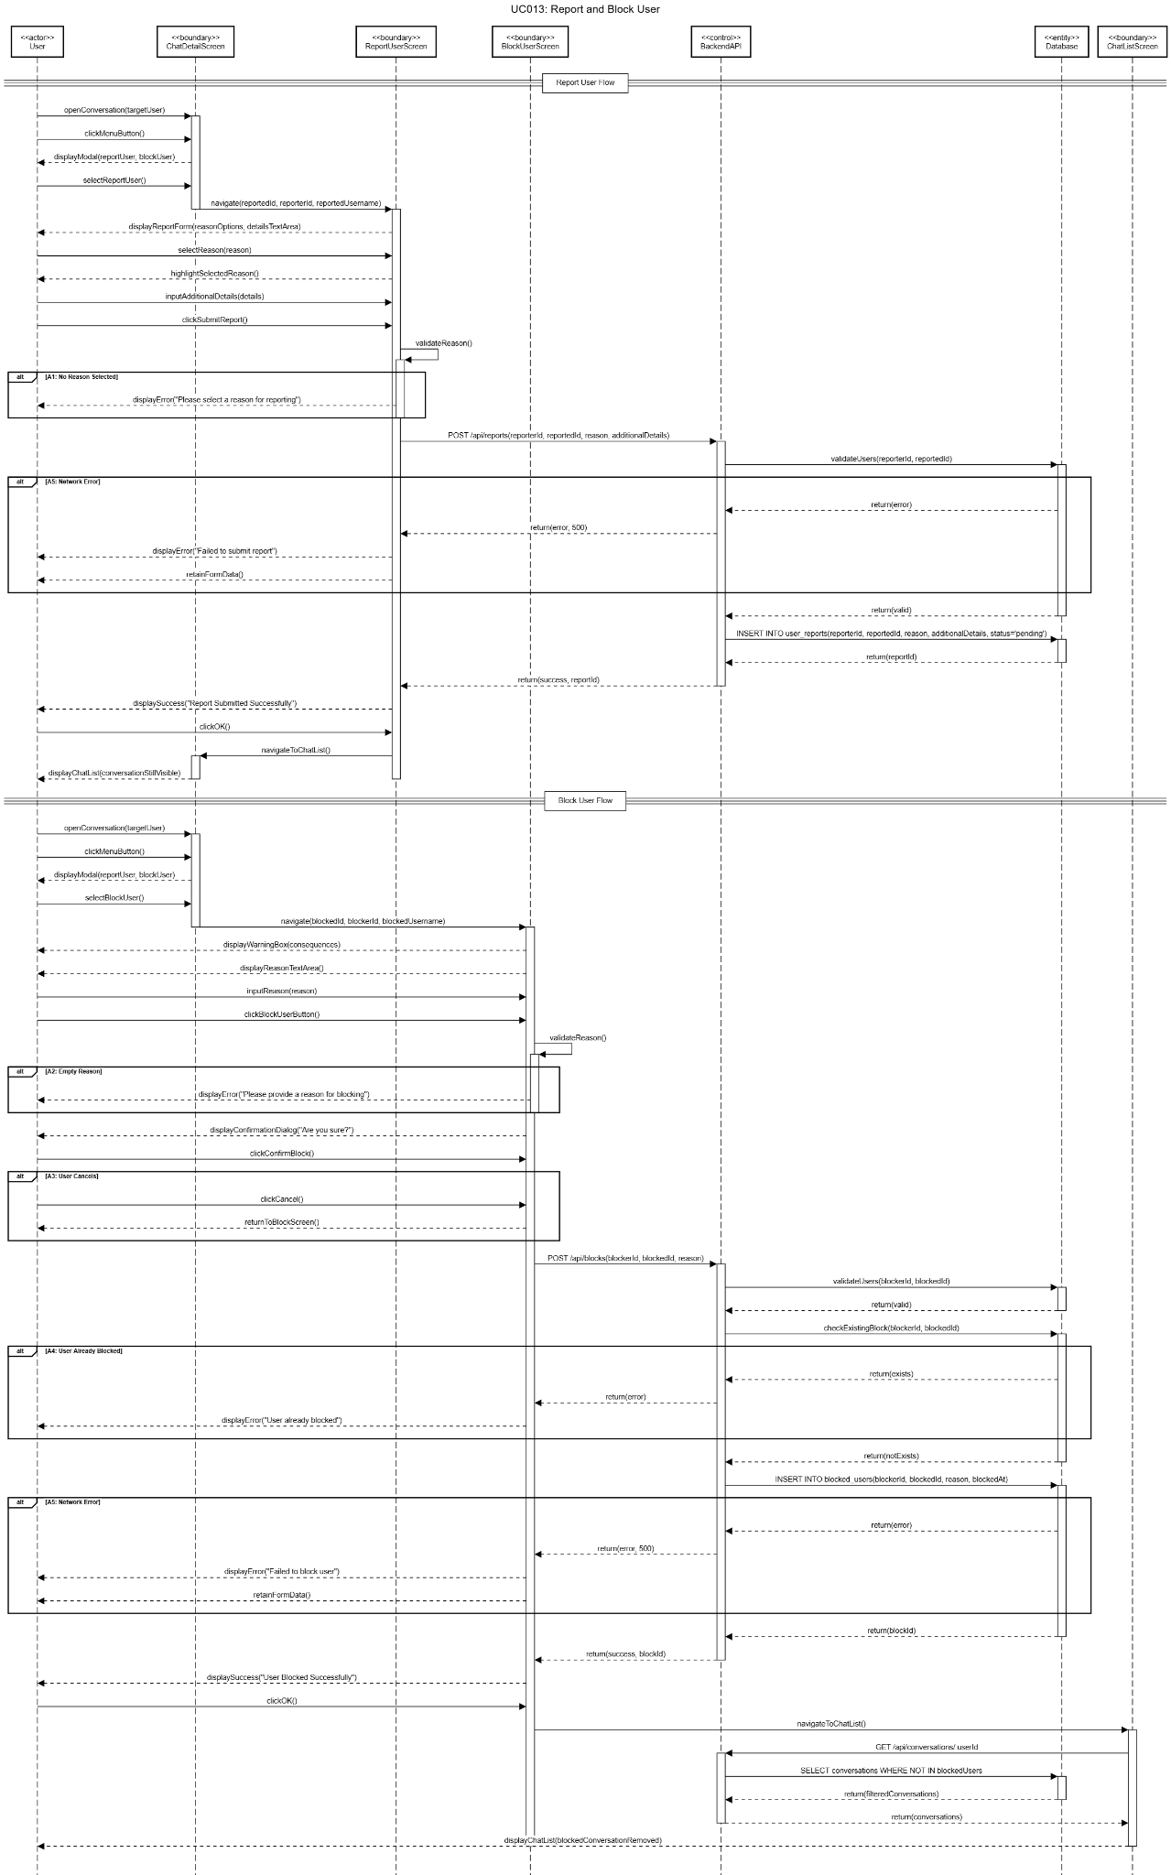

Figure 6.4: Sequence Diagram of UC013 Report and Block User

6.2 NOTIFICATION & ALERT MODULE (JIA YING)

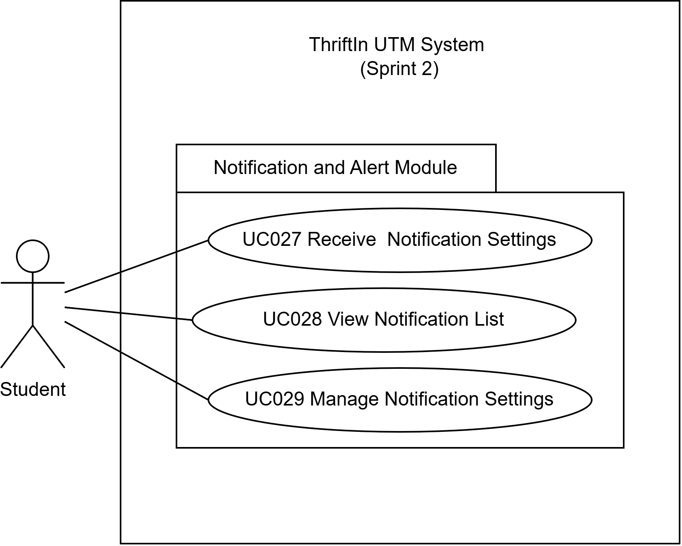
Figure 6.5: Packaging Diagram for Notification and Alert Module

Notification and Alert Module is designed to support effective communication and user engagement within the Thriftin UTM textbook marketplace. It ensures that users are promptly informed about important activities while allowing them to manage how notifications are delivered. The module consists of three main use cases: UC027 Receive Push Notification, UC028 View Notification List, and UC029 Manage Notification Settings.

Through UC027 Receive Push Notification, the system automatically generates notifications when users receive new messages from other buyers or sellers. To prevent notification overload, messages generated by the AI Shopping Assistant do not trigger notifications, as they are delivered instantly within the chat interface. Notification creation follows user-defined preferences, ensuring alerts are only sent when enabled. Unread notifications are reflected through a badge on the bell icon, allowing users to quickly identify pending messages that require attention.

UC028 View Notification List provides users with a centralized screen to review all notifications. Notifications are displayed in chronological order with clear visual distinction between read and unread items. Users can mark notifications as read individually or in bulk, and selecting a notification will navigate the user directly to the related chat conversation. This design allows users to efficiently manage notifications and respond promptly to marketplace interactions.

With UC029 Manage Notification Settings, users are given control over their notification experience. Users can enable or disable different notification types, and all changes are saved automatically. This ensures that notification preferences take effect immediately while maintaining at least one active notification channel to prevent users from missing critical updates. The settings interface is designed to be simple and user-friendly, supportg flexibility without compromising important communication.

Overall, the Notification and Alert Module establishes a reliable and user-centered notification system that enhances communication, improves responsiveness between buyers and sellers, and supports a smooth marketplace experience. By combining real-time alerts, organized notification management, and customizable preferences, the module plays an essential role in maintaining user engagement and ensuring timely interactions within the platform.

6.2.1 UC027: RECEIVE NOTIFICATION SETTINGS

Use Case: Receive Notification Settings
ID: UC027
Actor: User (Buyer/Seller), System
Preconditions:
- User is logged into the system
- Notification preferences are enabled
- Sender sends a message through the system
- Conversation is not an AI conversation
- Sender is not blocked
- Database is available
Flow of events:
- Sender sends a message to the user.
- System validates the conversation and participants.
- System checks if sender is blocked.
  - If blocked → AF1
- System stores the message.
- System checks if conversation is AI-based.
  - If AI conversation → AF2
- System checks notification preferences.
  - If notifications disabled → AF3
- System creates a notification record.
- System updates bell icon badge.
- Use case ends.
Alternate Flows:
AF1: Sender is blocked → message and notification are not created.

AF2: AI conversation → notification is skipped.

AF3: Notifications disabled → message delivered without notification.
Exception Flows:
EF1: Database error → notification not created, message still delivered.
Postconditions:
- Notification is created and marked unread
- Bell badge count is updated
- Message is stored successfully

Table 6.3: Use case Specification for UC027

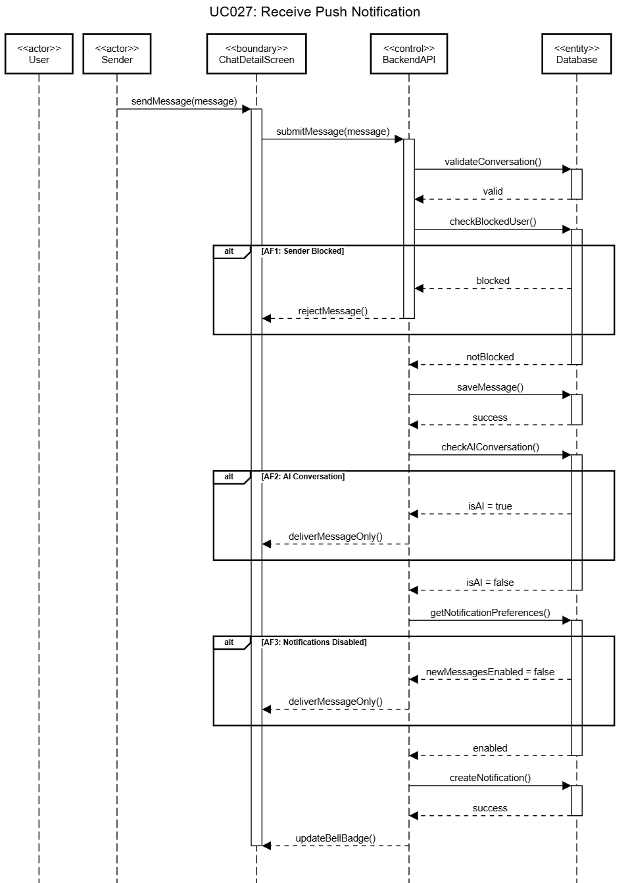
Figure 6.6: Sequence Diagram of UC027 Receive Notification Settings

6.2.2 UC028: VIEW NOTIFICATION LIST

Use Case: View Notification List
ID: UC028
Actor: User (Buyer/Seller), System
Preconditions:
- User is logged into the system
- Notification system is available
- Database connection is active
Flow of events:
- User taps the bell icon.
- System retrieves notifications for the user.
  - If no notifications → AF1
- System displays notifications in chronological order.
- User selects a notification.
- System marks notification as read.
- System opens the related conversation.
- Use case ends.
Alternate Flows:
AF1: No notifications → system displays empty state.

AF2: User selects “Mark All as Read” → all notifications marked as read.
Exception Flows:
EF1: Network error → error message displayed with retry option.
Postconditions:
- Notifications displayed correctly
- Read status updated in database
- Bell badge count updated

Table 6.4: Use case Specification for UC028

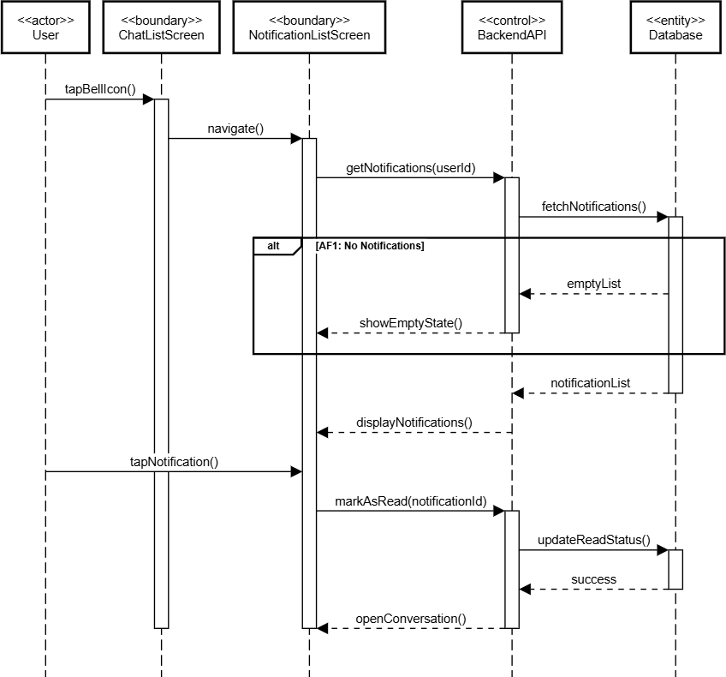
Figure 6.7: Sequence Diagram of UC028 View Notification List

6.2.3 UC029: MANAGE NOTIFICATION SETTINGS

Use Case: Manage Notification Settings
ID: UC029
Actor: User (Buyer/Seller), System
Preconditions:
- User is logged into the system
- User has access to notification settings
- Database connection is available
Flow of events:
- User opens notification settings.
- System retrieves notification preferences.
- User changes a notification setting.
- System validates at least one option remains enabled.
  - If validation fails → AF1
- System saves updated settings.
- System confirms changes.
- Use case ends.
Alternate Flows:
AF1: All options disabled → system shows warning and reverts change.

AF2: User selects “Reset to Default” → settings restored to default.
Exception Flows:
EF1: Network or database error → changes not saved and error displayed.
Postconditions:
- Notification preferences updated
- Changes applied immediately
- User returns to notification list
Table 6.5: Use case Specification for UC028

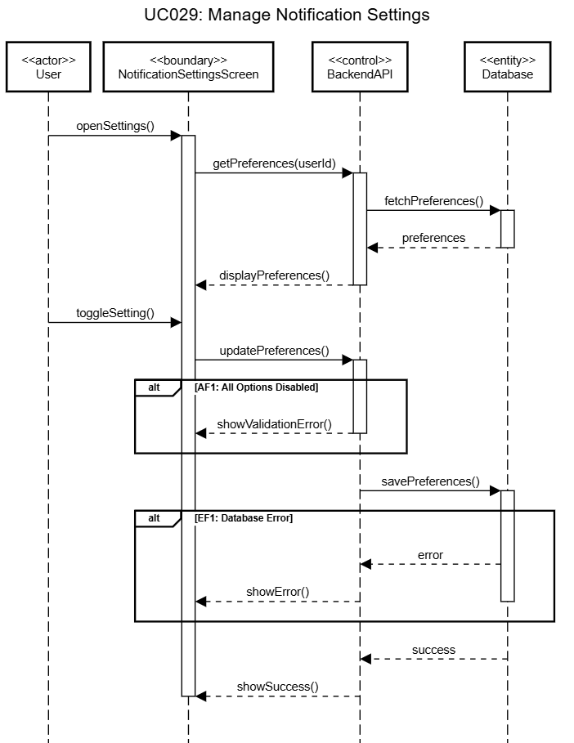

Figure 6.8: Sequence Diagram of UC029 Manage Notification Settings

6.3 HELP CENTRE AND FEEDBACK MODULE (JIA YING)

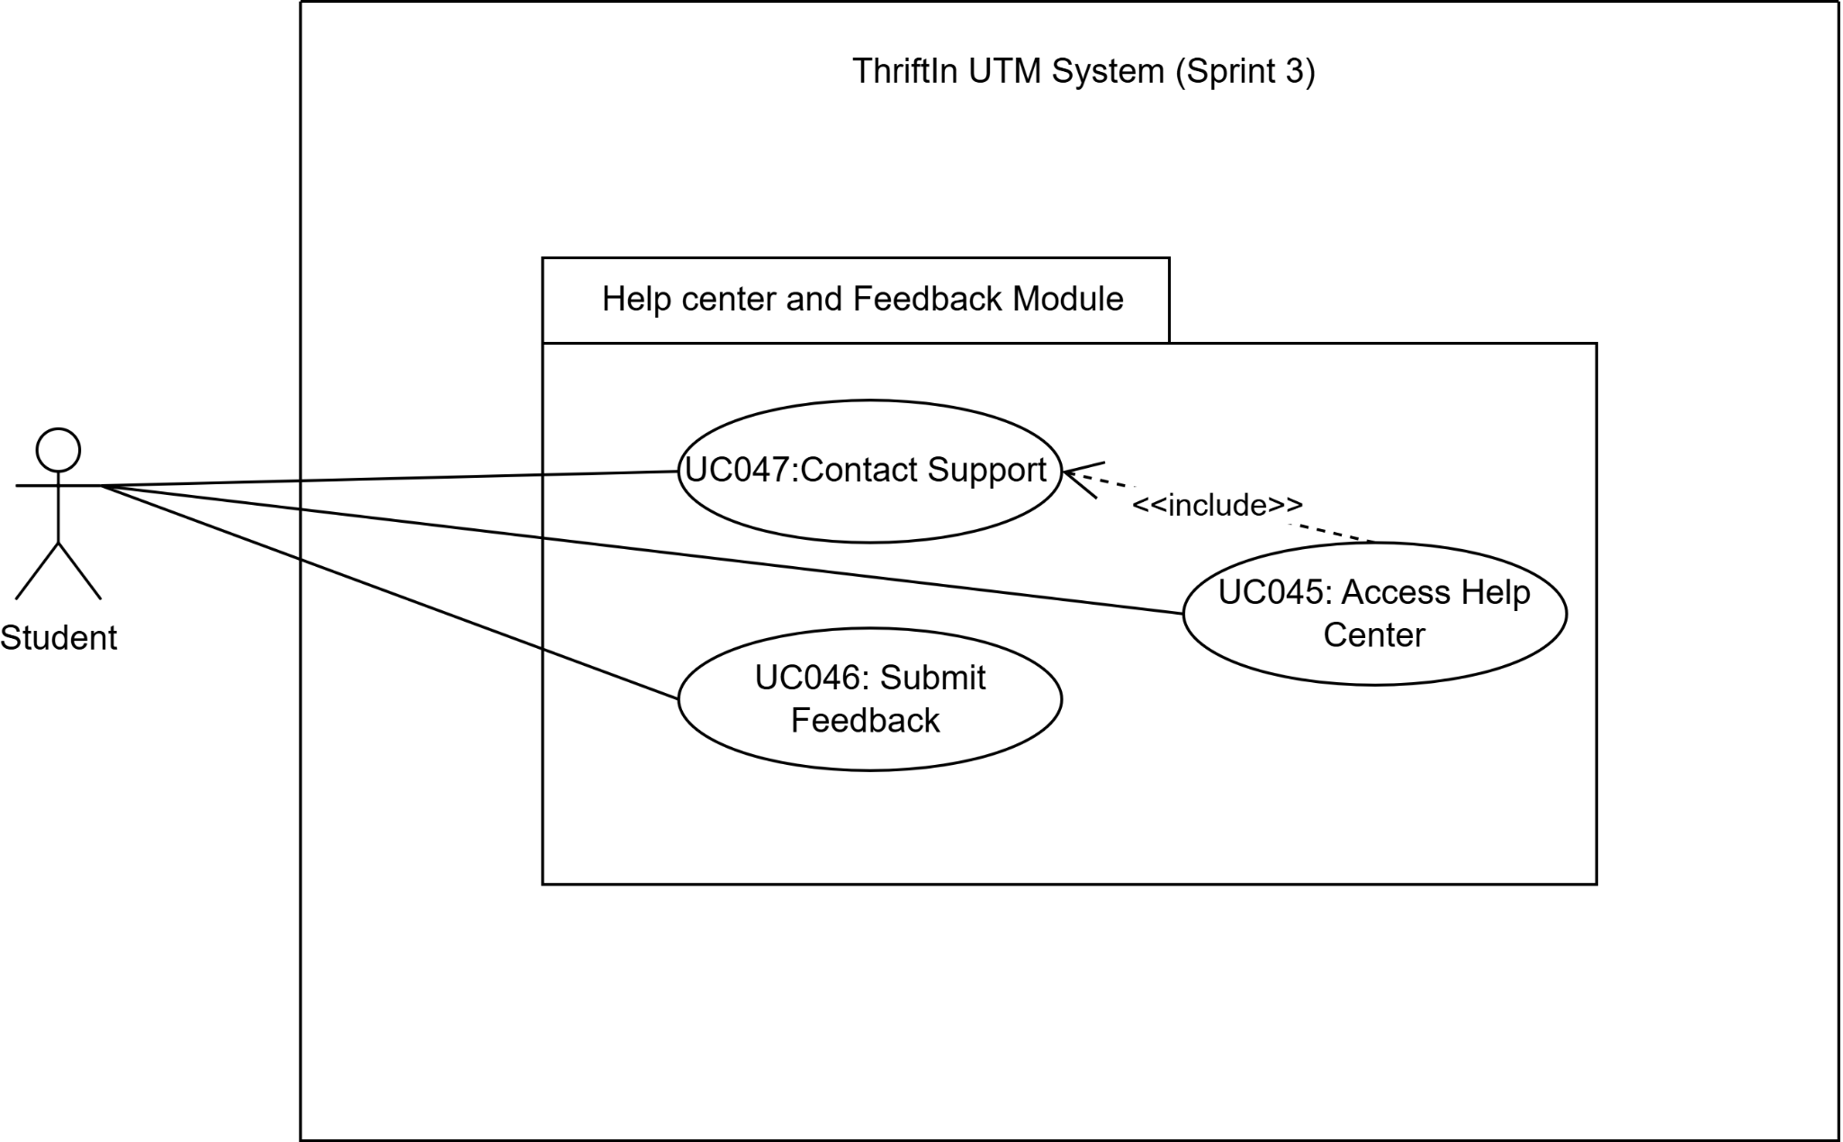
Figure 6.9: Packaging Diagram for Help center and Feedback Module

SPECIFIC REQUIREMENT
The Help Center and Feedback Module is designed to support effective user assistance and communication within the ThriftIn UTM textbook marketplace. It allows users to access help resources, submit feedback, and request support, while enabling administrators to manage help content and handle user issues efficiently. The module consists of four main use cases: UC045 Access Help Center, UC046 Submit Feedback and UC047 Contact Support.

Through UC045 Access Help Center and UC047 Contact Support, users can view, search, and filter help articles from a centralized Help Center. Users with existing support requests are also able to track request status within the same interface, ensuring easy access to relevant support information. UC046 Submit Feedback allows users to submit feedback by providing relevant details and optional attachments. The system validates submissions and generates a reference ID for tracking purposes.

Overall, the Help Center and Feedback Module provides a structured and user-centered support mechanism that improves issue resolution efficiency and enhances the overall user experience.

6.3.1 UC045: ACCESS HELP CENTER

Use Case Name: Access Help Center
Use Case ID: UC045
Actors: User
Preconditions:
- The user is logged into the system.
- Help Center module is available.
Flow of Events:
- The user navigates to the Help Center.
- System displays available help articles organized by category.
- User searches or filters articles by keyword or category.
- The user selects an article to view full content.
- The system displays article details including title, content, category, and publication date.
Alternative Flow:
A1: If no articles are available, the system displays “No help articles available”.
A2: If article retrieval fails, the system displays an error message and suggests retrying or searching.
Post-conditions:
The user has accessed and viewed help and support information.
Table 6.6: Use case Specification for UC045

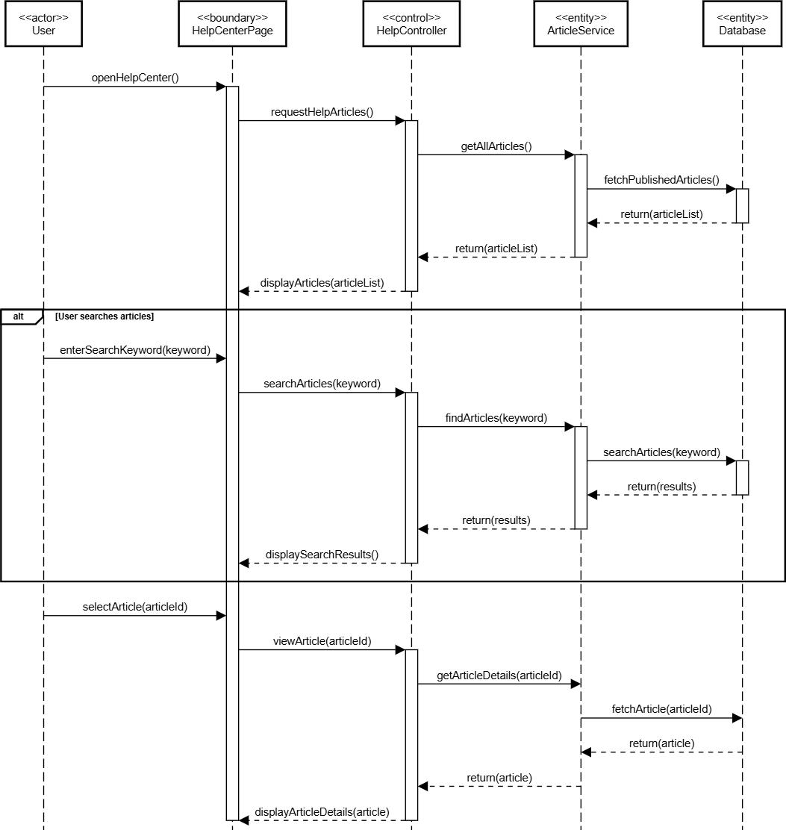
Figure 6.10: Sequence Diagram of UC045 Access Help and Support

6.3.2 UC046: SUBMIT FEEDBACK

Use Case Name: Submit Feedback
Use Case ID: UC046
Actors: User
Preconditions:
- The user is logged in.
- Feedback forms are available.
Flow of Events:
- The user opens the feedback submission form.
- The user enters details such as title, category, message, and priority.
- The system validates the input data.
- The user submits the form.
- The system stores the submission and generates a reference ID.
- The system displays a confirmation message to the user.
Alternative Flow:
A1: If validation fails, the system displays validation error messages.
A2: If submission fails due to system error, the system prompts the user to retry.
Post-conditions:
Feedback is successfully submitted and stored.
Table 6.7: Use case Specification for UC046

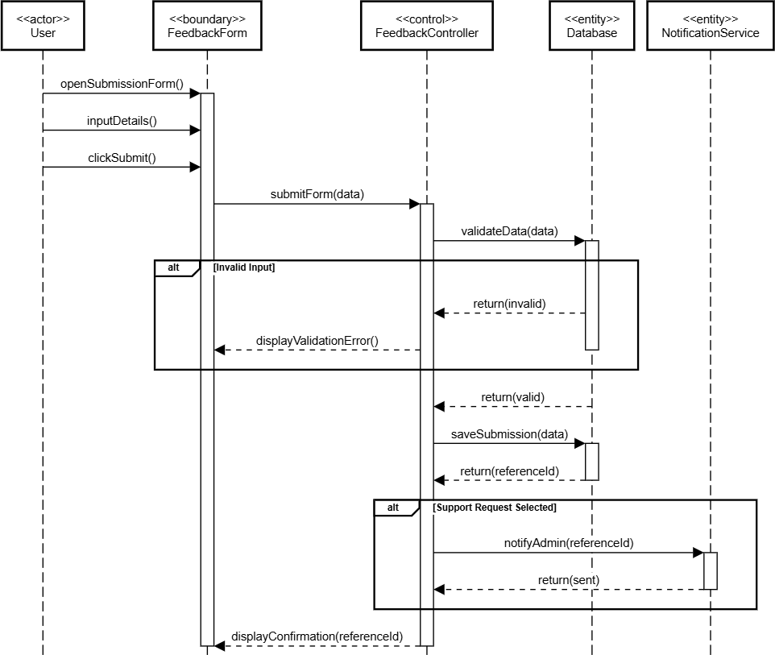
Figure 6.11: Sequence Diagram of UC046 Submit Feedback and Support Request

6.3.3 UC047: CONTACT SUPPORT

Use Case Name: Contact Support
Use Case ID: UC047
Actors: User
Preconditions:
- The user is logged in.
- Support Request forms are available.
Flow of Events:
- The user opens the support submission form.
- The user enters details such as title, category, message, and priority.
- The system validates the input data.
- The user submits the form.
- The system stores the submission and generates a reference ID.
- The system displays a confirmation message to the user.
Alternative Flow:
A1: If validation fails, the system displays validation error messages.
A2: If submission fails due to system error, the system prompts the user to retry.
Post-conditions:
Support requests are successfully submitted and stored.
Table 6.8: Use case Specification for UC047

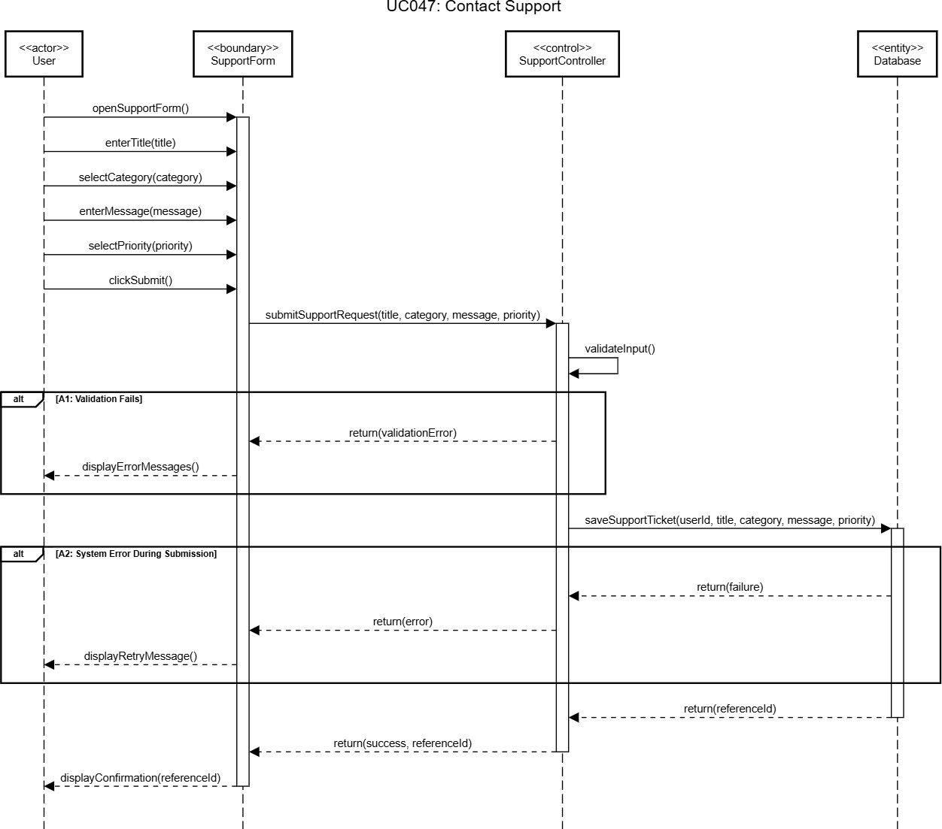
Figure 6.12: Sequence Diagram of UC047 Contact Support

